Complete FireRed Upgrade

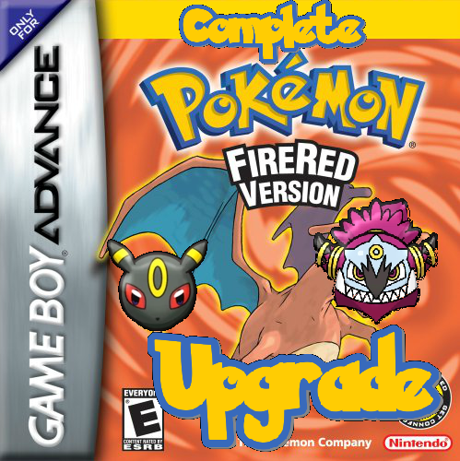

Never use Pokémon Game Editor (PGE)!
Contents
Understanding C Syntax 6
Defines & Comments 6
enum 6
Types 7
External Declarations 7
Arrays 8
Structures 9
Switch Statements 10
Setup 11
Recommended Insertion Steps 11
Necessary Modifications 12
Pokémon Defines 12
Item Defines 15
Relevant Additions 15
Optional Byte Changes 16
Capitalization/Decapitalization 16
Attack Descriptions 16
Multichoice Menus 16
Configuration Options 16
Configurable Options 17
Var Options 17
Flag Options 20
Start Menu Features 24
Pedometer Flags 24
Battle Frontier Options 25
Character Customization Vars 27
Healing Place Hack 28
TM / HM / Move Tutor Options 28
Times of Day 29
Other Number Definitions 29
Badge Obedience 31
OW Palette Ids 31
Pre-Battle Mugshot Options 32
Safari Zone Options 32
Randomizer Options 32
Memory Locations 33
Misc Features 33
Misc Battle Effect Options 41
Ability Options 41
Damage Calculation Options 41
Capturing Pokémon Options 42
Exp. Gain Options 42
Other Battle Options 43
DexNav Options 45
Engine Setup 46
Mega Evolution / Primal Reversion / Ultra Burst / Gigantamax 46
Z-Moves 55
Trainer Sliding Messages 56
Multi Battles 58
Wild Double Battles 60
Trainer Backsprites 61
Battle Terrain 63
Battle Music 64
Poke Balls 65
Trainers With EVs 66
Battle Frontier 68
Upgraded TM/HM Expansion 72
Reusable TMs 72
Pickup 73
Select from PC Hack 73
Time of Day Based Wild Encounters 74
Swarms 77
Roaming Pokemon 77
Day & Night System 78
Pre-Battle Mugshots 81
New Field Moves 82
Raid Battles 84
Custom Item Use Effect 85
Other Features Included 87
Save Expansion 87
Updated & New Item Effects 87
Trainer Face Fix 87
DexNav 87
Dynamic Overworld Palettes 87
Ability Pop-Ups 87
Hidden Abilities 88
Expanded Text Names 88
Pokédex Screen Stats 88
Turbo Boost 88
Various Customizable Updates 88
Triple Layer Tiles and Cut Grass Tiles¹⁰ 89
Expanded Coins 90
Multichoice Windows 90
Tile Interaction Scripts 91
Script Specials 92
Creating New Battle Mechanics 135
Moves 135
Abilities 138
Poke Balls 139
Items 142
Code Files 143
Table Compendium 151
Engine Scripts 158
Clean.py 158
String.py 158
Credits 160

Colour Coding Legend

Encoding | Represents
Bold | Indicates file paths or things to take note of.
Italicized | Used for things such as proper names or scripting command names.
Green | Used to indicate a definition that should be changed in src/config.h. In example scripts it is used for comments and strings.
Dull Orange | Used to indicate another constant defined somewhere (not in the config file). In scripts it is used for the #define and #org directives as well.
Italicized Purple | Used to indicate a table of some sort that can be modified (usually found in src/Tables, but not always).
Deep Orange | Used when referring to function names.
Gold | Used for certain definitions like #ifdef.
Blue Underlined | These words are hyperlinks. Clicking on them will take you somewhere (may or may not be in the document).
Red | Used for titles. In scripts they represent references to other scripts.
Faded Blue | Used for showing the inputs for script specials.

Understanding C Syntax

To use this engine, you are not expected to know how to code in C. However, it is wise to read through the following explanations to learn how to modify the various data structures found in the engine.

Defines & Comments
Read this article for defines. Read this article for comments. Read this article for conditional compilation.
Additionally, you may simply type #define SOMETHING without any associated value. This is used several times throughout the engine to allow the user to customize various options.

enum
Using an enumerated type is like using the #define directive, however, it can simplify the process of declaring several constants at once. Unlike #define, enums do not require you to declare the number of each constant. Each declaration is the value immediately following the previous value. Each declaration within an enum should end with a “,”, and each enum should begin and end with curly braces {} and be followed by a “;”.

Example 1:
enum
{
SUNDAY,
MONDAY,
TUESDAY,
};

In the example above, SUNDAY evaluates to 0 (it is the default starting value), MONDAY evaluates to 1, and TUESDAY evaluates to 2.

Example 2:
enum
{
MONDAY = 1,
TUESDAY,
THURSDAY = 4,
FRIDAY,
};

In the example above, MONDAY evaluates to 1, TUESDAY evaluates to 2, THURSDAY evaluates to 4, and FRIDAY evaluates to 5. Notice that values can be skipped by using the = sign.

Types
In C, each variable or data element has a type. The following are the most widely used types in the engine and should be made familiar:
- u8: The data is 1 byte, 0 to 255.
- s8: The data is 1 byte, -128 to 127.
- u16: The data is 2 bytes, 0 to 65535. (Size of Pokémon species, items, and moves)
- s16: The data is 2 bytes, -32768 to 32767
- u32: The data is 4 bytes, 0 to 4294967295.
- s32: The data is 4 bytes, -2147483648 to 2147483647
- u8*: The data is a pointer (pointers are 4 bytes) to some bytes. (Used for strings & pics)
- u16*: The data is a pointer (pointers are 4 bytes) to some list of 2-byte entries.
- u32*: The data is a pointer (pointers are 4 bytes) to some list of 4-byte entries.
- const: Placed before any of the above types. This means that the data is unmodifiable after compilation (basically any permanent data in the rom that can’t be changed during gameplay).
- static: Placed before any of the above types. This means that the variable/data structure/function will be used and is only used in the file it is declared in.

External Declarations
Due to this engine being multi-file, when using data found in other files, it is necessary to declare that elements from other files exist. If declaring in a .c (as opposed to .h) file, these declarations should be done beneath all of the #includes found at the top of the file. If these data structures are not declared before their occurrence in the file, the compiler will throw an undeclared (first use in this function) error. There are several cases when you will need to write your own declarations:
- When attempting to use an image compiled by the engine with the file name MyPicFileName
  - Using an image’s tiles: extern const u8 [IMAGE_NAME]Tiles[];
    - Eg. extern const u8 MyPicFileNameTiles[];
  - Using an image’s palette: extern const u16 [IMAGE_NAME]Pal[];
    - Eg. extern const u16 MyPicFileNamePal[];
  - Using an image’s compressed palette: extern const u8 [IMAGE_NAME]Pal[];
    - Eg. extern const u8 MyPicFileNameCompressedPal[];
  - Using an image’s tilemap: extern const u8 [IMAGE_NAME]Map[];
    - Eg. extern const u8 MyPicFileNameMap[];
- When attempting to use a string compiled in one of the .string files.
  - extern const u8 [STRING_NAME][];
    - Eg. extern const u8 gText_MyString[];
- When attempting to use a script written in one of the .s files.
  - extern const u8 [SCRIPT_NAME][];
    - Eg. extern const u8 EventScript_MyScript[];
  - Don’t forget to also type .global [SCRIPT_NAME] in the .s file!
    - Eg. .global EventScript_MyScript

Arrays
Commonly referred to as “tables” or “lists”, arrays contain the bulk of the data editable in the engine. All elements in an array are the same type. Similar to enum, each declaration within an array should end with a “,”, each array should be preceded by the type of each element, begin with [] = (enum doesn’t have this), start and end with curly braces {}, and be followed by a “;”.

Example 1:
u16 sMyArray[] =
{
5,
2665,
11,
};

The above array is a standard array of 2-byte entries. In a hex editor it would look like:
05 00 69 0A 0B 00

Example 2:
u8 sMyArray[] =
{
MONDAY,
TUESDAY,
SUNDAY,
};

In the above example, it is assumed that the constants SUNDAY, MONDAY, and TUESDAY declared in the enum first example above are declared prior. This array is an array of 1-byte entries. In a hex editor it would look like:
01 02 00
(Remember, Monday is 1, Tuesday is 2, and Sunday is 0)

Example 3:
const u8* sMyArray[] =
{
[MONDAY] = gText_MyString2,
[THURSDAY] = gText_MyString3,
[SUNDAY] = gText_MyString1,
};

In the above example, the same assumption as in Example 2 holds, as well as the assumption that the strings are declared prior. This array is an array of pointers to strings found in the rom. The day-of-week constants are used here are used to declare array index. So although they seem out of order, the array still compiles as (notice the two empty spots (0) b/c Thursday is 4):
[Pointer to gText_MyString1] [Pointer to gText_MyString2] 0 0 [Pointer to gText_MyString3]

Structures
Structs are like arrays in the sense that they store data, but unlike arrays, data stored within them does not need to be all the same type. Additionally, each element (referred to as a member) can be accessed with its unique name.

Example 1 - Declaring a Struct
struct MyStructTemplate
{
u8 member1;
u16 member2;
u16 member3;
};

Before structs can be used, they must be declared. The above struct has been declared to have three members: member1 is a byte, member2 is 2-bytes, and member3 is 2-bytes. Each member declaration ends with a “;”. Structs begin and end with {}, and are followed by a “;”.

Example 2 - Using a Struct
struct MyStructTemplate sMyStruct =
{
.member1 = 5,
.member2 = SPECIES_CHARMANDER,
.member3 = ITEM_ORAN_BERRY,
};

The above struct uses the declaration from Example 1 (as well as some other constants defined elsewhere). Each member in MyStruct is initialized by calling the member name preceded by a “.”, and ending the line with a “,”.

Example 3 - Struct Arrays
struct MyStructTemplate sMyStructArray[] =
{
{
.member1 = 5,
.member2 = SPECIES_CHARMANDER,
.member3 = ITEM_ORAN_BERRY,
},
{
.member1 = 5,
.member2 = SPECIES_SQUIRTLE,
.member3 = ITEM_ORAN_BERRY,
},
};
Structs can be elements of arrays too! No further explanation needed.

Switch Statements
Understanding switch statements are not necessary for using this engine, but they can help you understand how to modify predefined switch statements on your own.
The general outline of a switch statement looks like this:

switch (someVariable) {
case 0:
Do something;
break;
case 1:
Do something;
break;
default:
Do something;
break;
}
where each “case” determines what happens when “someVariable” contains that value. For example, if someVariable equals 1, then the switch statement will jump to Case 1. If the value is not one of the listed cases, then whatever is under default will be executed. If there is no default, then nothing will happen if the case value is not found. Cases can also be represented by constants. To add a case, simply add it underneath one of the pre-existing cases but above default (TUESDAY is intended to be added):

switch (Clock->dayOfWeek) { //Clock->dayOfWeek is a variable that holds the day of week
case SUNDAY:
Do something on Sunday;
break;
case MONDAY:
Do something on Monday;
break;
case TUESDAY:
Do something on Tuesday;
break;
default:
Do something other days of week;
break;
}

Cases can also be stacked, causing both values to result in the same functionality:
switch (Clock->dayOfWeek) {
case SUNDAY:
case MONDAY:
Do something on Sunday & Monday;
break;
}

Setup

Recommended Insertion Steps
The CFRU should ideally only ever be applied once to a rom. It’s not a good idea to insert it in a rom, add things such as maps and scripts to the generated rom, and then reuse the generated rom as a base for the CFRU again. This tutorial will help circumvent this issue.

- Add the Dynamic Pokémon Expansion (and other suggested hacks) to your rom. This will be referred to as Rom 1.

- Add the CFRU to a vanilla FireRed rom at the same offset you plan on adding it to your hack. This will be referred to as Rom 2.

- Open the generated file offsets.ini and search for gMoveNames.
Record the offset that you find there. This will be referred to as offset 1.

- Assuming your moves list ends with the Z-Moves, search for Z_Move_1 in offsets.ini.
Record the offset that you find there. This will be referred to as offset 2.

- Open Rom 2 in a hex editor and select all data from offset 1 up to but not including offset 2.
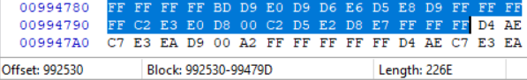

- Copy this data and paste it at offset 1 in Rom 1. At 0x148 place a pointer to offset 1.
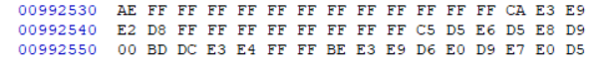

- Rom 2 has no more use so feel free to delete it.
- Treat Rom 1 as your base rom for the CFRU. It is recommended to do all scripting, mapping, and trainer editing in Rom 1. When you’re ready to test, run the command python scripts//make.py and test on the generated test.gba (it’ll take only a second to recompile if no changes have been made to the CFRU). This test.gba also makes a great location to test scripts to make sure they work properly before finalizing them.

Necessary Modifications

The following modifications must be made before setting up the engine!

Pokémon Defines
- Open the files include/constants/species.h and include/constants/pokedex.h.
- Modify the Pokémon indices found in this file to match the ones in your hack.
- If you have not added in any new Pokémon to Fire Red, you can leave the unused species indices as their default values.
- If you have added new Pokémon, ideally, you should not delete any Pokémon names and just assign all species you aren’t using a unique number starting after your last Pokémon slot. However, if this is too tedious for you, you’ll need to do the following two things.
- First, modify the following tables by removing entries you don’t wish to use:

Table | File
sSpecialZMoveTable | src/set_z_effect.c
sSmartWildAITable | src/Battle_AI/AI_master.c
gWildSpeciesBasedBattleBGM | src/Tables/Music_Tables.c
gMiniorCores | src/form_change.c
sBannedBackupSpecies | src/form_change.c
sTypeToArceusForm | src/form_change.c
sTypeToSilvallyForm | src/form_change.c
All Tables | src/Tables/Pokemon_Tables.c

- Secondly, the following Pokémon are necessary and must be changed if you are not using them (preferably all to unique numbers - I can’t guarantee they’ll all work as the same number). You can also try deleting their defines in include/constants/species.h. This should (but not always) work:

Species | Reason
SPECIES_NONE 0x0 | It’s 0. Don’t change or remove.
SPECIES_BULBASAUR 0x1 | Referred to by vanilla FR roaming code.
SPECIES_CHARMANDER 0x4 | Referred to by vanilla FR roaming code.
SPECIES_NIDORAN_M 0x20 | Special breeding.
SPECIES_FARFETCHD 0x53 | Signature item Stick.
SPECIES_CUBONE 0x68 | Signature item Thick Club.
SPECIES_MAROWAK 0x69 | Signature item Thick Club.
SPECIES_MAROWAK_A 0x40F | Signature item Thick Club.
SPECIES_CHANSEY 0x71 | Signature item Lucky Punch. Luck Incense breeding.
SPECIES_MR_MIME 0x7A | Odd Incense breeding.
SPECIES_DITTO 0x84 | Signature items Quick Powder & Metal Powder. Daycare.
SPECIES_SNORLAX 0x8F | Full Incense breeding.
SPECIES_PICHU 0xAC | Volt Tackle breeding.
SPECIES_MARILL 0xB7 | Sea Incense breeding.
SPECIES_SUDOWOODO 0xB9 | Rock Incense breeding.
SPECIES_WOBBUFFET 0xCA | Lax Incense breeding.
SPECIES_UNOWN 0xC9 | Has many forms. Change those too.
SPECIES_MANTINE 0xE2 | Wave Incense breeding.
SPECIES_RAIKOU 0xF3 | Referred to by vanilla FR roaming code.
SPECIES_ENTEI 0xF4 | Referred to by vanilla FR roaming code.
SPECIES_SUICUNE 0xF5 | Referred to by vanilla FR roaming code.
SPECIES_AZURILL 0x15E | Sea Incense breeding.
SPECIES_WYNAUT 0x168 | Lax Incense breeding.
SPECIES_ROSELIA 0x16B | Rose Incense breeding.
SPECIES_CLAMPERL 0x175 | Signature items Deep Sea Tooth & Deep Sea Scale.
SPECIES_CASTFORM 0x181 | Signature ability: Forecast.
SPECIES_VOLBEAT 0x182 | Special breeding.
SPECIES_LATIAS 0x197 | Signature item Soul Dew.
SPECIES_LATIOS 0x198 | Signature item Soul Dew.
SPECIES_CHIMECHO 0x19B | Pure Incense breeding.
SPECIES_EGG 0x19C | It’s an egg. Don’t change or remove.
SPECIES_BUDEW 0x1CB | Rose Incense breeding.
SPECIES_BURMY 0x1D1 | Changes form after battle.
SPECIES_BURMY_SANDY 0x2C3 | Changes form after battle.
SPECIES_BURMY_TRASH 0x2C4 | Changes form after battle.
SPECIES_CHERRIM 0x1DA | Signature ability: Flower Gift.
SPECIES_CHERRIM_SUN 0x2EF | Signature ability: Flower Gift.
SPECIES_CHINGLING 0x1E6 | Pure Incense breeding.
SPECIES_BONSLY 0x1EB | Rock Incense breeding.
SPECIES_MIME_JR 0x1EC | Odd Incense breeding.
SPECIES_HAPPINY 0x1ED | Luck Incense breeding.
SPECIES_MUNCHLAX 0x1F3 | Full Incense breeding.
SPECIES_MANTYKE 0x1FF | Wave Incense breeding.
SPECIES_ROTOM 0x214 | Special breeding.
SPECIES_DIALGA 0x218 | Signature item Adamant Orb.
SPECIES_PALKIA 0x219 | Signature item Lustrous Orb.
SPECIES_GIRATINA 0x21C | Signature item Griseous Orb.
SPECIES_GIRATINA_ORIGIN 0x2CE | Signature item Griseous Orb.
SPECIES_PHIONE 0x21E | Special breeding from Manaphy.
SPECIES_DARKRAI 0x220 | Only species that can use Dark Void.
SPECIES_SHAYMIN 0x221 | Changes form when frozen.
SPECIES_SHAYMIN_SKY 0x2CF | Changes form when frozen.
SPECIES_DARMANITAN 0x260 | Signature ability: Zen Mode.
SPECIES_DARMANITANZEN 0x2E1 | Signature ability: Zen Mode.
SPECIES_KELDEO 0x2BC | Changes form with Secret Sword.
SPECIES_KELDEO_RESOLUTE 0x2F5 | Changes form if doesn’t know Secret Sword.
SPECIES_MELOETTA 0x2BD | Changes form with Relic Song.
SPECIES_MELOETTA_PIROUETTE 0x2EA | Changes form with Relic Song.
SPECIES_GRENINJA 0x2FE | Signature ability: Battle Bond.
SPECIES_ASHGRENINJA 0x347 | Signature ability: Battle Bond.
SPECIES_FURFROU 0x310 | Special breeding.
SPECIES_AEGISLASH 0x315 | Signature ability: Stance Change.
SPECIES_AEGISLASH_BLADE 0x341 | Signature ability: Stance Change.
SPECIES_ZYGARDE 0x33A | Signature ability: Power Construct.
SPECIES_ZYGARDE_10 0x345 | Signature ability: Power Construct.
SPECIES_ZYGARDE_COMPLETE 0x346 | Signature ability: Power Construct.
SPECIES_HOOPA 0x33C | Special message why trying to use Hyperspace Fury.
SPECIES_HOOPA_UNBOUND 0x33D | Only Pokémon that can use Hyperspace Fury.
SPECIES_GROUDON_PRIMAL 0x38D | Is referenced as a Red Primal.
SPECIES_KYOGRE_PRIMAL 0x38E | Is referenced as a Blue Primal.
SPECIES_LYCANROC 0x3C2 | Special battle animation.
SPECIES_LYCANROC_N 0x416 | Special battle animation.
SPECIES_LYCANROC_DUSK 0x43A | Special battle animation.
SPECIES_WISHIWASHI 0x3C3 | Signature ability: Schooling.
SPECIES_WISHIWASHI_S 0x417 | Signature ability: Schooling.
SPECIES_MINIOR_SHIELD 0x3DF | Signature ability: Shields Down.
SPECIES_MINIOR_RED 0x429 | Signature ability: Shields Down.
SPECIES_MINIOR_BLUE 0x42A | Signature ability: Shields Down.
SPECIES_MINIOR_ORANGE 0x42B | Signature ability: Shields Down.
SPECIES_MINIOR_YELLOW 0x42C | Signature ability: Shields Down.
SPECIES_MINIOR_INDIGO 0x42D | Signature ability: Shields Down.
SPECIES_MINIOR_GREEN 0x42E | Signature ability: Shields Down.
SPECIES_MINIOR_VIOLET 0x42F | Signature ability: Shields Down.
SPECIES_MIMIKYU 0x3E3 | Signature ability: Disguise.
SPECIES_MIMIKYU_BUSTED 0x430 | Signature ability: Disguise.

Also be sure to change the species indices in asm_defines.s as well (just copy and paste the data from before but use a text editor to do a search and replace of all #define with .equ and all " 0x" with ", 0x" (without quotation marks and notice the whitespace).

If any Pokémon is missing from the above table please submit an issue!

Item Defines
Part 1
- Open the file include/constants/items.h.
- Modify the item indices found in this file to match the ones in your hack.
- DO NOT DELETE ANY ITEM NAMES. If there is an item you are not using, then set its index to some random really high number (for example, 0xFFFE) (avoid 0xFEFE and 0xFFFF). Make sure to also remove these items from both gFlingTable and gItemsByType found in src/Tables/Item_Tables.

Part 2
- Open the file include/constants/hold_effects.h.
- Scroll down to where it says “//NEW ITEM EFFECTS”. This is the list of new hold item effects. When relevant, the item quality is included.
- Set up your items in G3T using the example for the Fire Gem as a base:
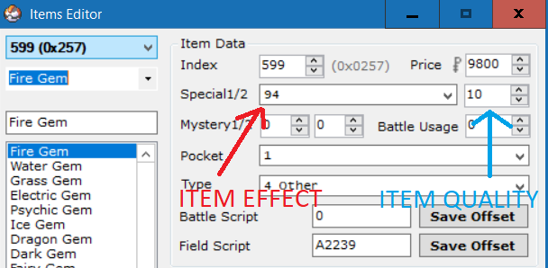
As you can see, the item effect is set to 94 and the item quality is set to 10 (the move type for Fire).

Relevant Additions
The following are a list of relevant and recommended add-ons created by other users of the PokeCommunity that for some reason or another, were chosen to be left out from this engine. If you choose to apply any of these, they should be applied prior to applying the engine.
- Dynamic Pokémon Expansion (HIGHLY RECOMMENDED)
- Overworld Form Change (Only Arceus, Silvally, Genesect, & Giratina are included in the CFRU)
- DS-Style Pokémon Selection Screen
- Black & White Pokémon Summary Screen (HIGHLY RECOMMENDED)
- Sideways Stairs (HIGHLY RECOMMENDED)
- MrDollSteak’s Decap. and Attack Rombase (For the decapitalization - USE AT YOUR OWN RISK)
- Nature Coloured Stats (see BW Summary Screen comments for alternate implementation)
- IV Rankings (see BW Summary Screen comments for alternate implementation)
- Unown Report (NOT COMPATIBLE)
- HGSS Kanto Reloaded Music Patch
- HGSS Johto Music Patch
- BW/BW2 Music Patch (Change four bytes at 0x4A32A0 to A0 FA 03 02 after patching)
- All-Instrument Patch (Make sure to change insert offset of engine to avoid overwriting)
- Squeetz’ Music Rom Base

Optional Byte Changes
Open the file bytereplacement in a text editor and search for ##Optional Byte Changes##. Place a # before anything here (until ##Remove Things##) to remove it from the engine.

Capitalization/Decapitalization
This engine does not decapitalize vanilla strings. However, there are certain strings that have been decapitalized/capitalized and can be changed. The following files have such strings which can be modified in a text editor:
- strings/ability_name_table.string
- strings/attack_name_table.string
- strings/frontier_trainer_names.string
- strings/overworld_strings.string (specifically search for Bag Strings)
- strings/party_menu.string (specifically gMenuText_Move)
- strings/poketools.string
- strings/type_names.string
- strings/z_move_names.string

Attack Descriptions
Some of the newer attack descriptions were written to span five lines. This is not supported by the original FireRed summary screen, so it is highly recommended to update to the Black & White Pokémon Summary Screen (linked to above). If you do not wish to do that, find any attack descriptions which span five lines and shorten them manually.

Multichoice Menus
If you plan on making a hack of vanilla FireRed, note that certain multichoice menus around Celadon City will no longer work. If you would prefer to not use custom multichoice menus, find the section labeled Multichoice Pointers in special_inserts.asm, and either comment it out or remove it.

Configuration Options
See below.

Configurable Options

There are many configurable options in the file src/config.h. These options are meant to provide the user with as much versatility as possible. Below is a more detailed description of each option than show in the configuration file:

Var Options
Flag Definition | Description
VAR_TERRAIN | Setting this var to one of the following values before initiating a battle will load the battlefield with the corresponding terrain:  1: Electric Terrain  2. Grassy Terrain  3. Misty Terrain  4. Psychic Terrain
VAR_TOTEM | This represents are series of vars using for initiating battles with Totem Pokémon. There are four vars in total, each representing a specific Pokémon slot on the field. Adding the following values to the var will indicate which slot that var is for:  0: Player Pokémon in Singles, Left Player Pokémon in Doubles  1: Enemy Pokémon in Singles, Right Enemy Pokémon in Doubles  2: Right Player Pokémon in Doubles  3: Left Enemy Pokémon in Doubles  The vars must be set to the addition of two values. Choose one from each of the following sets:  Stats:  1: Attack  2: Defense  3: Speed  4: Special Attack  5: Special Defense  6: Accuracy  7: Evasion  Amount:  0x10: Increase Stat by 1  0x20: Increase Stat by 2  0x30: Increase Stat by 3  0x40: Increase Stat by 4  0x50: Increase Stat by 5  0x60: Increase Stat by 6  0x90: Decrease Stat by 1  0xA0: Decrease Stat by 2  0xB0: Decrease Stat by 3  0xC0: Decrease Stat by 4  0xD0: Decrease Stat by 5  0xE0: Decrease Stat by 6  0xFFFF: Increase all stats by 1  So, for instance, in a single battle, having the enemy Pokémon start the battle with its Attack raised by 2, you would set the var VAR_TOTEM + 1 to the value of 0x21 (0x1 + 0x20).  Additionally, this feature can also be used in trainer battles. If used here, any Pokémon sent out into the set position will have their stats raised. So, using the example from above, all the opposing trainer’s Pokémon in Singles would start with their Attack raised by 2.
VAR_BACKSPRITE_SWITCH | Setting this var to a value other than 0 will change the default back sprite loaded for the player in battle.  See src/Tables/back_pic_tables.c for a list of available backsprites.
VAR_BATTLE_BG | If defined, setting this var to a value other than 0 will cause the regular battle background loaded to be replaced by a custom one.  See /include/battle.h for a list of options.  Search for BATTLE_TERRAIN_GRASS in the file to see them.
VAR_SWARM_INDEX | A var that is automatically set by the engine. It contains the index in the swarming table of the species that is currently swarming. Swarms are set to change on a daily basis. If TIME_ENABLED is commented out, then the code will need to be modified to find an alternative method to enable swarms. It can be found in src/wild_encounter.c.  The swarming table can be edited by searching for gSwarmTable in src/Tables/wild_encounter_tables.c.
VAR_SWARM_DAILY_EVENT | A pair of two vars (this one and the one immediately following it) that are automatically set by the engine. They are used to determine if a swarm has already been chosen for the given date. If TIME_ENABLED is commented out, then these vars will be set once and never again.
VAR_DEFAULT_WALKING_SCRIPT | If defined, then a var that contains the index of the script in walking script table that is set to run on every step. Set this var to 0 if you do not want any custom scripts to be run each step. To add a walking script, search for sDefaultWalkingScripts in src/overworld.c and either add (const u8*) pointers to scripts preloaded in the ROM, or define your own script (like EventScript_WalkingScript1) in one of the assembly files and declare it at the top like:  extern const u8 EventScript_WalkingScript1[];
VAR_DEXNAV | A var that holds the species to search for in the Overworld via the DexNav feature. Press Select in the DexNav GUI to save.
VAR_STATUS_INDUCER | If defined, then a var that if set, causes wild and Trainer Pokémon to be generated with the set status condition. It is split into an upper and lower byte. If the upper byte is set to 0, then this status condition will be given to Pokémon until this var is cleared. Any value in the upper byte other than 0 acts as a timer and is subtracted by 1 for each battle completed. For example, setting this var to 0x0640 will paralyze all enemy Pokémon in battles for 6 battles. See here for a list of status bytes.
VAR_SECOND_OPPONENT | A var that can be set by the engine (with trainerbattle 0xA or trainerbattle 0xB) to represent the trainer id of the second trainer in battles against two opponents. If set manually in conjunction with FLAG_TWO_OPPONENT, a battle against two opponents will be started the next time a trainer battle is initiated.
VAR_PARTNER | A var that can be set by the engine (with trainerbattle 0xA or trainerbattle 0xC) to represent the trainer id of the partner trainer in multi battles. If set manually in conjunction with FLAG_TAG_BATTLE, a battle with a partner against a single trainer will be started the next time a trainer battle is initiated. If setting manually, take care to set VAR_PARTNER_BACKSPRITE as well.
VAR_PARTNER_BACKSPRITE | A var that can be set by the engine (with trainerbattle 0xA or trainerbattle 0xC) to represent the backsprite id of the partner trainer in multi battles. If setting manually, take care to also set VAR_PARTNER and FLAG_TAG_BATTLE.

Flag Options
NOTE: Many of the following flags are cleared at the end of battle. To remove this, open the file src/end_battle.c and remove the flag from gEndBattleFlagClearTable. Many of the following flags can also be disabled by commenting out the lines where they are defined.

Flag Definition | Description
FLAG_INVERSE | Setting this flag will enable Inverse Battles.  This flag is automatically cleared at the end of each battle. Comment out to remove Inverse Battles.
FLAG_SKY_BATTLE | Setting this flag will indicate to the engine that a Sky Battle is in progress.  This flag is automatically cleared at the end of each battle. Comment out to remove Sky Battles.
FLAG_NO_CATCHING | Setting this flag will prevent wild Pokémon from having Poké Balls thrown at them.  This flag is automatically cleared at the end of each battle. Comment out to not use this flag.
FLAG_NO_RUNNING | Setting this flag prevents the player from running away during wild battles.  This flag is automatically cleared at the end of each battle. Comment out to not use this flag.
FLAG_NO_CATCHING_AND_RUNNING | This flag acts as a combination of the above two flags.  This flag is automatically cleared at the end of each battle. Comment out to not use this flag.
FLAG_CATCH_TRAINERS_POKÉMON | Setting this flag allows the player to capture Pokémon belonging to the opposing trainer. Capturing a Pokémon in this way will automatically end the battle.  This flag is automatically cleared at the end of each battle. Comment out to remove this feature.
FLAG_EXP_SHARE | Setting this flag activates the Gen 6+ Exp. Share.  Comment out to use the old Exp. Share.
FLAG_DOUBLE_BATTLE | Setting this flag will cause battles against trainers to be Double Battles, if possible.  Comment out to not use this flag.
FLAG_TAG_BATTLE | This flag is set by the engine when the scripting command trainerbattle 0xA or trainerbattle 0xC is used in a script to activate a tag battle. If setting this flag manually, take care to also set VAR_PARTNER and VAR_PARTNER_BACKSPRITE. This flag is automatically cleared at the end of each battle.
FLAG_TWO_OPPONENTS | This flag is set by the engine when the scripting command trainerbattle 0xA or trainerbattle 0xB is used in a script to activate a battle against two opponents. If setting this flag manually, take care to also set VAR_SECOND_OPPONENT.  This flag is automatically cleared at the end of each battle.
FLAG_ACTIVATE_TUTORIAL | If TUTORIAL_BATTLES is defined, Setting this flag activates Professor Oak’s tutorial during the next trainer battle.  This flag is automatically cleared at the end of each battle. Comment out to not use this flag.
FLAG_WILD_CUSTOM_MOVES | Setting the flag before a wild battle starts will create the wild Pokémon with the moves given in the input vars. This works with both regular wild battles and scripted wild battles (if scripted, set the input vars before using the wildbattle scripting command). Setting any value to 0xFFFF will cause the default move to be loaded in that slot. Setting any value to 0x0 will load a blank move in that slot. Note that there are additional inputs for wild double battles. Comment out to not use this flag. The input is as follows:  Var 0x8000: Move 1 - Pokémon 1  Var 0x8001: Move 2 - Pokémon 1  Var 0x8002: Move 3 - Pokémon 1  Var 0x8003: Move 4 - Pokémon 1  Var 0x8004: Move 1 - Pokémon 2 (Wild Double)  Var 0x8005: Move 2 - Pokémon 2 (Wild Double)  Var 0x8006: Move 3 - Pokémon 2 (Wild Double)  Var 0x8007: Move 4 - Pokémon 2 (Wild Double)
FLAG_SMART_WILD | Setting this flag allows wild Pokémon to use the basic AI checks used in trainer battles.  This flag is automatically cleared at the end of each battle. Comment out to not use this flag.
FLAG_SCALE_WILD_POKEMON_LEVELS | Setting this flag will cause all random wild Pokémon encounters (this does not include scripted encounters) to have Pokémon with levels that match the lowest level in your party.  Comment out to not use this flag.
FLAG_SCALE_TRAINER_LEVELS | Setting this flag causes all Trainer Pokémon to have levels that match the highest level in your party.  Comment out to not use this flag.
FLAG_HIDDEN_ABILITY | Setting this flag before a wild battle causes wild Pokémon to be generated with their hidden abilities. It also lets the givepokemon scripting command give Pokémon with their hidden abilities.  This flag is automatically cleared at the end of each battle.
FLAG_GIGANTAMAXABLE | Setting this flag before a wild battle or before using the givepokemon scriping command will allow the given Pokémon to Gigantamax, as long as their evolution line is properly configured.  This flag is automatically cleared at the end of each battle.
FLAG_DOUBLE_WILD_BATTLE | Setting this flag causes all wild battles to be against two wild Pokémon in a Double battle format (if the player has at least two viable Pokémon on their team).  This flag is automatically cleared at the end of each battle. Comment out to not use Wild Doubles.
FLAG_NO_RANDOM_WILD_ENCOUNTERS | Setting this flag will stop Pokémon from appearing while walking through grass or caves, or while surfing on water. Pokémon can still appear if the player chooses to fish, smash rocks, or use Sweet Scent.  Comment out to not use this flag.
FLAG_REMOVE_EVO_ITEM | A flag set by the engine to help with certain item-based evolutions.
FLAG_SHINY_CREATION | If set, the Pokémon generated by the game will be shiny. This includes wild Pokémon, gift Pokémon, or all the Pokémon in the next trainer battle.  This flag is automatically cleared at the end of each battle. Comment out to not use this flag.
FLAG_AUTO_RUN | Setting this flag enables auto-run. For convenience, this flag is toggled in the overworld by pressing the L-Button (as long as the button setting is not set to L=A). By default, this flag is defined in the config to be the same as the flag that allowed running in vanilla FR.
FLAG_RUNNING_ENABLED | If this line is uncommented, this flag can be used to control when the player can run. If this flag is not set, the player will be forced to walk.
FLAG_BIKE_TURBO_BOOST | Setting this flag speeds up the bike when it is in use. If the bike moves at this speed, it will even be able to go up muddy hills like in RSE. For convenience, this flag is toggled in the overworld by pressing the L-Button (as long as the button setting is not set to L=A).
FLAG_DISABLE_BAG | Setting this flag prevents the bag from being utilized in-battle.
FLAG_MOVE_RELEARNER_IGNORE_LEVEL | Setting this flag allows the Move Relearner to show a full list of moves Pokémon can learn through level-up (not restricted by the Pokémon’s level).  Comment out to not use this flag.
FLAG_EGG_MOVE_RELEARNER | Setting this flag allows the Move Reminder to teach Egg Moves instead.  Comment out to not use this flag.
FLAG_DYNAMAX_BATTLE | Setting this flag allows Pokémon to Dynamax in battle. The AI will automatically Dynamax their Pokémon with the need of any held item, but the player must have a Dynamax Band in their bag in order to Dynamax their Pokémon. A list of Dynamax Band items should be defined in the table sDynamaxBandTable found in src/dynamax.c.
FLAG_RAID_BATTLE | Setting this flag will cause wild Pokémon to appear Dynamaxed and be fought in a Max Raid Battle. It is best not to set this flag manually and use Special 0x118 - Start Raid Battle instead.
FLAG_RAID_BATTLE_NO_FORCE_END | If FLAG_RAID_BATTLE is set, then Raid Battles won’t be forcefully ended, nor will the player be given a chance to capture the Raid Boss. This is best used for scripted events where the player must defeat the Raid Boss in order to progress.
FLAG_FAST_BATTLE_MESSAGES | Setting this flag removes the wait time after battle messages are printed on the screen.
FLAG_FOLLOWER_IGNORE_ACTIVE_SCRIPT | Setting this flag will cause an active follower to confinue following even while a script is active.  Comment out to not use this flag.
FLAG_KEEP_CONSUMABLE_ITEMS | Setting this flag causes all consumable items to be returned after the next battle.  This flag is automatically cleared at the end of each battle. Comment out to not use this flag.
FLAG_DAILY_EVENTS_START | The start of a series of flags that get cleared daily. The flags range from this flag number up to and include the flag number + 0xFF.

Start Menu Features
Any of the following flags can be commented out to remove them from the engine.
Definition | Description
FLAG_SYS_BAG_HIDE | This flag allows the hacker to toggle the Bag in the start menu, for events where the player isn’t allowed to use items or lost their bag for various reasons. If this is commented out, BAG will always be present on the start menu. (Set to Hide)
FLAG_SYS_PLAYER_HIDE | This allows the hacker to toggle on/off the Trainer Card from the start menu. Commenting this out will cause PLAYER to always be present. (Set to Hide)
FLAG_SYS_SAVE_ HIDE | This allows the hacker to toggle the Save Game feature from the start menu. Commenting this out causes SAVE to be permanent on the start menu. (Set to Hide)
FLAG_SYS_DEXNAV | This allows the hacker to toggle TOOLS from the start menu. If this flag is defined and not set, POKéDEX will show up on the start menu (if the Pokédex flag is set of course). When the flag is set, TOOLS will replace POKéDEX, which yields a separate menu including both POKéDEX and DEXNAV. If this is commented out, The DexNav feature will be inaccessible. Do not give the player the DexNav before giving them the Pokédex!

Pedometer Flags
Setting any of these flags will initiate a pedometer of the corresponding size. The pedometer value can be read using special 0x8A.
Definition | Description
FLAG_LONG_PEDOMETER | 4 byte pedometer (max value 0xFFFFFFFF or 4 294 967 295)
FLAG_MED_PEDOMETER | 2 byte pedometer (max value 0xFFFF or 65 535)
FLAG_SMALL_PEDOMETER_1 | 1 byte pedometer (max value 0xFF or 255)
FLAG_SMALL_PEDOMETER_2 | 1 byte pedometer (max value 0xFF or 255)

Battle Frontier Options
These flags and vars should be used in any battle facility (not just Battle Tower).
Definition | Description
FLAG_BATTLE_FACILITY | Setting this flag indicates to the engine that the Player is in a Battle Facility. This means that:  - Trainer Pokémon will be generated within the restrictions of the tier set in the var VAR_BATTLE_FACILITY_TIER. The amount of trainer Pokémon generated will match the number set in the var  VAR_BATTLE_FACILITY_POKE_NUM.  - Trainer Pokémon will have Pokémon generated with the level contained in the var VAR_BATTLE_FACILITY_POKE_LEVEL.  - The battle format will be loaded from the var defined in  VAR_BATTLE_FACILITY_BATTLE_TYPE.  - The music in-battle will be played based on the value contained within the var VAR_BATTLE_FACILITY_SONG_OVERRIDE.  - The bag will be inaccessible in battle.
VAR_BATTLE_FACILITY_POKE_NUM | Setting this var to a value between 1 & 6 dictates the quantity of Pokémon the player and trainers can use in the Battle Facility.  Setting it to 0 will default in 1.  Setting it to a number greater than 6 will default in 6.
VAR_BATTLE_FACILITY_POKE_LEVEL | Setting this var to a value between 1 and what is defined in MAX_LEVEL will set all Pokémon in the Battle Facility to that level.  Setting it to 0 will default in 1.  Setting to a number greater than MAX_LEVEL will default in MAX_LEVEL.
VAR_BATTLE_FACILITY_BATTLE_TYPE | Setting this var to one of the below values set the battle format in the Battle Tower:  0: Single Battle  1: Double Battle  2: Multi Battle  3: Link Multi Battle  4: Random Single Battle  5: Random Double Battle  6: Random Multi Battle  Random battles assign the player a random team.  Any other value defaults in Single Battle.
VAR_BATTLE_FACILITY_TIER | Setting this var to one of the below values indicates to the engine which ruleset should be following for battles in the Battle Tower:  0: Regular Battle Tower Rules  1: No Restrictions  2: Smogon OU  3: Smogon Uber  4: Smogon Little Cup  5: Skeli’s Middle Cup / GS Cup  6: Smogon Monotype  7: Smogon Camomons  8: Uber Camomons  9: Little Cup Camomons  10: Middle Cup Camomons / GS Cup Camomons  11: Smogon Scalemons  12: Smogon 350 Cup  13: Smogon Averagemons  14: Smogon Benjamin Butterfree  15: Dynamax Standard  16: National Dex OU  17: Battle Mine Format 1 (OU, Camomons, Benjamin Butterfree)  18: Battle Mine Format 2 (Scalemons, 350 Cup, Averagemons)  19: Battle Mine Format 3 (Little Cup, Little Cup Camomons)
VAR_BATTLE_FACILITY_TRAINER1_NAME | This var is automatically set by the engine to hold the index of the random name for the first Battle Tower trainer. It is set to 0xFFFF after every battle. Do not set it manually.
VAR_BATTLE_FACILITY_TRAINER2_NAME | This var is automatically set by the engine to hold the index of the random name for the second Battle Tower trainer in Multi Battles. It is set to 0xFFFF after every battle. Do not set it manually.
VAR_BATTLE_FACILITY_SONG_OVERRIDE | Setting this var to a song Id will cause that song to be played in Battle Tower battles and Link Battles.
VAR_FACILITY_TRAINER_ID | This var is set by special 0x52 to indicate which trainer class and details is being spawned as the first opponent. The frontier trainer details should be added to the gTowerTrainers table which can be found in src/Tables/battle_frontier_trainers.c.
VAR_FACILITY_TRAINER_ID_2 | This var is set by special 0x52 to indicate which trainer class and details is being spawned as the second opponent in multi battles. The frontier trainer details should be added to the gTowerTrainers table which can be found in src/Tables/ battle_frontier_trainers.c
VAR_FACILITY_TRAINER_ID_PARTNER | This var is set by special 0x52 to indicate which trainer class and details is being spawned as the player’s partner in multi battles if the partner is chosen to be randomized. The trainer details should be added to the gFrontierMultiBattleTrainers table found in src/Tables/Frontier_Trainers.c.

Character Customization Vars
Definition | Description
VAR_PLAYER_WALKRUN | Set this var to change the player’s walking/running overworld sprite frames on map reload. The upper byte is used as the table Id, For example, setting to 0x0200 will load the walking/running frames from table 2, sprite 0.
VAR_PLAYER_BIKING | Switch player biking frames (same rules as above).
VAR_PLAYER_SURFING | Switch player surfing frames (same rules as above).
VAR_PLAYER_VS_SEEKER | Switch player VS Seeker frames (same rules as above).
VAR_PLAYER_FISHING | Switch player Fishing frames (same rules as above).
VAR_PLAYER_VS_SEEKER_ON_BIKE | Switch player Biking/VS Seeker frames (same rules as above).
VAR_PLAYER_UNDERWATER | Switch player underwater sprite (same rules as above).
VAR_TRAINERCARD_MALE | Set this var to the trainer sprite id of the male player front sprite that appears on the trainer card.
VAR_TRAINERCARD_FEMALE | Set this var to the trainer sprite id of the female player front sprite that appears on the trainer card.
VAR_RUNTIME_CHANGEABLE | If a person event has a given overworld table id 0xFF, it can be changed at runtime by changing these variables to a sprite number. There are 15 variables used in total.  For example, setting VAR_RUNTIME_CHANGEABLE+2 to 16, will cause all NPCs with ids 0xFF02 to appear with the little boy overworld sprite (in vanilla FR).  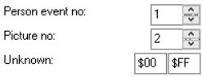  #define VAR_RUNTIME_CHANGEABLE 0x4080  #org 0x800000  setvar VAR_RUNTIME_CHANGEABLE+2 16 'Var 0x4082

Healing Place Hack
The following vars relate to JPAN’s healing place hack. If SET_HEALING_PLACE_HACK is not defined, ignore these vars.
VAR_HEALINGMAP | Set this var to the map and bank for the player to respawn to after whiting out. For example, if it is set to 0x0104, the player will respawn in their room (vanilla FR) (map bank 4, map 1).
VAR_HEALING_XPOS | Set this var to the x-position the player will respawn at on the map in VAR_HEALINGMAP.
VAR_HEALING_YPOS | Set this var to the y-position the player will respawn at on the map in VAR_HEALINGMAP.

TM / HM / Move Tutor Options
Definition | Description
EXPANDED_TMSHMS | Allows TMs and HMs past the original 58 to be used up to 128 total TMs + HMs.
EXPANDED_MOVE_TUTORS | Allows Move Tutors past the original 16 up to 128. This also removes the restriction that only allows the powerful elemental moves to be learned by the Kantonian starters.
NUM_TMS | Set this to the total number of TMs in the game.
NUM_HMS | Set this to the total number of HMs in the game.
NUM_MOVE_TUTORS | The number of move tutors. 64 is a good number.
LAST_TOTAL_TUTOR_NUM | Should be equal to (NUM_MOVE_TUTORS - 1) + 9. Must be set to an actual integer or the compilation will not work. This allows special additional move tutors to be added without having to change the size of the compatibility table. These are:  1. Draco Meteor  2. Secret Sword  3. Relic Song  4. Volt Tackle  5. Dragon Ascent  6. Thousand Arrows  7. Thousand Waves  8. Core Enforcer  9. Steel Beam  For more information regarding the move tutor defines, see include/constants/tutors.h.
TMS_BEFORE_HMS | Uncomment this line if you want the HMs to appear after the TMs in your bag.
DELETABLE_HMS | Uncomment this line if you’d like HMs to be deleted without the use of the Move Deleter like normal moves.
REUSABLE_TMS | Allows TMs to be reused infinitely without being removed from the bag. Also prevents TMs from being sold, held, or bought more than once. If using this feature, don’t forget to assign all TMs a Mystery 1 (in G3T) value of 1!

Times of Day
Definition | Description
TIME_MORNING_START | If TIME_ENABLED is defined, set this to the hour (in 24 hr system) that morning starts. This is also the day start time used for many events that only have a daytime/nighttime variant.
TIME_DAY_START | If TIME_ENABLED is defined, set this to the hour (in 24 hr system) that day starts.
TIME_EVENING_START | If TIME_ENABLED is defined, set this to the hour (in 24 hr system) that evening starts.
TIME_NIGHT_START | If TIME_ENABLED is defined, set this to the hour (in 24 hr system) that night starts.

Other Number Definitions
Definition | Description
KANTO_DEX_COUNT | Number of Pokémon in the regional Pokedex.
NATIONAL_DEX_COUNT | Number of Pokémon in the national Pokedex.
MAX_LEVEL | The highest possible level for a Pokémon. If you change this value, make sure to also modify the equivalent value found in asm_defines.s.
NUM_TRAINER_CLASSES | The number of trainer classes. Vanilla FR has 107.
EVOS_PER_MON | If you’ve changed the number of evolutions per Pokémon, update this number. Vanilla FR has 5.
EV_CAP | The most EVs a Pokémon can accrue for a given stat.
POWER_ITEM_EV_YIELD | The amount of additional EVs gifted in a certain stat by Power Items such as the Power Bracer.
DUSK_BALL_MULTIPLIER | The catch rate (*10) for Dusk Balls. So 30 is 3.0x.
STANDARD_IV | The number of IVs for each stat that standard Trainer’s Pokémon are generated with (if they don’t have an entry in gBaseIVsByTrainerClass found in src/Tables/trainers_with_evs.h).
SWARM_CHANCE | The chance in percent that a swarm Pokémon will appear on a route if there is currently a swarm in progress on that route.
WILD_DOUBLE_RANDOM_CHANCE | The chance that a wild double will be initiated if the player is walking in grass with a background byte with its 4th bit set. For instance, grass with a background byte of 0x5 will have a chance of starting a wild double battle, and grass with a background byte of 0x25 will have a chance of starting a wild double battle and be covered by the player (water is similarly 0x6 and 0x26).
CREATE_WITH_X_PERFECT_IVS | Set this to the number of 31 IVs Pokémon defined in the table gSetPerfectXIvList should be generated with. For example, if Mewtwo is in the table, and this is defined to 3, any Mewtwo generated (wild or Trainer) will always have at least 3 IVs set to 31. This does not include roaming Pokémon.  Table found in src/Tables/pokemon_tables.c.
CREATE_ROAMER_WITH_X_PERFECT_IVS | Set this to the number of 31 IVs roaming Pokémon should be generated with.
EGG_HATCH_LEVEL | Set this to level Pokémon Eggs should hatch at. Before Gen 4 it was 5, from Gen 4 onwards it has been 1.
AI_TRY_TO_KILL_RATE | In battles against a trainer with AI flags of 1 (only check if the move shouldn’t be used), the AI will try to use a move to knock out the opponents XX percent of the time, where XX is the number defined here. Setting this to 0 means basic AI will always use random moves in-battle, assuming that move has no reason not to be used.
MB_OMNIDIRECTIONAL_JUMP | Setting a tile’s behaviour byte to this number makes the tile act as a 4 way ledge. Meaning, the player will jump over it when approaching it from all 4 directions. For a related option, see CAN_ONLY_USE_OMNIDRECTIONAL_JUMP_  ON_HEIGHT_2.
MB_LOCKED_DOOR | Setting a tile’s behaviour byte to this number displays a message that the door is locked when the player interacts with it.
MB_ROCK_CLIMB_WALL | Setting a tile’s behaviour byte to this number makes it climbable with the move Rock Climb. See New Field Moves for more instructions.
MB_LAVA | Setting a tile’s behaviour byte to this number allows the player to surf on any of these tiles if they have a Fire-type Pokémon in their party. Comment out to remove this feature.
MAP_PLAYER_HOME | The map bank and map number of the player's home. This is used to help load the correct message when the Player white’s out. The upper byte represents the map bank, while the lower byte represents the map number. So:  Means map bank 4 and map number 0, aka, the Player’s home in vanilla FR.
MAX_COINS_DIGITS | Number of digits of game corner coins the player can hold (eg. default is 4 digits = up to 9999 coins).  If you use this feature, the slot machine script must be modified to prevent play if the Player has more than 9999 coins. Otherwise the game will crash!

Badge Obedience
Definition | Description
BASE_OBEDIENCE_LEVEL | The highest level that a traded Pokémon will obey the player at if they have no badges.
BADGE_1_OBEDIENCE_LEVEL | The highest level that a traded Pokémon will obey the player at if they have 1 badge.
BADGE_2_OBEDIENCE_LEVEL | The highest level that a traded Pokémon will obey the player at if they have 2 badges.
BADGE_3_OBEDIENCE_LEVEL | The highest level that a traded Pokémon will obey the player at if they have 3 badges.
BADGE_4_OBEDIENCE_LEVEL | The highest level that a traded Pokémon will obey the player at if they have 4 badges.
BADGE_5_OBEDIENCE_LEVEL | The highest level that a traded Pokémon will obey the player at if they have 5 badges.
BADGE_6_OBEDIENCE_LEVEL | The highest level that a traded Pokémon will obey the player at if they have 6 badges.
BADGE_7_OBEDIENCE_LEVEL | The highest level that a traded Pokémon will obey the player at if they have 7 badges.

OW Palette Ids
These represent the OW palette Ids of the ninja overworld disguises. If you have changed the default OW palettes, you may want to change these values as well.
Definition | Description
TREE_DISGUISE_PAL_ID | The OW palette Id the ninja tree disguise uses (movement type 0x39 in AdvanceMap).
ROCK_DISGUISE_PAL_ID | The OW palette Id the ninja mountain disguise uses (movement type 0x3A in AdvanceMap).
WEIRD_DISGUISE_PAL_ID | The OW palette Id the ninja weird disguise uses (I have no idea what the movement type is).

Pre-Battle Mugshot Options
Different vars for the Pre-Battle Mugshots.
Definition | Description
FR_PRE_BATTLE_MUGSHOT_STYLE | Uses the default preset mugshots for the FireRed Elite 4 and Champion
VAR_PRE_BATTLE_MUGSHOT_STYLE | Change mugshot tilemap style.
VAR_PRE_BATTLE_MUGSHOT_SPRITE | Can be used to change the player’s mugshot image to a VS. Symbol.
VAR_MUGSHOT_PLAYER_PAL | Change player’s tilemap palette for Two Bars.
FLAG_LOAD_MUGSHOT_SPRITE_FROM_TABLE | If the opponent’s or player’s sprite has a replacement mugshot sprite in the table sPreBattleMugshotSprites, then the sprite will be loaded from there.  Comment out to not use this flag.  Table found in src/Tables/mugshot_tables.c

Safari Zone Options
The following options allow you to set specific safari ball and safari step counter initial and maximum values.
Definition | Description
EXPAND_SAFARI_BALLS | If defined, the player can hold up to 0xFFFF (65535) Safari Balls!
SAFARI_ZONE_MAX_STEPS | Maximum number of Safari steps the player can have remaining (see special 0x89 to add/remove steps).
SAFARI_ZONE_BALL_START | The number of Safari balls the player will start the safari zone with.
MAX_SAFARI_BALLS | The maximum number of Safari balls the player can have (See special 0x87 to add/remove safari balls up to this amount).

Randomizer Options
Definition | Description
FLAG_POKEMON_RANDOMIZER | Setting this flag causes any Pokémon created to have its species randomized. The Pokémon created can fall anywhere between SPECIES_BULBASUAR and NUM_SPECIES. Pokémon banned from being created should be added to the gRandomizerSpeciesBanList table found in src/Tables/pokemon_tables.c.  Comment out to not use this flag.
FLAG_POKEMON_LEARNSET_RANDOMIZER | Setting this flag randomizes the level-up learnset of each Pokémon.  Comment out to not use this flag.
FLAG_ABILITY_RANDOMIZER | Setting this flag randomizes the possible abilities for each Pokémon. The abilities found in the gRandomizerAbilityBanList table found in src/Tables/pokemon_tables.c will never be chosen.
NUM_SPECIES_RANDOMIZER | The final number of Pokemon (+ 1) of species that can appear in the randomizer. Change to NUM_SPECIES to include Gen 8.

Memory Locations
Definition | Description
EXISTING_FOSSIL_IMAGE_TABLE_ADDRESS | If FOSSIL_IMAGE HACK is defined, and you already have a fossil image table inserted somewhere in your hack that you wish to use, uncomment this line and replace the given pointer with your pointer. See Special 0x18B for table details.
EXISTING_OW_TABLE_ADDRESS | If you have used JPAN’s hacked engine to add new overworld tables in, and you would like to use the table already inserted in your hack to keep track of these tables, uncomment this line and replace the given pointer with your pointer. Note that error handling for invalid table Ids will be disabled if you use this.

Misc Features
Definition | Description
TIME_ENABLED | Various features are updated to account for the time of day. Certain palettes are also dynamically faded depending on the time of day. Removing this feature will always result in Daytime.
DNS_IN_BATTLE | If TIME_ENABLED is defined, then certain background palettes will be faded dynamically in battle depending on the time of day. These values can be set in include/new/dns_data.h.
OVERWRITE_RIVAL | Loads the buffered rival’s name for trainer classes 0x51, 0x59, and 0x5A.
TRAINER_CLASS_POKE_BALLS | Creates trainer Pokémon with custom Poke Balls based on trainer class determined by what is set in src/Tables/ class_based_poke_ball_table.c.
TRAINERS_WITH_EVS | Trainer Pokémon with a custom moveset, custom item, an AI value greater than 1, and an IV value (labeled EVs in most trainer editors) greater than 0 will have custom stats loaded from the spread number indicated by the IV value in  src/Tables/trainers_with_evs_table.h.  For example, setting the IV value to 1 will loaded the spread labeled “1” in gTrainersWithEvsSpreads.  Modifying the required conditions to activate this feature can be done by searching for the line #ifdef TRAINERS_WITH_EVS in src/build_Pokémon.c.
CONTINUE_LOST_BATTLES | If TUTORIAL_BATTLES is defined, then if Var 0x8000 is set to 0xFEFE before a battle begins, trainerbattle 0x9 can be used to continue a lost battle. The result of the battle will then be stored in Var LAST_RESULT (LastResult).  If TUTORIAL_BATTLES is not defined, then trainerbattle 0x9 will always allow a lost battle to be continued.
DISPLAY_REAL_MOVE_TYPE_ON_MENU | When choosing a move or viewing a Pokémon’s moves on the summary screen, the move type the move will become when used will be displayed (such as Hidden Power, Weather Ball in Weather, etc.).
DISPLAY_REAL_ACCURACY_ON_MENU | When pressing the L-button while choosing a move, the "true" move accuracy will be displayed. For example, the move Psychic used by a Pokémon with Compound Eyes will have its accuracy appear as 130.
DISPLAY_REAL_POWER_ON_MENU | When pressing the L-button while choosing a move, the "true" move power will be displayed. For example, moves like Fury Cutter and Return will show their correct power.
DISPLAY_EFFECTIVENESS_ON_MENU | Move types will be highlighted in the move menu based on their type effectiveness against opponents. The highlighting scheme is as follows:  - Green: Super Effective  - Yellow: Not Very Effective  - Red: No Effect  - Bold: STAB (applies over above except for “No Effect”)
OVERWRITE_BG_FOR_LEADER_CHAMPION | Special Battle Background palettes will be loaded in for battles against Gym Leaders and the Champion, using the regular indoor background graphics as a base.
BRIDGE_FIX | The water battle background will only be loaded in battle if the player's surfing sprite is shown. This means that if the player is walking on water, the battle background loaded will be incorrect.
MEGA_EVOLUTION_FEATURE | Mega Evolutions can be used.
DYNAMAX_FEATURE | Dynamax can be used.
TUTORIAL_BATTLES | Professor Oak’s tutorial will be activated for trainerbattle 0x9.
TANOBY_RUINS_ENABLED | Causes Unown to be spawned in maps using the Tanoby Ruins map names according to the current chamber. Error prevention has been added to also allow random Unown to be generated outside of the Tanoby Ruins maps.
ALTERING_CAVE_ENABLED | If the current map is the Altering Cave and Var 0x4024 is set, Wild Pokémon will spawn based on the contents of the var.
SWEET_SCENT_ONLY_IN_CLEAR_WEATHER | In certain generations, Sweet Scent only spawns wild Pokémon in the Overworld if the weather is clear.
OBEDIENCE_BY_BADGE_AMOUNT | Pokémon obedience is determined by the number of badges the Player has rather than by which badges the player has. The other badge defines in this case act as “number of badges acquired” instead of “acquired badge X”.
SAVE_BLOCK_EXPANSION | Expands the amount of memory that is saved when the player saves the game. This feature breaks compatibility with the FR Mystery Gift and Trainer Tower features. Uncommenting this line also requires removal of all related hooks. Search for Save Expansion Hooks in hooks. WARNING: Removing this also removes added vars, PC box space, roaming Pokémon, and many other features. It is highly recommended to keep it.
SELECT_FROM_PC | If defined, allows the player to select and manipulate data of Pokémon from the PC storage boxes. See PC Selection for more details.
SET_HEALING_PLACE_HACK | If defined, the whiteout hack from JPAN’s FR engine is used, allowing VAR_HEALINGMAP, VAR_HEALING_XPOS, and VAR_HEALING_YPOS to be utilized to overwrite the default respawn point.
FOSSIL_IMAGE_HACK | Grants the ability to load custom images from a table using Special 0x18B. If EXISTING_FOSSIL_IMAGE_TABLE_ADDRESS  is commented out, then the table of images can be found by searching for gFossilImageTable in src/script_specials.c. Otherwise the table is loaded from  EXISTING_FOSSIL_IMAGE_TABLE_ADDRESS.
EVO_HOLD_ITEM_REMOVAL | Evolving a Pokémon by having it hold an item upon level up or trading removes the item after evolution (like normal). Commenting this out means Pokémon will retain their items after evolution.
EXPAND_MOVESETS | Adds level up moves for each Pokémon which can be found in src/Tables/learnsets.c. This file also includes learnests for expanded Pokémon which are commented out by defeault.  Comment this line if you would rather use the learnsets created in the Dynamic Pokémon Expansion. Commenting this line out without properly having expanded the level up moves in some way will cause Pokémon to learn garbage moves (and possibly crash the game).
FATHER_PASSES_TMS | During breeding, any TMs the father knows will be passed down to the baby if it can learn that TM. This feature was removed from main series Pokémon games in Gen 6.
INHERIT_MASTER_CHERISH_BALL | If defined, an offspring can be hatched into a parent’s Master or Cherish Ball (unlike in the actual games).
GIVEPOKEMON_CUSTOM_HACK | The second last entry (last entry in PKSV) of the givepokemon scripting command allows you to give the player a custom designed Pokémon. Set this value to any number other than 0 and set the following vars:  Var 0x8000: Move 1  Var 0x8001: Move 2  Var 0x8002: Move 3  Var 0x8003: Move 4  Var 0x8004: Nature  Var 0x8005: 0 if not shiny. 1 if shiny.  Var 0x8006: HP IV  Var 0x8007: Attack IV  Var 0x8008: Defense IV  Var 0x8009: Speed IV  Var 0x800A: Special Attack IV  Var 0x800B: Special Defense IV  If the value set for one of the moves is not a valid move (ie. 0xFFFF) the default move will be loaded in that slot.
GIVEPOKEMON_BALL_HACK | The last byte of the givepokemon scripting command allows you to pass in a Poké Ball type to assign to the Pokémon. Ball types can be found in include/new/catching.h. Does not work in PKSV.
FRLG_ROAMING | When a roaming Pokémon is created, it will either be a Entei, Raikou, or Suicune, depending on the player's starter choice. No other roamer can be created other than these 3.
CAN_RUN_IN_BUILDINGS | Allows the player to run indoors (you’re a jerk if you don’t let them).
NO_POISON_IN_OW | Pokémon will not take damage from Poison in the overworld as the player walks.
POISON_1_HP_SURVIVAL | Instead of allowing Pokémon to faint from Poison in the overworld, Pokémon will survive the poison with 1 HP like in Gen 4. If NO_POISON_IN_OW is defined then this line is useless.
BW_REPEL_SYSTEM | When the player’s repel wears off, they will be prompted with a textbox to use another one if they have in their bag.
AUTO_NAMING_SCREEN_SWAP | After the player types the first character as an uppercase character in any naming screen, the text with automatically flip to lowercase letters.
MULTIPLE_PREMIER_BALLS_AT_ONCE | When the Player buys more than 10 Poké Balls at once, they will receive Premier balls equal to the number of Poké Balls they bought divided by 10 (rounded down), as opposed to just a single Premier Ball regardless of how many Poké Balls were purchased.
NON_TRAINER_SPOTTING | This feature allows you to assign scripts to regular NPCs and set their trainer byte, to cause them to walk up to the player as if they were a trainer. Additionally, by setting the NPC’s Unknown halfword in AdvanceMap (right under Person Id) to a flag, the game will check (and set) that flag before the NPC walks up to the player to prevent the script from running in an infinite loop (placing a flag here is not needed if you’ll make the NPC disappear after their first encounter).
BIKE_ON_ANY_NON_INSIDE_MAP | Normally, the ability to bike on the map is determined by a byte in the map header. This feature makes it so the bike can be used on all outdoor maps. The bike can still be used on inside maps with the map header bike bit set.
GEN_4_PLAYER_RUNNING_FIX | Increases the lag between frames as the player OW runs, to simulate a more accurate Gen 4 running effect.
EXPAND_MOVE_REMINDER_DESCRIPTION | Move descriptions will take up 5 lines in the Move Reminder screen as opposed to 4. It is recommended to use this feature as many attack descriptions were expanded to take up 5 lines.
ITEM_PICTURE_ACQUIRE | An item image is shown in the lower right corner of the textbox when the player finds or obtains an item used one of the standard scripting functions (callstd). Key Items, TMs, & HMs appear enlarged in the centre of the screen instead. This feature breaks the default Game Corner item prize vendor script.
ITEM_DESCRIPTION_ACQUIRE | Item descriptions will be shown to the player the first time an item is added to the Bag. ITEM_PICTURE_ACQUIRE must be defined for this to work.
EXPANDED_TEXT_BUFFERS | Expands the number of text buffers available for string scripting. The following text buffers are now available.  XSE Buffer # String Arg Size  0x5 FD 07 (\v\h07) 32 bytes  0x6 FD 08 (\v\h08) 32 bytes  0x7 FD 09 (\v\h09) 32 bytes  0x8 FD 0A (\v\h0A) 32 bytes  0x9 FD 0B (\v\h0B) 32 bytes  0xA FD 0C (\v\h0C) 100 bytes  0xB FD 0D (\v\h0D) 100 bytes
FOOTSTEP_NOISES | When the player or any NPC walks through grass or sand, sounds will be played. The sounds that play can be altered by modifying the values in the functions PlayGrassFootstepNoise and  PlaySandFootstepNoise both found in  src/overworld.c.
CAN_ONLY_USE_OMNIDRECTIONAL_  JUMP_ON_HEIGHT_2 | If a tile’s behaviour byte in AdvanceMap is set to MB_OMNIDIRECTIONAL_JUMP, then the player will only jump over the block when their height is 2 (0xC in AdvanceMap, also labeled Height 2 (0x3)). This means that the player will not jump over the tile if they’re surfing, for example.
HOOPA_CHANGE_IN_PC | Hoopa-Unbound will revert to its confined form when placed in or withdrawn from a PC Box.
SHAYMIN_CHANGE_IN_PC | Shaymin-Sky will revert to its land form when placed in or withdrawn from a PC Box. This feature was removed in Gen 7.
HIGH_PITCH_MEGA_PRIMAL_CRY | Whenever the cry of a Mega Evolved Pokémon is played, it will played at a higher pitch. This is useful if you're using the base form cries for the Mega Evolutions as well.
SCROLLING_MULTICHOICE | Enables scrolling multichoice menus by using special 0x158. Breaks compatability with vanilla FireRed scolling menus.
REPLACE_SOME_VANILLA_SPECIALS | Replaces the following FireRed specials:  Special 0x7C – BufferNickname  Special 0x7D – CheckTradedPokemon  Special 0x9E – NicknamePokemon  Special 0x156 – StartGhostBattle  Special 0x18B – ShowFossilImage  And scripting commands:  0xB3 CheckCoins  0xB4 AddCoins  0xB5 RemoveCoins  with newer versions. This breaks compatibility with vanilla FR and requires modifications to any scripts that use them.
REPLACE_ASH_WEATHER_WITH_WHITE_SANDSTORM | If defined, replaces the falling ash weather effect with a white version of the sandstorm weather effect.
ONLY_CHECK_ITEM_FOR_HM_USAGE | HMs can be used in the field if either a Pokémon knows the HM, or if the HM is in the player’s bag and they have a Pokémon in their party that can learn the move from the HM. Make sure you have the item data for HMs properly defined in include/constants/items.h or you get a compile error!
FADE_NPCS_IN_FOG | Blends the NPC palettes in foggy weather to create the illusion that they're under the fog. This breaks the FR Pokemon Tower healing zone.

Misc Battle Effect Options
Definition | Description
OLD_BURN_DAMAGE | Burn damage does 1/8 of max health instead of 1/16.
OLD_PARALYSIS_SPD_DROP | Paralysis lower Speed down to 1/4 instead of ½.
OLD_CONFUSION_CHANCE | Confusion stops attacks 50% of the time instead of 33%.
INFINITE_WEATHER | Weather abilities make weather last for infinite turns.
INFINITE_TERRAIN | Terrain abilities make terrain last for infinite turns.
NO_SHEER_COLD_NERF | Remove all Gen 7 Sheer Cold nerfs.
OLD_MOVE_SPLIT | The Physical/Special split is based on move types.  Status moves are still set with the split byte, however.
OLD_CONFUSION_HEAL_BERRIES | Berries like Figy and Wiki Berries to restore only an 1/8 of max HP when HP is below ½.
GEN_7_CONFUSION_HEAL_BERRIES | Berries like the Figy and Wiki Berry to restore ½ of max HP (Gen 8 is 1/3) when HP is below ¼.

Ability Options
Definition | Description
OLD_GALE_WINGS | Gale Wings activates regardless of the user's HP.
OLD_PRANKSTER | Prankster won’t fail against Dark-Types.

Damage Calculation Options
Definition | Description
OLD_CRIT_DAMAGE | Critical hits to do 2x damage; 3x with Sniper.
CRIT_CHANCE_GEN_6 | Uses the Gen 6 crit chance.
CRIT_CHANCE_GEN_2_TO_5 | Uses the Gen 2-5 crit chance. Cannot be used in conjunction with CRIT_CHANCE_GEN_6.
BADGE_BOOSTS | Having badges gives the player’s Pokémon stat boosts.
OLD_ATE_BOOST | “Ate” abilities give a 1.3x boost instead of 1.2x.
OLD_GEM_BOOST | Gems give a 1.5x boost instead of 1.2x.
OLD_TERRAIN_BOOST  OLD_EXPLOSION_BOOST | Terrains give a 1.5x boost instead of 1.3x.  Exploding moves halve the target’s Defense.
OLD_HIDDEN_POWER_BP | Hidden Power has its Base Power calculated from the attacker’s IVs.
PORTAL_POWER | Enables Hoopa-Unbound’s signature ability in Pokémon Unbound, Portal Power. This reduces the power of non-contact moves by 25%.
OLD_SOUL_DEW_EFFECT | Soul Dew doubles Latios & Latias' Sp. Atk & Sp. Def.
OLD_PARENTAL_BOND_DAMAGE | The second hit of Parental Bond does 50% of the original damage instead of 25%.
GEN_6_POWER_NERFS | Reduces the base power of any moves that had their base Power reduced in X&Y. Commenting out increases the power of moves that would have had a higher power had they been released prior (such as Fleur Cannon and Origin Pulse to 140).
GEN_7_POWER_NERFS | Reduces the base power of Sucker Punch to 70.
BUFFED_LEECH_LIFE | Increases the power of Leech Life to 80.
DARK_VOID_ACC_NERF | Reduces the accuracy of Dark Void to 50.

Capturing Pokémon Options
Definition | Description
NO_HARDER_WILD_DOUBLES | In Gen 5, Pokémon encountered in wild double battles were harder to catch (based on how many species are owned). This feature implements that catch rate decrement.
CRITICAL_CAPTURE | Allows for Critical Capture to occur. The odds at which this occurs can be found in the table sCriticalCaptureSpeciesCounts found in src/catching.c. They are based on how many species are owned.

Exp. Gain Options
Definition | Description
TRAINER_EXP_BOOST | Gives an Exp. boost for defeating a trainer’s Pokémon. (Pre Gen 7)
OLD_EXP_SPLIT | Exp. is split amongst all participating Pokémon. (Pre Gen 6)
FLAT_EXP_FORMULA | Use a Flat Exp. calculation formula. (Gens 2- 4, 6)
GEN_7_BASE_EXP_YIELD | Base Exp. is retrieved from the table gBaseExpBySpecies found in the file src/Tables/Experience_Tables.c, instead of being loaded from the Pokémon’s base stats. This is done to account for larger Exp. values that started in Gen 5. The table is pre-set to match Gen 7 Exp. values.
CAPTURE_EXPERIENCE | When a Pokémon is caught, experience will be rewarded as if the caught Pokémon fainted.
EXP_AFFECTION_BOOST | When a Pokémon has 220 or more friendship points, it will receive 1.2x Exp. in battles. The parameters for this activating can be found in the function MonGetsAffectionBoost of src/exp.c.

Other Battle Options
Definition | Description
NO_GHOST_BATTLES | Disables the Ghost battle feature from Pokémon Tower in Lavender town.
GEN4_PLUS_SELECTION_SCREEN | This does not give the Gen 4+ selection screen, it only adds in-battle features that supports it.
OBEDIENCE_CHECK_FOR_PLAYER_ORIGINAL_POKÉMON | Opens up the possibility that the Player's Pokémon can disobey them, as opposed to just traded Pokémon.
WILD_ALWAYS_SMART | All wild Pokémon use AI features meant for trainers.
HAIL_IN_BATTLE | Enables the Hail weather effect in battle when the OW weather is set to WEATHER_STEADY_SNOW (0x7).
FOG_IN_BATTLE | Enables the Fog weather effect in battle. Do not enable this feature without first enabling one of the fog features below!
FOG_IN_BATTLE_1 | Enables the Fog weather effect when the OW weather is set to WEATHER_FOG_1 (0x6).
FOG_IN_BATTLE_2 | Enables the Fog weather effect when the OW weather is set to WEATHER_FOG_2 (0x9).
FOG_IN_BATTLE_3 | Enables the Fog weather effect when the OW weather is set to WEATHER_FOG_3 (0xA).
HIDE_HEALTHBOXES_DURING_ANIMS | Hides the healthboxes (battle bars, etc.) during move animations, and some special animations (like Mega Evolution). This has been done since Gen 4.
DONT_HIDE_HEALTHBOXES_ATTACKER_STATUS_MOVES | If HIDE_HEALTHBOXES_DURING_ANIMS is defined, when the attacker is using a move that only targets itself, the healthboxes will not be hidden. This was done in Gen 4.
FASTER_HEALTHBOX_CHANGE | When a Pokémon takes damage or has some of its HP restored in battle, the healthbar will decrease and increase at a constant rate, as opposed to being slower for Pokémon with more HP.
ENCOUNTER_MUSIC_BY_CLASS | The music played when a trainer spots the player in the overworld is determined by the trainer class, rather than the music Id set in the trainer data. The song options are listed in src/Tables/Music_Tables.c and can be modified by changing the values in  gClassBasedTrainerEncounterBGM. Any class not defined in the array will be automatically set to BGM_EYE_BOY.
OKAY_WITH_AI_SUICIDE | The AI is allowed to use self-destructing moves.
HEALTHBAR_TYPE_ICONS | Pokémon types will always been shown next to a Pokémon’s healthbar in battle. If not defined, this will only be shown in Camomons battles. The coordinates of these icons can be adjusted by modifying sTypeIconPositions found in src/move_menu.c.

DexNav Options
The following options relate to the DexNav feature and can be found in include/new/dexnav_config.h.
Definition | Description
DEXNAV_TIMEOUT | The number of seconds before the DexNav search times out for the player. The maximum is 1092 seconds.
SNEAKING_PROXIMITY | The amount of tiles (both horizontally and vertically) the player is allowed to be before having to sneak to avoid the Pokémon from running away. Sneaking is defined by not running or biking.
SEARCHLEVEL0_MOVECHANCE  SEARCHLEVEL5_MOVECHANCE  SEARCHLEVEL10_MOVECHANCE  SEARCHLEVEL25_MOVECHANCE  SEARCHLEVEL50_MOVECHANCE  SEARCHLEVEL100_MOVECHANCE | The chance in percent that a Pokémon with any of these search levels will be encountered with an Egg Move in the first slot.
SEARCHLEVEL0_ABILITYCHANCE  SEARCHLEVEL5_ABILITYCHANCE  SEARCHLEVEL10_ABILITYCHANCE  SEARCHLEVEL25_ABILITYCHANCE  SEARCHLEVEL50_ABILITYCHANCE  SEARCHLEVEL100_ABILITYCHANCE | The chance in percent that a Pokémon with any of these search levels will be encountered with its Hidden Ability (if it can have one).
SEARCHLEVEL0_ITEM  SEARCHLEVEL5_ITEM  SEARCHLEVEL10_ITEM  SEARCHLEVEL25_ITEM  SEARCHLEVEL50_ITEM  SEARCHLEVEL100_ITEM | The chance in percent that a Pokémon with any of these search levels will be encountered with a held item (if it can have one).
SEARCHLEVEL0_ONESTAR  SEARCHLEVEL5_ONESTAR  SEARCHLEVEL10_ONESTAR  SEARCHLEVEL25_ONESTAR  SEARCHLEVEL50_ONESTAR  SEARCHLEVEL100_ONESTAR  SEARCHLEVEL0_TWOSTAR  SEARCHLEVEL5_TWOSTAR  SEARCHLEVEL10_TWOSTAR  SEARCHLEVEL25_TWOSTAR  SEARCHLEVEL50_TWOSTAR  SEARCHLEVEL100_TWOSTAR  SEARCHLEVEL0_THREESTAR  SEARCHLEVEL5_THREESTAR  SEARCHLEVEL10_THREESTAR  SEARCHLEVEL25_THREESTAR  SEARCHLEVEL50_THREESTAR  SEARCHLEVEL100_THREESTAR | The chance in percent that a Pokémon with any of these search levels will be encountered with X number of perfect IVs, where X is equal to the number of stars.

Engine Setup

Mega Evolution / Primal Reversion / Ultra Burst / Gigantamax
Before setting up Mega Evolution, two things must be done. First, make sure EVOS_PER_MON in the config file is set to the correct number (it should be the same as the number + 1 at 0x43116 in your rom). Second, if you’re not using the Dynamic Pokémon Expansion, your Pokémon Editor of choice will need to be modified:

G3T:
In your Gen3Tools folder, open up Customisation/Pokémon Editor.ini, and add the line FE=Mega Evolution to the bottom of the file.

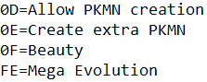

D&D:
Has Mega Evolution pre-installed, however it cannot set up Wish-based Mega Evolution correctly.

G3HS:
- Open up the file PokeRoms.ini, find your rom code.
- Modify “evolutionmethods” such that the 254th evolution method is set to Mega Evolution:

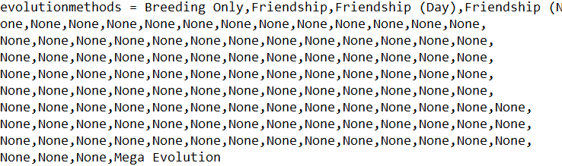

- Modify “evomethodsproperties” such that the 254th method is set to Item.

Mega Evolution
Mega Evolution set up is similar to the how the previous Mega Evolution system by Touched was set up. If a Pokémon is able to Mega Evolve, Mega Evolution can be trigged by pressing start on the move menu once the mega trigger appears.

NOT Using Dynamic Pokémon Expansion:
- Create a Mega Stone in G3T with the following format:
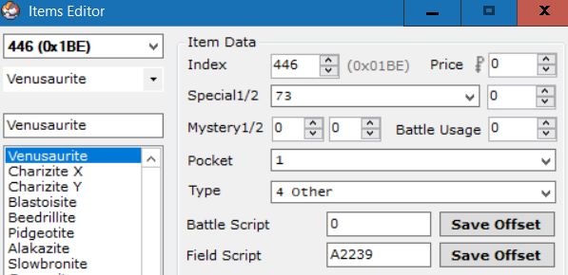
- Create a Mega Ring key item. Its format is the same as any other key item.
- Update the definition for the Mega Ring item in include/constants/items.h.
- Open the file src/mega.c and search for sKeystoneTable. Add your mega ring item to this table:
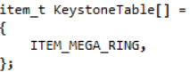
NOTE: The item does not need to be called Mega Ring. Any item added to this table can act as a mega ring.

- If DEBUG_MEGA is defined in the config file, then Mega Evolution can be used from the start of the game without the requirement of having the Mega Ring in the bag. Otherwise, the player must have a Mega Ring item in the bag to use Mega Evolution (Mega Evolution can always be used in Link Battles or the Battle Frontier). If you want a trainer to be able to use Mega Evolution, add a mega ring item to their battle items:
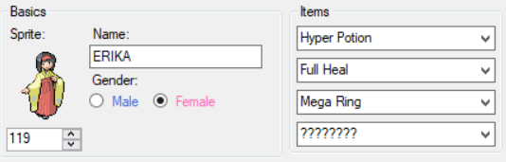
Don’t forget to give the trainer’s Pokémon the relevant Mega Stone to hold!

- Find the Pokémon in G3T that you wish to bestow the ability of Mega Evolution upon. Set up the evolution data with following template:
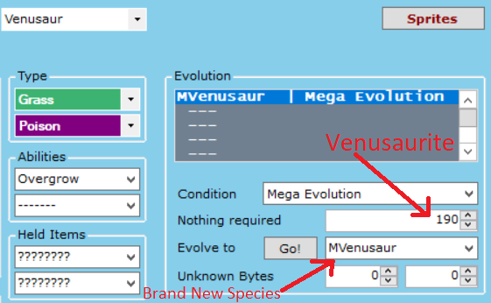
In the above image:
- “Nothing required” is set to the mega stone item index created earlier.
- “Evolve to” is set to a new species representing the mega form (you’ll need to expand Pokémon or replace an existing one). Make sure this mega form has the same gender rate and Exp rate as the non-mega form or things will get messed up.

Wish Mega Evolution (for Rayquaza) should be set up using the following template: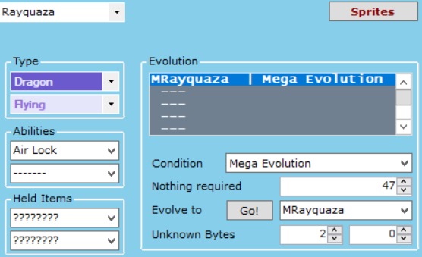
In the above image:
- “Nothing required” should be set to the move id for Dragon Ascent (0x22F / 559). G3T has issues with setting numbers past 0xFF, so you’ll need to hex edit or use a different Pokémon editor to set the proper value for Dragon Ascent.
- “Evolve to” is set to a new species representing Mega Rayquaza (you’ll need to expand Pokémon or replace an existing one). Make sure Mega Rayquaza has the same gender rate and Exp rate as Rayquaza or things will get messed up.
- The first of “Unknown Bytes” should be set to 2.

- Set the Mega form’s evolution data like the following template:
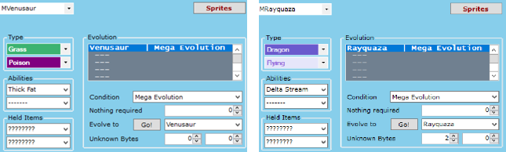
Notice that the item is left blank. Also notice that Mega Rayquaza still has its first unknown byte set to 2. Do not forget this!

- Now just give the player a mega ring item and a Pokémon with the appropriate mega stone and they will be able to Mega Evolve!

Using Dynamic Pokémon Expansion:
The DPE has the official Mega Evolutions set up by default. Use this as a reference for adding new Mega Evolutions.
Add evolution methods in src/Evolution_Table.c with the following format:

Regular Mega Evolution:

Wish Mega Evolution:

Notes about Mega Evolution:
- Only a single Mega Evolution may be used by each side during any given battle.
- In multi battles, both trainers can Mega Evolve a single Pokémon, effectively allowing for two Mega Evolutions per side during any given battle.
- Mega Evolution is not prevented if any Pokémon on the side Ultra Bursted or underwent Primal Reversion.
- If Rayquaza holds a Z-Crystal, it’ll be unable to Mega Evolve.

Primal Reversion
Primal Reversion does not rely on a mega ring to activate and will thus always activate if Kyogre or Groudon hold the appropriate item. Much less setup is required for Primal Reversion.

NOT Using Dynamic Pokémon Expansion:
- Find the Red Orb and Blue Orb in G3T’s item editor and modify them to match the following:
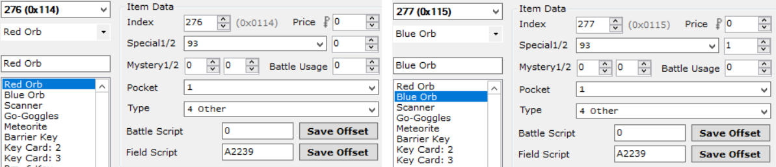
The item effect should be set as 93 and the item quality should be set as 0 for the Red orb and 1 for the Blue Orb. These numbers determine whether the Primal Reversion is Red (0) or Blue (1).

- Modify Kyogre and Groudon’s evolution data in G3T to match the following:
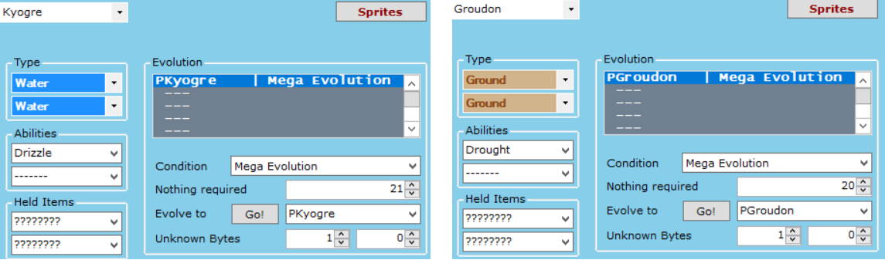
In the above images:
- “Nothing required” is set to the Blue Orb item index for Kyogre and to the Red Orb item index for Groudon. Note again that G3T does not represent these item indices correctly so you may need to use another editor.
- “Evolve to” is set to a new species representing the primal form (you’ll need to expand Pokémon or replace an existing one). Make sure this primal form has the same gender rate and Exp rate as the non-primal form or things will get messed up.
- The first of the “Unknown Bytes” is set to 1 to represent Primal Reversion.

- Set up the primal forms’ evolution data in G3T to match the following:
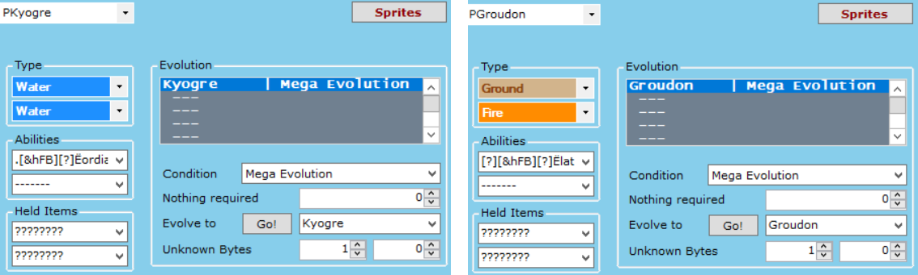
Notice that the items are left blank. Also notice that both Primal Pokémon still have their first unknown bytes set to 1. Do not forget this!

Note about Primal Reversion:
- The alpha and omega symbols on the health bar are generated based on which species is in its Primal form. By default, the alpha symbol is set to appear if the species is Primal Kyogre, and the omega symbol is set to appear if the species is Primal Groudon. To change this requirement, modify the following functions in src/mega.c:

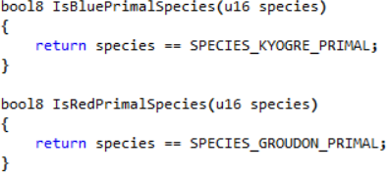

These can easily be modified by adding species to compare to. For example, to make the omega symbol to appear for Primal Dialga as well, make the following modification:

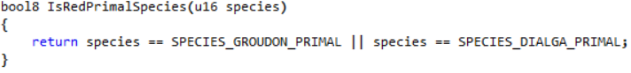
Don’t forget to also define PKMN_PRIMAL_DIALGA in include/constants/species.h!

Using Dynamic Pokémon Expansion:
Add evolution methods in src/Evolution_Table.c with the following format:

Ultra Burst
Primal Reversion does not rely on a mega ring to activate and will thus always activate if Necrozma holds the appropriate item. Much less setup is required for Ultra Burst.

NOT Using Dynamic Pokémon Expansion:
- Create an Ultranecrozium Z item in G3T with the following format:
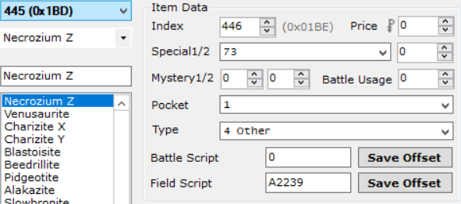

- Modify both Necrozma forms’ evolution data in G3T to match the following:
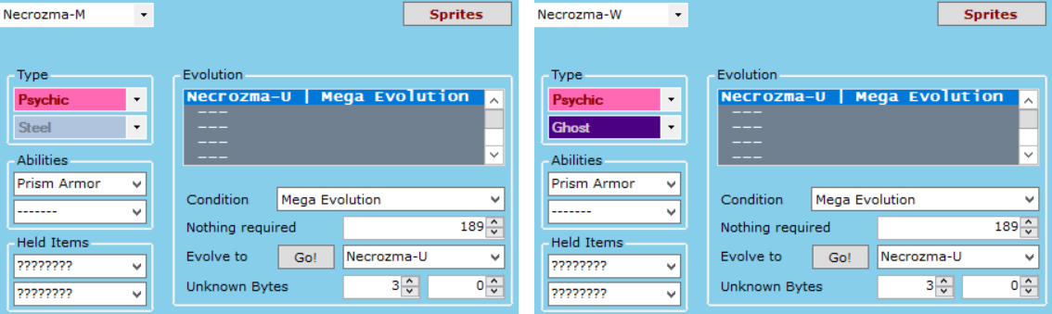
In the above images:
- “Nothing required” is set to the Ultranecrozium Z item index. Note again that G3T does not represent these item indices correctly so you may need to use another editor.
- “Evolve to” is set to a new species representing Ultra Necrozma (you’ll need to expand Pokémon or replace an existing one). Make sure all Necrozma forms have the same gender rate and Exp rate or things will get messed up.
- The first of the “Unknown Bytes” is set to 3 to represent Ultra Burst.

- Set up the Ultra Necrozma’s evolution data in G3T to match the following:
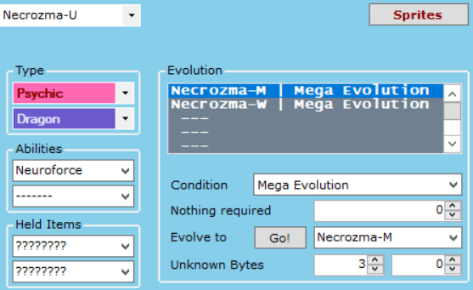
In the above image:
- The items are left blank.
- The first unknown byte is set to 3. Do not forget this!

Note about Ultra Burst:
- Contrary to what is shown in the above image, Ultra Necrozma does not need reversion data from both Necrozma fusion forms (it needs for at least one of them). Ultra Necrozma will always revert to the form it Ultra Bursted from at the end of the battle, regardless of which species is written in its evolution data. If the Ultra Necrozma was encountered in the wild, it will revert to the first species in its evolution list by default.
- Ultra Burst is trigged the same way as Mega Evolution on the move menu.
- As Ultra Burst is not considered Mega Evolution, Ultra Necrozma can still use Z-Moves if it knows the appropriate base move (Photon Geyser by default).

Using Dynamic Pokémon Expansion:
Add evolution methods in src/Evolution_Table.c with the following format:

Gigantamax
NEEDS WRITING
Basically the same as Mega Evolution but the parameter for the base form is TRUE and the parameter for the Gigantamax Form is FALSE. The extra byte at the end is 0.

Z-Moves
Z-Moves work akin to how they work in real Pokémon games.
If a Pokémon holds a Z-Crystal corresponding to a specific type, any move of that type can be turned into a Z-Move by pressing the Start-button on the move menu, and then the A-button to confirm the selection. If a move cannot be turned into a Z-Move, the Start-button will do nothing.
If a certain Pokémon holds its signature Z-Crystal, then its signature move can be turned into its signature Z-Move (also with the Start-button). A list of these signature Z-Moves can be found under sSpecialZMoveTable in src/set_z_effect.c.

The only setup required for Z-Moves involves the creation of Z-Crystals. Each Z-Crystal should be created in G3T with the following format:
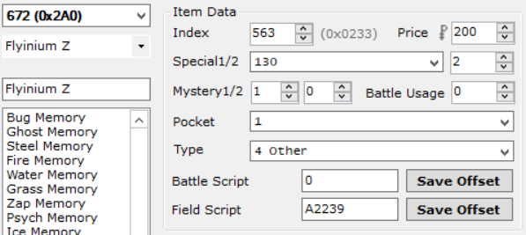
The item effect should be set as 130 and the item quality should be set to the move type the Z-Crystal works for (in the above image it is set to 2 [TYPE_FLYING]). The Mystery 1 byte can also be set to 1 to remove the item quantity for Z-Crystals (acts as if the player only has the single, unique Z-Crystal). However, note that it can then no longer be given to a Pokémon. The field script will need to be modified to act like a give item script.
Special Z-Crystals should be set up similarly, the key difference being that item quality should be set to 255.
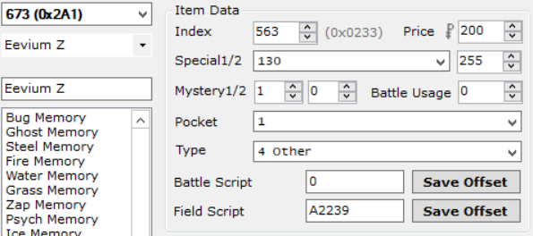

Once the Z-Crystals are created, have a Pokémon hold one, give it the appropriate move, and then watch the magic happen!

Trainer Sliding Messages
In generations after Gen 3, Trainers could interrupt the battle with a message. This engine supports three kinds of those messages:
- After the opponent’s first Pokémon faints.
- After the opponent’s last Pokémon is sent in.
- When the opponent’s last Pokémon is low on health.

Trainers can have any combination (or none at all) of the above messages. To set these up, do the following:
- Navigate to src/trainer_sliding.c and search for sTrainerSlides. This is the table used to define the sliding messages.
- Add an entry with the following format:

Where 0x59 is the trainer Id (Youngster Ben in this case), sText_BenFirstMonDown is the message displayed when the opponent’s first Pokémon has fainted, sText_BenLastSwitchIn is the message displayed when the opponent switches in their last Pokémon, and sText_BenLastLowHP is the message displayed when the opponent’s last Pokémon is on low health. If you would not like the trainer to say anything at one of these stages, simply replace the entry with NULL:

In this case, the trainer will say something after the first Pokémon is defeated and when their last Pokémon is low on HP, but not after they send in their last Pokémon.

- In the file include/new/trainer_sliding_data.h, add declarations for the strings you’ve defined. For example, for the first message struct declared above, the bottom of the file should look like this:

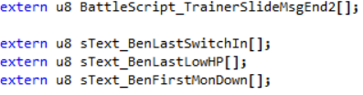

- Open the file strings/trainer_sliding_strings.string and add entries for the strings you’ve defined. For example, for the first message struct declared above:

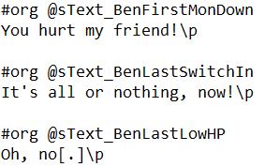

The format for the strings follows similarly to XSE, the key difference being that each line does not start with "= ". An equal’s sign at the beginning of the line will be treated as such and be seen in the game. Also note that each line ends with "\p" in order to wait for the player’s key press.

Follows these steps and continuously add new entries to the table to add flavour to battles!

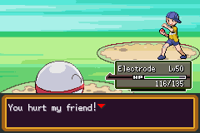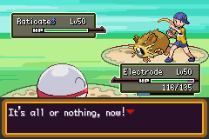

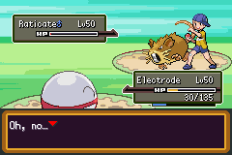

Multi Battles
There are 4 different types of Multi Battles supported by this engine:
- Player Vs. Two Trainer Opponents.
  - Can be set up in a script or by being spotted by two different trainers.
- Player & Partner Vs. Two Trainer Opponents.
- Player & Partner Vs. One Trainer Opponent.
- Player & Partner Vs. Two Wild Pokémon.

There are two different ways of setting these up:

XSE Friendly Method
This method allows you to set up multi battles through scripted events.
- To set up a battle against two opponents:
  - Set the flag FLAG_TWO_OPPONENT.
  - Set the var VAR_SECOND_OPPONENT to the trainer id of the second trainer.
  - Use the loadpointer scripting command in conjunction with special 0xXX to load the second trainer’s defeat text.
  - Then use the scripting command trainerbattle 0x3 (or 0x9) to start the battle.
- To set up a battle with a partner:
  - Set the flag FLAG_TAG_BATTLE.
  - Set the var VAR_PARTNER to the trainer id of the partner.
  - Set the var VAR_PARTNER_BACKSPRITE to the backsprite Id of the partner.
  - Then use the scripting command trainerbattle 0x3 (or 0x9) to start the battle.
This will initiate a battle with a partner against a single opponent.
- To battle with a partner and two opponents, set all flags and vars listed in the previous two steps, and then use the scripting command trainerbattle 0x3 (or 0x9) to start the battle. A sample script to do this looks as follows:

#define FLAG_TWO_OPPONENT 0x909
#define FLAG_TAG_BATTLE 0x908
#define VAR_SECOND_OPPONENT 0x5010
#define VAR_PARTNER 0x5011
#define VAR_PARTNER_BACKSPRITE 0x5012
#define SPECIAL_LOAD_SECOND_DEFEAT_TEXT 0xAC

#org @start
setflag FLAG_TWO_OPPONENT 'Setup battle against two opponents
setflag FLAG_TAG_BATTLE 'Setup battle with partner
setvar VAR_SECOND_OPPONENT 0x59 'Second opponent is Youngster Ben
setvar VAR_PARTNER 0x5B 'Team up with Youngster Josh
setvar VAR_PARTNER_BACKSPRITE 0x2 'Brendan’s Backsprite
loadpointer 0x0 @SecondTrainerDefeatText
special SPECIAL_LOAD_SECOND_DEFEAT_TEXT
trainerbattle 0x3 0x5A 0x0 @FirstTrainerDefeatText 'First opponent is Youngster Calvin
end
Non-XSE Friendly Method
This method for setting up multi battles is not possible to code in XSE, but it is significantly easier to code and allows more versatility with random trainer scripts. It is recommended to use the Thumb assembler in conjunction the XSE defines provided in this engine to compile these custom scripts (which can then be called after inserting the hex data).
- To set up a battle against two opponents, use the following scripting command:
trainerbattle 0xB FOE_1_ID FOE_2_ID FOE_1_NPC_ID FOE_2_NPC_ID 0x0 INTRO_TEXT_A INTRO_TEXT_B DEFEAT_TEXT_A DEFEAT_TEXT_B CANNOT_BATTLE_TEXT
Where:
  - FOE_1_ID: The trainer Id of the first opponent.
  - FOE_2_ID: The trainer Id of the second opponent.
  - FOE_1_NPC_ID: The local Id (person Id in AdvanceMap) of the first opponent.
  - FOE_2_NPC_ID: The local Id (person Id in AdvanceMap) of the second opponent.
  - INTRO_TEXT_A: The intro battle text said by the first opponent.
  - INTRO_TEXT_B: The intro battle text said by the second opponent.
  - DEFEAT_TEXT_A: The defeat text said by the first opponent.
  - DEFEAT_TEXT_B: The defeat text said by the second opponent.
  - CANNOT_BATTLE_TEXT: The text said by either opponent when the player doesn’t have enough viable Pokémon to fight with.
This trainerbattle 0xB command is special such that you can assign it to random NPCs to effectively make better random double battles than with a Twins class, for example. When using this on two random NPCs, make sure they stand next to each other! Otherwise it’ll look off when they walk towards the player together.

  - To set up a battle with a partner, use the following scripting command:
trainerbattle 0xC FOE_ID PARTNER_ID PARTNER_BACKSPRITE_ID 0x0 DEFEAT_TEXT
Where:
- FOE_ID: The trainer Id of the opponent.
- PARTNER_ID: The trainer Id of the player’s partner.
- PARTNER_BACKSPRITE_ID: The backsprite Id of the player’s partner.
- DEFEAT_TEXT: The text said when the opponent loses the battle.

- To battle with a partner and two opponents, use the following scripting command:
trainerbattle 0xA FOE_1_ID FOE_2_ID PARTNER_ID PARTNER_BACKSPRITE_ID 0x0 DEFEAT_TEXT_A DEFEAT_TEXT_B
Where each of the title definitions is the same as listed trainerbattle 0xB and trainerbattle 0xC. Note that both trainerbattle 0xB and trainerbattle 0xC cannot be used on random NPCs. They must be used from within and event script.

And with that, you can set up amazing multi battles!

Wild Double Battles
Encountering two wild Pokémon at once was introduced in Gen 4 with it occurring when the player was teamed up with another player. Then, in Gen 5, it became possible to encounter two Pokémon at once in special grass. This engine supports both of those features.

Wild Double Battles With Partner
If there is ever a situation where you’d like all wild battles in a given area to be with a partner, add the following as an On entering map/on menu close [5] level script in AdvanceMap:
#define FLAG_DOUBLE_WILD_BATTLE 0x9F9

#org @start
setflag FLAG_DOUBLE_WILD_BATTLE
setflag FLAG_TAG_BATTLE 'Setup battle with partner (same as above)
setvar VAR_PARTNER_BACKSPRITE 0x2 'Brendan’s backsprite (same as above)
end

This will cause all battles against trainers on the map to be fought with a partner, and all wild battles fought on the map to be against two Pokémon. Conditions can also be added to the script (such as a checkflag to only execute the script if some flag is set). Don’t forget to clear these flags once the player no longer needs a partner!

Wild Double Grass

Special grass tiles that can initiate wild battles can be created as well. Grass with a background byte of 0x5 will have a chance of starting a wild double battle, and grass with a background byte of 0x25 will have a chance of starting a wild double battle and be covered by the player. Wild double water tiles are similarly done using 0x6 and 0x26. The chance a wild double battle will be started when walking in this grass is determined by the value set (in percent) in WILD_DOUBLE_RANDOM_CHANCE.

Scripted Wild Double Battles
Here is a sample script:

wildbattle 0xFFFF 0x0 0x0 'Double indicator
wildbattle PKMN_CLEFAIRY 20 ITEM_NONE
wildbattle PKMN_PIKACHU 20 ITEM_NONE
special 0x138 'Starts the battle
waitstate

Sample double wild grass in AdvanceMap:

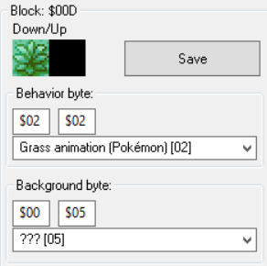

I’m not entirely sure if this script will compile properly in XSE, but if you use it in PKSV by replacing wildbattle with battle and waitstate with waitspecial the battle will begin properly.

Trainer Backsprites
Adding a backsprite into the game has never been easier.
- Go to graphics/Backsprites and add a minimum of 4 backsprites to a single file for your new trainer. Make sure they’re each a size of 64 x 64 and indexed to 16 colours! Sample Brendan and May backsprites come bundled with the engine.

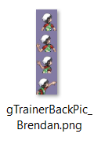

- Open include/constants/trainers.h and define a new constant for your new backsprite. I will call the tutorial one TRAINER_BACK_PIC_BRENDAN_NEW:

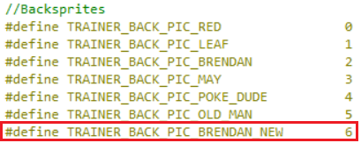

- Open src/Tables/Backsprite_Tables.c to allow the game to read your new backsprites.
- Search for gTrainerBackPicPaletteTable and right above it add two lines with format:
extern const u8 [FILE_NAME_NO_EXTENSION]Pal[];
#define gTrainerPalette_[NAME] gTrainerBackPic_[FILE_NAME_NO_EXTENSION]Pal

So our entry for the new Brendan would look like:

- Now add this new palette underneath the Old Man’s entry in the table gTrainerBackPicPaletteTable:

- Add a line for the animation of the backsprite. The pointer should be 0x8239F44 for 5 frames, and 0x8239F54 for four frames. So since the backsprite has four frames:

- Search for gTrainerBackAnimsPtrTable and add your new entry after the old man.

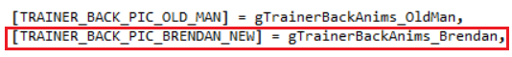

- Add an entry in the gTrainerBackPicCoords table after the old man:

- Next, add a declaration and a table for the image frames like so:
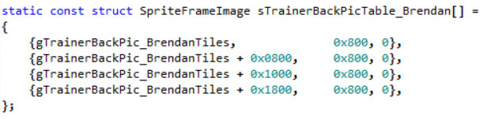

Format for each name is [FILE_NAME_NO_EXTENSION]Tiles.

- Finally, search for gSpriteTemplateTable_TrainerBackSprites and add an entry for the new backsprite after the old man:

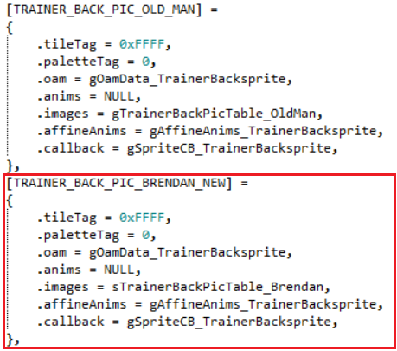
The entry in .images should be the same as the table added in step 9.
And you’re done!

Battle Terrain
If you have inserted any new battle backgrounds using the tutorial here, then certain modifications will need to be made to make the engine compatible with those backgrounds.
- Open up the file include/battle.h. Search for BATTLE_TERRAIN_CHAMPION in the file, and add a new definition there. So, for instance, if your new background was a snow field:

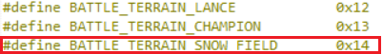

- Open up the file src/Tables/Terrain_Table.c. Search for BATTLE_TERRAIN_CHAMPION in the file, and add a new entry to the table. So continuing on with the snow example:

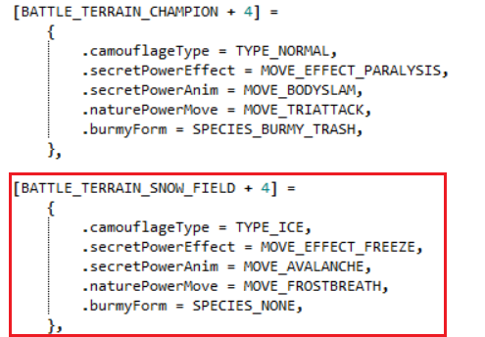

Notice the entry name is the same as the definition from earlier + 4.
The table has entries for:
- camouflageType: The type the move Camouflage transforms into.
- secretPowerEffect: The secondary effect of the move Secret Power.
- secretPowerAnim: The animation of the move Secret Power.
- naturePowerMove: The attack the move Nature Power becomes.
- burmyForm: The form Burmy transforms into after this battle. If you would not like Burmy to change form after this battle, leave it as SPECIES_NONE (as shown above).

Battle Music
There are three different music tables that can be set up. Each table can be found in src/Tables/music_tables.c. Any custom song definitions used in these tables should be added to include/constants/songs.h. Trainer classes can be found and added into the file include/constants/trainer_classes.h.

Class Based Encounter Music
If ENCOUNTER_MUSIC_BY_CLASS is defined, then the table, gClassBasedTrainerEncounterBGM, can be modified to determine which music plays in the background when each trainer class is encountered in the overworld. For example, this table causes all Youngsters to have the same encounter music, without having to the set the byte for each of them in their trainer data. If you wanted to change which encounter music Youngsters have, all you have to do is make the following change:

→

Now, all Youngsters will play the girl encounter when they spot the player.
If you do not want to use this feature, the switch statement in SetUpTrainerEncounterMusic found in src/overworld.c will need to be modified to add new encounter song Ids in.

Class Based Battle Music
The table, gClassBasedBattleBGM, can be modified to determine the song that plays during trainer battles against certain classes. For example, if I wanted to make all Team Rocket battles play the Gym Leader theme, I would add the following onto the end of the table:

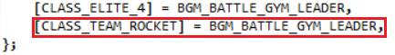

In a Multi Battle, if either trainer has custom battle music, their theme will play. If both trainers have custom battle music, then the theme for the trainer on the right (first opponent) will play.

Wild Species Based Battle Music
The table, gClassBasedTrainerEncounterBGM, can be modified to determine the song that plays during wild battles against certain species of Pokémon. For example, to make all Rattata battles play the Deoxys theme, I would add the following onto the end of the table:

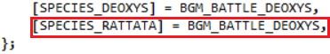

Victory Music
In the file src/end_battle.c is a function called HandleEndTurn_BattleWon. In this function is a switch statement (look for VICTORY_MUSIC_SELECTION) which controls the songs that play when defeating certain trainer classes. See the example from Pokémon Unbound (include in the file) for how to append new classes to this switch statement.

Poke Balls
Several new Poké Balls have been added to the engine, in addition to the Trainer Class Based Poké Ball hack.

Adding Support for Added Balls
Although catching data has been added in for the new balls, item data has not. This means that if you want to give the player a certain ball, you’ll need to add in item data for it. Adding a new Poké Ball follows the following format in G3T:

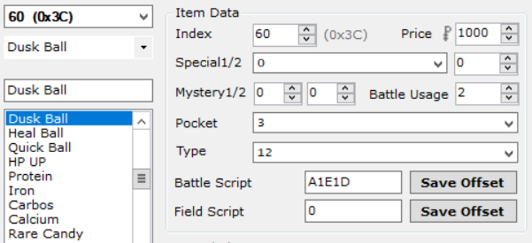

Regarding the Type field, this related to the Ball Type of the given ball. So looking in include/new/catching.h, it can be seen that Dusk Ball’s type is 12.

Class Based Poke Balls
Loosely based on the hack created by Sagiri, if TRAINER_CLASS_POKE_BALLS is defined, this implements the feature from Gen 7 where certain Trainer classes always send out Pokémon in a specific type of Poké Ball.
To modify the trainer class balls, open src/Tables/class_based_poke_ball_table.c. All the trainer classes have been preloaded into the table, but if you would like to change a trainer class name to your own custom name, do so in include/constants/trainer_classes.h and then update the table accordingly. The ball type defines that can be used can be found in include/new/catching.h. So, for example, to change the Youngster’s ball to a Great Ball, make the following change:

→

And then the next time the player battles a Youngster, all their Pokémon will be sent out in Great Balls!

See Adding New Poke Balls to add new Poke-Ball types.

Trainers With EVs
Loosely based on DoesntKnowHowToPlay’s hack, if TRAINERS_WITH_EVS is defined, this feature allows trainer Pokémon to have certain EV spreads. Preloaded spreads can be found in src/Tables/trainers_with_evs_table.h. New spreads should also be added in here as well.
Note that since this is a .h file, if you want your changes to compile, you will need to make a change to the file src/build_pokemon.c so the compiler recompiles the Trainer’s With EVs file. The change can be as simple as adding a whitespace character and then removing it. Don’t use the undo button to remove the change! The change needs to be removed manually by using the backspace character so the editor saves the file with an updated timestamp.

Assigning a Spread
In order for a Pokémon to use a spread, the following must be done:
- The Pokémon must have a custom moveset.
- The Pokémon must have a custom item (this item can still be set to 0).
- The Pokémon must have an IV (labeled "EVs" in most Trainer editors) value greater than 1 (the 0th spread is left empty for this reason).

For example, looking in the file, you can see that spread 5 is predefined as a "Bulky Physical Attacker". If I wanted to assign this to a Pokémon, the layout would look like this (in Hopeless Trainer Editor):

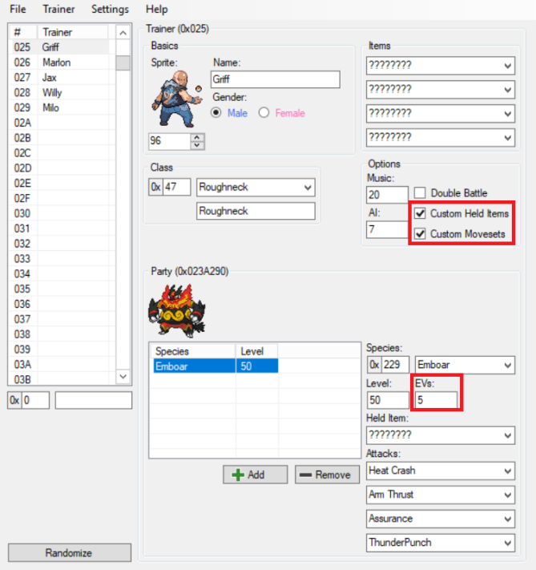

As can be seen in the image, both Custom Movesets and Custom Hold Items have been selected, and the EVs value has been set to 5. Note that the hold item has been set to "????????", meaning that Emboar is not actually holding an item (this is still fine).

Creating a New Spread
If you want to create a new spread, add it to the end of the table and start counting at 31. The table can at most hold up to the 255th spread. Spreads have the following members:
- .nature: The nature of the Pokémon. Natures can be found in include/pokemon.h.
- .ivs: The IVs for the Pokémon. All stats are set to this value (meaning custom Hidden Powers are not possible).
- .hpEv: The number of HP EVs the Pokémon has.
- .atkEv: The number of Attack EVs the Pokémon has.
- .defEv: The number of Defense EVs the Pokémon has.
- .spAtkEv: The number of Special Attack EVs the Pokémon has.
- .spDefEv: The number of Special Defense EVs the Pokémon has.
- .spdEv: The number of Speed EVs the Pokémon has.
- .ball: If set to TRAINER_EV_CLASS_BALL and TRAINER_CLASS_POKE_BALLS is defined, then the ball loaded will be the one for the trainer class. Otherwise look in include/new/catching.h for a list of available Poké Ball types.
- .ability: The ability number of the Pokémon. Can be set to:
  - Ability_1: The Pokémon will have its first ability.
  - Ability_2: The Pokémon will have its second ability.
  - Ability_Hidden: The Pokémon will have its hidden ability.
  - Ability_Random_1_2: The Pokémon will have one of its primary abilities.
  - Ability_RandomAll: The Pokémon will have one of its possible abilities.

Example:
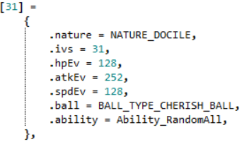

In the above example, the nature for the spread is set to Docile, each stat has an IV of 31, the HP stat has 128 EVs, the Attack stat has 252 EVs, and the Speed stat has 128 EVs. All EV stat not referenced in this spread will be set to a default value of 0. Any Pokémon using this spread will also be released in a Cherish Ball and have any one of it possible abilities (including its hidden ability).

Battle Frontier
There is support for four unique battle facilities included in this engine: the Battle Tower, Battle Sands, Battle Mine, and Battle Circus (names can be changed - see below for descriptions). This is an advanced option and will not be explained in great detail. The various battle facilities and necessary setup will be explained here, but script making will not be detailed. Use the documentation provided for the frontier specials to come up with your own unique battle facility scripts.
The basic setup for any battle facility is to first configure the configuration vars for the Battle Frontier. Special 0xF5 can be used to select Pokémon to participate in a battle facility, but the Battle Frontier vars must be configured first and FLAG_BATTLE_FACILITY must be set prior. Don’t forget to use Special 0x27 to back up the player’s party before the battle, and use Special 0x28 to restore the original party after all the battles have completed. See the example script for Special 0x73 for an example on how to properly enter the player’s Pokémon.
When saving the game, make sure the player has their original team or it will be lost if they rage quit. Once the Pokémon are entered, simply use the trainer generator specials before initiating a battle.
When the player enters a battle facility, the var 0x403A (a temporary var usually used for elevator scripts) should be set to one of the following values:
- In Battle Tower: 0
- In Battle Sands: 1
- In Battle Mine: 2
- In Battle Circus: 3
This will help the game understand which streaks to load among other things.

Each battle facility has its own set of predefined tiers.
The Battle Tower tiers can modified by editing gBattleTowerTiers. Note that Monotype (Lv. 100 only here) shares a record with Little Cup (Lv. 5 only), so either both or neither must be present in the list. The Battle Tower can have at most six tiers (seven if Monotype + Little Cup are used).
The Battle Sands uses the same tiers as the Battle Tower.
The Battle Mine has three formats, each with their own list of tiers: gBattleMineFormat1Tiers, gBattleMineFormat2Tiers, and gBattleMineFormat3Tiers. As many tiers may be added to each format as you’d like.
The Battle Circus can have as many tiers added to gBattleCircusTiers as you’d like.

Battle Tower
The Battle Tower should be used as the most basic of Battle Facilities. Nothing is special about each battle.

Battle Sands
For all battles, the player’s Pokémon is controlled by some AI character. Each battle, a random stat boost is applied to one Pokémon on each side of the field. These stat boosts increase in intensity the higher the win streak. The AI character chosen to control the player’s Pokémon should ideally be chosen by using sp06D_LoadFrontierMultiTrainerById with the random input.
Battle Mine
Each battle has a random format determined before the battle which randomizes level, party size, inverse settings, and tier (varies depending on Battle Mine format). The selection of options can get more harrowing the higher the win streak. See the function sp070_RandomizeBattleMineBattleOptions in src/frontier.c for the logic of choosing the battle settings. Make sure to call the aforementioned special before battles, as well as call sp071_LoadBattleMineRecordTier after battles to revert to the original chosen tier (Battle Mine Format 1, 2, or 3).

Battle Circus
Each battle has a random permanent effect chosen before battle. These effects increase in intensity and amount per battle the higher the win streak. See the function sp072_LoadBattleCircusEffects for the logic of choosing the effects. The effects can be:

- Permanent Electric Terrain
- Permanent Grassy Terrain
- Permanent Misty Terrain
- Permanent Psychic Terrain
- Permanent Rain
- Permanent Sun
- Permanent Sandstorm
- Permanent Hail
- Permanent Fog
- Permanent Trick Room
- Permanent Magic Room
- Permanent Wonder Room
- Permanent Gravity
- Permanent Ion Deluge
- Permanent Fairy Lock
- Permanent Mud Sport
- Permanent Water Sport
- Permanent Safeguard
- Permanent Mist
- Permanent Sea of Fire
- Permanent Rainbow
- Permanent Confusion
- Permanent Taunt
- Permanent Torment
- Permanent Torment
- Permanent Heal Block
- Permanent Throat Chop
- Permanent Ability Suppression
- Always land critical hits
- Never land critical hits
- Inverse Battle
- Dynamax Battle
- Swap random Pokémon on each side

Trainers
Pre-defined Trainers for the battle frontier can be found in gTowerTrainers in the file src/tables/battle_frontier_trainers.c. By default they are hidden behind a #ifdef UNBOUND, but this can easily be fixed by changing the line to #ifndef UNBOUND. Below is an explanation of each member of struct BattleTowerTrainer:
- owNum: The OW sprite id of the trainer. See include/constants/event_objects.h.
- trainerClass: The trainer class of the trainer. See include/constants/trainers.h.
- trainerSprite: The in-battle sprite of the trainer. See include/constants/trainers.h.
- gender: Either BATTLE_FACILITY_MALE or BATTLE_FACILITY_FEMALE.
- preBattleText: A pointer to a string that is displayed before the battle.
- playerWinText: A pointer to a string that is displayed when the player wins.
- playerLoseText: A pointer to a string that is displayed when the player loses.

The struct struct SpecialBattleFrontierTrainer can be used for both Frontier Brains and Special Trainers. For the Frontier Brain of the Battle Mine, see the example (Pablo) from Pokémon Unbound. An explanation of each member:
- owNum: The OW sprite id of the trainer. See include/constants/event_objects.h.
- trainerClass: The trainer class of the trainer. See include/constants/trainers.h.
- trainerSprite: The in-battle sprite of the trainer. See include/constants/trainers.h.
- gender: Either BATTLE_FACILITY_MALE or BATTLE_FACILITY_FEMALE.
- name: A pointer to a string that’s the name of the trainer.
- regularSpreads: An array of Pokémon spreads for any tier that uses standard Pokémon.
- legendarySpreads: An array of Pokémon spreads for any tier that uses legendary (banned in the Standard tier and allowed in Ubers/No Restrictions) Pokémon.
- middleCupSpreads: An array of Pokémon spreads for any tier that uses Pokémon that have evolved once and can still evolve.
- littleCupSpreads: An array of Pokémon spreads for any tier that uses Little Cup Pokémon.
- regSpreadSize: The number of regular Pokémon spreads.
- legSpreadSize: The number of legendary Pokémon spreads.
- mcSpreadSize: The number of Middle Cup spreads.
- lcSpreadSize: The number of Little Cup spreads.

The struct struct MultiBattleTowerTrainer is for trainers that can be teamed up with in Multi Battles. Their struct is very similar to the Special Trainer struct, with one key member addition:
- otId: The trainer Id assigned to each of the multi trainer’s Pokémon.
Other than that one difference, this struct is set up in almost the same way (see the example from Pokémon Unbound for more details).

Any trainer text should be defined in strings/frontier_trainer_text.string.
Any trainer names should be defined in strings/frontier_trainer_names.string.

Spreads
What would a Battle Frontier be without Pokémon to battle against? In the file src/tables/battle_tower_spreads.h (linked to the compilation of src/build_pokemon.c) there are several tables of generic Pokémon spreads (each is self-explanatory by its name). By default they are hidden behind a #ifdef UNBOUND, but this can easily be fixed by changing the line to #ifndef UNBOUND.

Most of the members of struct BattleTowerSpread are very self-explanatory, but there are a few members that should be explained:
- ball: The Poké Ball the Pokémon is in. See include/new/catching.h for ball types.
- shiny: TRUE if the Pokémon is shiny. FALSE or don’t include the line if it is not.
- forSingles: The Pokémon can be generated in a single battle.
- forDoubles: The Pokémon can be generated in a double battle.
- modifyMovesDoubles: Certain moves of the Pokémon will change in a double battle (eg. Stone Edge becomes Rock Slide).

Special spreads for Special Trainers and Frontier Brains should be defined in the very, very large file src/tables/frontier_special_trainer_spreads.h. (linked to the compilation of src/tables/battle_frontier_trainers.c). When designing teams for these trainers, take care to always make sure a team of 6 with unique items, unique species, and no Mega Pokémon can be created in any tier the spread set is usable in.

Upgraded TM/HM Expansion
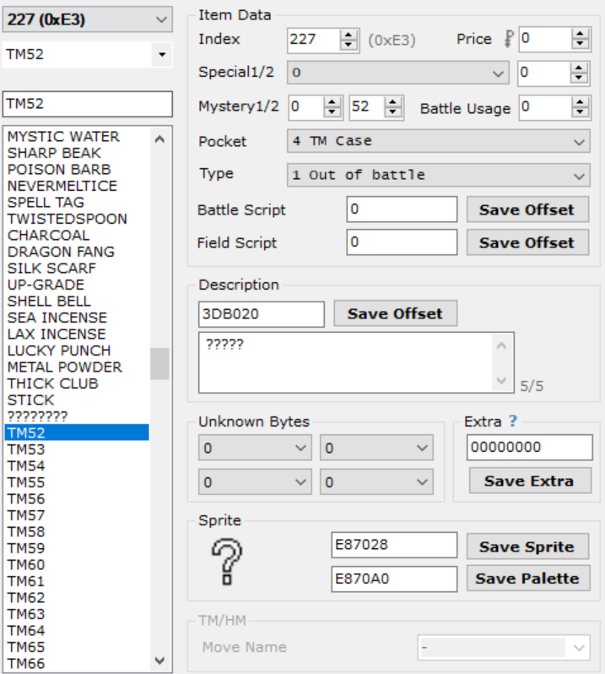
This engine includes a vastly improved TM/HM system over those created in the past. This version allows the hacker to use ANY item id for their TMs. None of this item ID sorting or item gap nonsense! It also fixes the graphical problems with high TM numbers in the TM case.
To set this feature up, set the Mystery 2 byte of the item to the TM Id, starting at 01 for TM01. The HMs must start at a TM Id after the max number of TMs you plan on including. For example, if you want 120 TMs and 8 HMs, HM01 would be given a TM Id of 121. Otherwise, the items are set up as normal (see image ->). The item sprite and palette don’t matter, as the disk is loaded outside of the item data, and the TM animation must be removed for the expansion to work correctly.
This engine does not mess with any of the original tables to allow a hack in progress to keep all its data. Therefore, once all your item data is set up, you must set up the TM Move Table and TM Compatibility Table. The TM Move Table has a pointer at 0x125A8C and is simply a list of move IDs corresponding with the TM ID. The TM Compatibility Table is more complicated. Its pointer lies at 0x43C68 and is 16 bytes per species. It is explained how to modify it in Step 3 from this tutorial.

If you’re using the Dynamic Pokémon Expansion, simply modify the provided TM files to add/remove any TM data. The compiler will take care of the rest! Make sure you read the readme on how to set up the TM data first, though!

Reusable TMs
If you’ve defined REUSABLE_TMS in src/config.h, you will then also need to set the Mystery 1 byte to 1 for each of your TMs. This will tell the game to treat the item like an HM (except extra code has been written to sort TMs/HMs by the TM index. For more info see TM/HM Expansion), preventing you from giving it to a Pokemon to hold, selling it, etc. That’s it!

Pickup
The items found by the ability Pickup can be modified in src/Tables/item_tables.c. Modify sPickupCommonItems and sPickupRareItems to change the items that appear. DO NOT add any new items to the tables; only change the pre-existing items. The default values were chosen based on the following table (common is highlighted in blue, rare is highlighted in red):

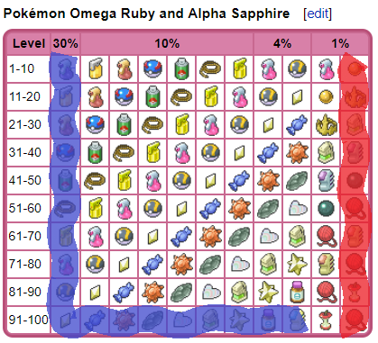

Select from PC Hack
If SELECT_FROM_PC is defined, the player can select Pokémon directly from the PC to modify certain data. To initiate, set pcSelect_StateTracker (defined in asm_defines.s) to 1 before using Special 0x3C. The hack will store the box number and slot to Var 0x8000 and Var 0x8001, respectively. All data retrieval/manipulation specials will be able to access the selected PC Pokémon by setting Var 0x8003 to 1. For example, nicknaming a Pokémon in the PC:

#define pcSelect_StateTracker 0x203B7AC

#org @start
writebytetooffset 0x1 pcSelect_StateTracker
special 0x3C 'Select boxed mon, box stored to Var8000, slot to Var8001
waitstate
writebytetooffset 0x0 pcSelect_StateTracker
compare LASTRESULT 0x7F
if 0x1 goto @NothingSelected 'User cancelled out of the PC menu
bufferpokemon 0x0 0x8002
setvar 0x8003 0x1 'Data source is in the PC Box
special 0x7d
compare LASTRESULT 0x1
if 0x1 goto @traded
special 0x9e
waitstate
end

Time of Day Based Wild Encounters
In order to use this feature, TIME_ENABLED must be defined. Once it is open the file src/Tables/wild_encounter_tables.c. Find where it says //Modify this section. This is the data that will be modified.
Example: Modifying the Night Data
For this example, HOOTHOOT will be added onto ROUTE 1 in place of PIDGEY.

First, the wild data needs to be created. If you open up AdvanceMap to the wild data for ROUTE 1, you should see this:

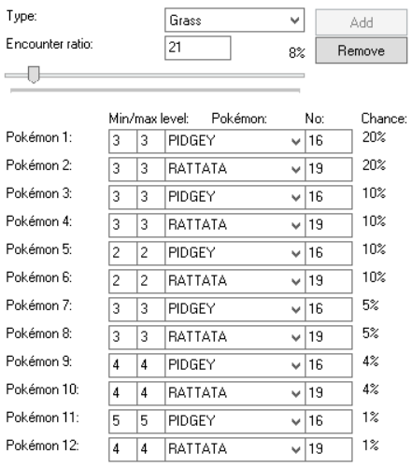

Now that you know what the data looks like, convert it into a C structure (see image below) and paste it at the top file, directly under the line “#ifndef UNBOUND //Modify this section”, or under previously created wild data structures. No matter what, it must be placed above the line
“const struct WildPokemonHeader gWildMonMorningHeaders[] =”:

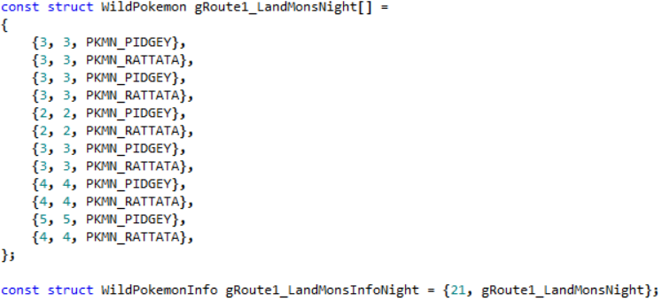
^ This line is very important and must be added in as well. Make sure the label correctly matches the name for your newly created wild data structure. The 21 is the encounter rate.
Now that the wild data has been copied from AdvanceMap, it’s time to make modifications.
Change all the “PKMN_PIDGEY” to “PKMN_HOOTHOOT”:
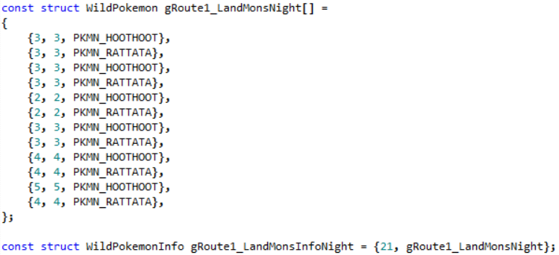

The data for Route 1 at night is now complete. As this is data for night time, we need to add it to our night table, gWildMonNightHeaders. Make sure you leave the pre-existing entry at the bottom of the table:
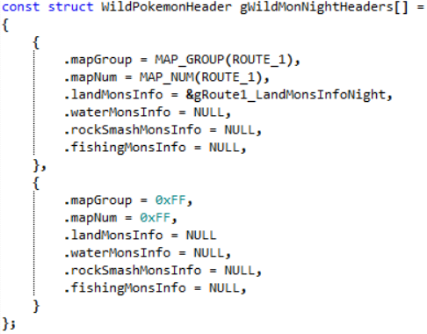

The only thing left to do now is define “MAP_ROUTE_1”. Go back to AdvanceMap and find the map bank and map number for ROUTE 1 (the map bank is 3, and the map number is 19). In include/constants/maps.h, add a line formatted like (if the define already exists edit the line):
#define MAP_NAME ((MAP_BANK << 8) | MAP_NUM)
Make sure the map name matches what’s in the brackets for “.mapGroup” and “.mapNum” (ie. ROUTE_1 became MAP_ROUTE_1).
Now wild night data has successfully been added for Route 1. Morning and Evening data follow the same pattern. Any route that doesn’t have morning or night data defined will load the standard day data set in AdvanceMap.
For water, fishing, or Rock Smash data, follow the same steps, but look here to see how to structure those kinds of wild datasets.
If you followed everything correctly, here is what the file should look like now:
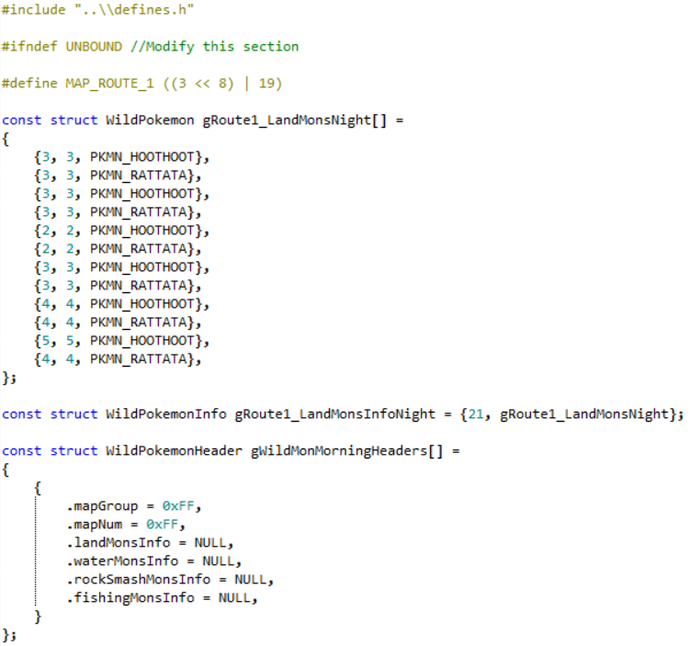
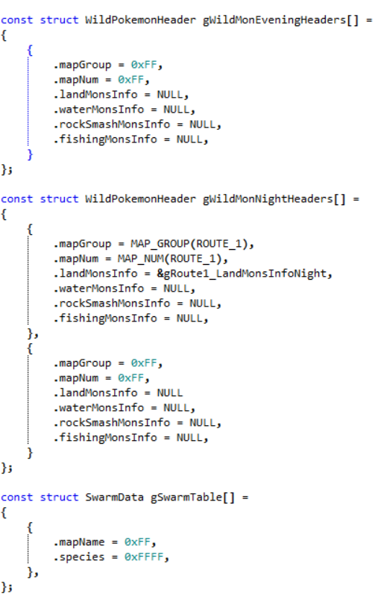

Swarms
Also known as “mass outbreaks”, swarms are when a certain species of Pokémon that doesn’t normally appear in the wild, makes an appearance for a single day. To get the most out of this feature, the real-time clock is utilized to run a function daily that updates the swarms. To add a swarm, in the file src/Tables/wild_encounter_tables.c, search for the first occurrence of gSwarmTable. Each element in this table is a struct with the following members:
- mapName: The map name (or section) id where the swarming Pokémon will be located.
- species: The species to swarm in locations with the given mapName.

For example, to make Sentret swarm on Route 1, add the following to the table (the levels are loaded from Route 1’s wild data):

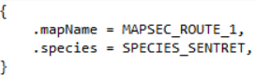

The species names can be found in include/constants/species.h. The map names can be found in include/constants/region_map_sections.h. If you’d like to use a map name that’s not found in that file, before this entry is added, the following line needs to be added to the file:

To buffer swarm text so an NPC can tell the player what and where a Pokémon is swarming, see special 0x58.

Roaming Pokemon
Roaming Pokémon have been staples in the Pokémon games since Gen 2. This engine allows you have up to 10 roaming Pokémon at once, where, if one is encountered, can be trapped, battled, and captured by the player. To set up Pokémon that roam around, use special 0x129 (see the example script for special 0x59).
In order to control where Pokémon can roam, open up src/roamer.c and look for sRoamerLocations. The roaming movement is divided into several sets of maps with each set containing at most seven different maps (each row in the table is a set). The different maps are and should be defined in include/constants/maps.h. Every time the player changes maps, the roamer moves as well. Most likely they will move within a given set, but they may change sets entirely. It’s recommended to only place closely related maps within each set. So, for example, if you had two regions, you’d want one set containing only maps from region A, and another set containing only maps from region B. As many sets as you’d like can be added to the table, however the table must be terminated with:

Day & Night System
A brand new DNS has been included in the engine. It features dynamic palette fading throughout the day, as well as options to allow windows to light up at night. Both of these options can be customized by editing include/new/dns_data.h. Note that since this is a .h file, if you want your changes to compile, you will need to make a change to the file src/dns.c so the compiler recompiles the DNS file. The change can be as simple as adding a whitespace character and then removing it. Don’t use the undo button to remove the change! The change needs to be removed manually by using the backspace character so the editor saves the file with an updated timestamp.

Changing Which Palettes Are Faded
Open up the dns_data.h file and search for OW_BG_PAL_0. Here is a listing of all palettes that can be faded. OW_BG_PAL_0 through OW_BG_PAL_15 represent the palettes of the background in the overworld. By default, OW BG palettes 0 - 12 are set to be faded, but 12 can be unfaded by making the following change:

Similarly, whether any other palette is faded can be changed by changing its value from TRUE to FALSE or vice versa. It is NOT recommended to fade palettes 13-15 as these are the colours used for the menus and text boxes.
Other than the OW backgrounds, the OW_SPRITE_PAL represent the sprites in the overworld, the BBG_PAL defines represent the background in battle, and the B_SPRITE_PAL defines represent the sprites in battle.

Changing the Colours Faded Throughout the Day
In the same file is a table representing the actual fading colours (gDNSNightFadingByTime). Currently the table only has entries from 12 AM - 7:59 AM and 5 PM - 11:59 PM. The rest of the day no fading changes can be seen. If you would like to add fading for more time during the day, simply look for the line Day has no fade and start adding new entries there. For example, adding an entry for 8 AM - 8:59 AM:

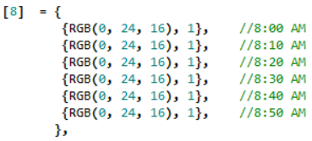
The colour can change every ten minutes, so each of those colour indices represent a colour at that ten minute period.

Light Up Windows
There are currently two ways to handle light up windows. The first is more tedious. It involves leaving OW_BG_PAL_12 as FALSE (see Changing Which Palettes Are Faded) and make all tiles you’d like to light up use that palette. Then, use an on-entry script in AdvanceMap to do setmaptiles and place your light up windows only when the time is night. This can be an extreme annoyance and a time consumer, which is why the second, new method was developed.
This new method uses a table to fade certain palette colours if it nighttime.
- To start off, find the offset of the tileset containing the palette you wish to fade. For this example, I’ll be fading the windows of the player’s door in Palette Town. Looking in AdvanceMap, the player’s door uses tiles from Tileset 1, which has an offset of 0x82D4AAC.

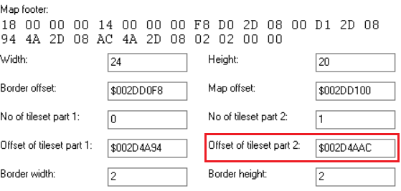

- Now open the tile viewer and determine which colours are the ones you wish to fade. For my example, I’ve determined that the player’s door uses palette 8, and the colours used are in indices 8, 9, and 10:

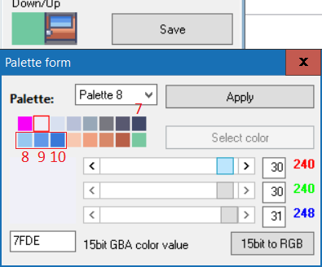

- Now determine the colours you wish to change them to. It’s okay to play around with these colours in AdvanceMap. Hitting Apply won’t save anything permanently unless you exit out of the block editor and choose to save. For my example, I could going to change the window to a yellowy colour:

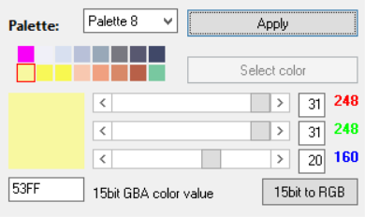

These colours can be represented by the RGB values of (31, 31, 20), (31, 31, 11), and (31, 31, 10).
- Putting it all together now:

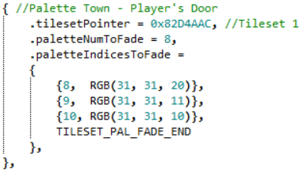

In the image .tilesetPointer is set to the offset of the tileset found in step 1, .paletteNumToFade is set to 8 representing the 8th palette. .paletteIndicesToFade has entries for index 8, 9, and 10, each with the corresponding colour they should be faded. After all that, is the line TILESET_PAL_FADE_END. DO NOT FORGET THIS LINE!

Some more examples have been left in the file to help guide you further if you need it.

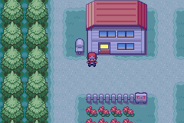

Pre-Battle Mugshots
The battle transition from the Elite Four has been modified for Fire Red. Originally created by Jambo51, the updated feature allows toggling of different transition styles with vars, as well as use custom images in place of the trainer’s front sprite. To use this feature, you must define var values for VAR_PRE_BATTLE_MUGSHOT_STYLE and VAR_PRE_BATTLE_MUGSHOT_SPRITE. The following table details the types of configurations you can use with these vars.

VAR_PRE_BATTLE_MUGSHOT_STYLE
0 | One Big Bar. Full Trainer Sprites
1 | One Small Bar. Half Trainer Sprites
2 | Two Small Bars. Half Trainer Sprites

VAR_PRE_BATTLE_MUGSHOT_SPRITE
0 | Player’s Front Picture
1 | “VS” Symbol instead of Player

To load a custom image instead of the opponent’s trainer front sprite, set the flag FLAG_LOAD_MUGSHOT_SPRITE_FROM_TABLE. The table sPreBattleMugshotSprites in src/Tables/Mugshot_Tables.c allows you to set the custom image to load for that given trainer’s front sprite index. Two examples exist to show you how to add one in for a different trainer picture.

As per Jambo’s original routine, the unused 3rd argument in the trainerbattle script command lets you turn on the pre-battle mugshot. Changing the value to 0x0Y00 lets you select different palettes for each transition tilemap (for a total of 15 different palettes). The palettes associated with each can be modified by changing the palettes of the images found in the directories graphics/Battle_Mugshots/Big and graphics/Battle_Mugshots/DP.

Finally, if you are using the Two Bar mugshot style, the 3rd trainerbattle argument only changes the palette of the opponent’s tilemap. The value of VAR_MUGSHOT_PLAYER_PAL can be changed to load a different palette for the player’s side as well.

Example Script:
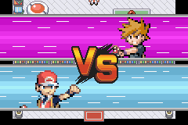
#define VAR_PRE_BATTLE_MUGSHOT_STYLE 0x503A
#define VAR_PRE_BATTLE_MUGSHOT_SPRITE 0x503B

#org @RivalBattle
msgbox @BattleMe 0x6
setvar VAR_PRE_BATTLE_MUGSHOT_STYLE 0x2
setvar VAR_PRE_BATTLE_MUGSHOT_SPRITE 0x0
trainerbattle 0x3 0x146 0x100 @LossMessage
end

New Field Moves
The engine allows you to (relatively) easily add new field moves! Rock Climb, Dive, and Defog are already added for you. Note that this feature may require some coding on your behalf.

If you want to only adjust the added field moves, you can adjust the badge requirement in the table gFieldMoveBadgeRequirements in src/party_menu.c (0 means no badge requirement).

Adding New Field Moves
- Open up src/party_menu.c and find the section “Field Moves”

- Add your field move to the enum FieldMovesIDs section (always include FIELD_MOVE_COUNT at the end!). For example, let’s add FIELD_MOVE_SUNNY_DAY.

- Add your field move to the list of party menu options, gPartyMenuCursorOptions as so:
[MENU_FIELD_MOVES + FIELD_MOVE_SUNNY_DAY] = {gMoveNames[MOVE_SUNNY_DAY], CursorCb_FieldMove},

- Create the appropriate callback for your field move inside gFieldMoveCursorCallbacks:
[FIELD_MOVE_SUNNY_DAY] = {SetUpFieldMove_SunnyDay, 0x0D},
Where SetUpFieldMove_SunnyDay is a function you will have to create (see step 8).

- Add the field move description to gFieldMoveDescriptions:
[FIELD_MOVE_SUNNY_DAY] = gText_FieldMoveDesc_SunnyDay,
Where gText_FieldMoveDesc_SunnyDay can be defined in strings/party_menu.string and declared at the top of the “Field Moves” section of src/party_menu.c like:
extern const u8 gText_FieldMoveDesc_SunnyDay[];

- Link the field move and move ID inside gFieldMoves (keep FIELD_MOVE_COUNT at the end!)
[FIELD_MOVE_SUNNY_DAY] = MOVE_SUNNY_DAY,

- Add the badge requirement of your new field move to gFieldMoveBadgeRequirements:
[FIELD_MOVE_SUNNY_DAY] = 6 // Requires badge 6 to use, for example

- Now we must include the logic for seeing if we can use our field move! This is dependent on what the new field move is. Ostensibly, Sunny Day can only be used outside, which can be checked the same way as fly, for our intents and purposes. We might also want to make sure it isn’t already sunny via GetCurrentWeather. So, our function might look like (feel free to adjust):

static bool8 SetUpFieldMove_SunnyDay(void)
{
if (GetCurrentWeather() == WEATHER_SUNNY)
return FALSE;
else if (Overworld_MapTypeAllowsTeleportAndFly(gMapHeader.mapType))
{
gFieldCallback2 = FieldCallback_PrepareFadeInFromMenu;
gPostMenuFieldCallback = FieldCallback_SunnyDay;
return TRUE;
}
return FALSE;
}

These functions return TRUE if the field move is usable and FALSE if not. Most also set up some callback to run a script upon exiting the party menu. In our case we want to run FieldCallback_SunnyDay, which we can emulate from FieldCallback_RockClimb as so:
static void FieldCallback_SunnyDay(void)
{
((u32*) gFieldEffectArguments)[0] = GetCursorSelectionMonId();
ScriptContext1_SetupScript(SystemScript_SunnyDay);
}

We will then have to create our script of SystemScript_SunnyDay, either in XSE or in the CFRU engine via assembly/overworld_scripts/system_scripts.s (see Step 9) and declare it above with either:
Compiled with XSE: #define SystemScript_SunnyDay (const u8*) 0x8XXXXXX (0x8XXXXXX is a pointer to where the script was compiled)
Compiled in CFRU: extern const u8 SystemScript_SunnyDay[];

- Our script will only run if the field move is usable, so we don’t have to worry about adding a ton of logic into our script. For Sunny Day, all we need to do is display the HM bar animation and then set the new weather, like so:
.global SystemScript_SunnyDay
SystemScript_SunnyDay:
lockall
doanimation 0x28
waitstate
setweather 0x1
doweather
msgbox gText_BecameSunny MSG_KEEPOPEN @define this in strings/overworld_strings.string
releaseall
end
And that’s all!

Raid Battles
NEEDS WRITING
For now:
Mechanics found in src/dynamax.c.
Den listings found in src/Tables/raid_encounters.h
Partners found in src/Tables/raid_partners.h

Custom Item Use Effect
The engine comes packaged with code for several forme changing items (such as Nectar), as well as EV-Reducing Berries. Due the volatility of the item table’s location, these are not installed by default. Here’s how to enable them to work in your game.

- Open up routinepointers and scroll down to the bottom. You should see something that looks like this:

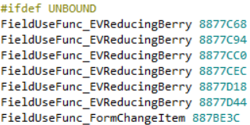

These are pointers added to Pokémon Unbound’s item table to enable the use of various items. Because these pointers are specific to Pokémon Unbound, the first thing you need to do is remove the lines and . This will allow these pointers to be written to your game.

- Add basic data for the following items to your base rom: Gracidea, DNA Splicers, Prison Bottle, Reveal Glass, N-Solarizer, N-Lunarizer, Pink Nectar, Purple Nectar, Red Nectar, and Yellow Nectar. Make sure that the item Type in G3T is set to 1 Out of battle. For EV-Reducing Berries, each item effect parameter should be set to the stat Id (below, the Tamato Berry’s is set to 3 for Speed).

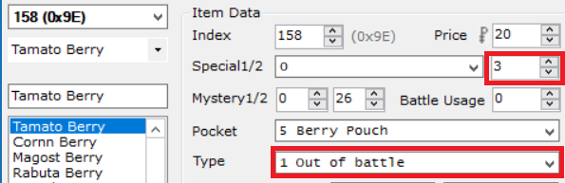

Do the following for each of the items, one at a time.

- Edit the Field Script field in the item editor to be some nonsense string of characters. Click Save Offset.

- Search for the item string as a reverse pointer in your rom (above EF CD AB 08). Record the offset where the string is found, and add 0x8000000 to this offset (below offset found is 3DCB6C which becomes 83DCB6C).

- If your item is a forme changing item, add the following line to the file (or replace one of Unbound’s pointers):
FieldUseFunc_FormChangeItem OFFSET
Eg.

If your item an EV-Reducing Berry, add the following line to the file (or replace one of Unbound’s pointers):
FieldUseFunc_EVReducingBerry OFFSET
Eg.

Once that’s all done, you’re free to compile and test out your new items! If you don’t include all of the aforementioned items, just make sure that no residual pointers from Pokémon Unbound are left in your game, first.
Note that unlike the official games, the DNA Splicers have been configured to allow the player to fuse up to one Reshiram and one Zekrom at a time (as opposed to one of either).



Other Features Included

Save Expansion
The default save space has been expanded tremendously to allow for:
- 4096 new Flags (0x900 - 0x18FF)
- 200 new Vars (0x5000 - 0x51FF)
- 10 new PC Boxes (for a total of 24)
- Up to 10 Roaming Pokémon
- Up to 778 unique items in the bag
- 4 New Step Counters

Updated & New Item Effects
Several new items effects have been added such as effects for the Power Items and the Shiny Charm, a complete set of battle effects, as well as some other items like the Black Flute and White Flute (which have been updated to the standards from ORAS).

Trainer Face Fix
The player will face trainers before battle.

DexNav
A simplified DexNav system for Fire Red is included in the engine. It replaces the POKEDEX option in the Start Menu with TOOLS, which can either load a multichoice menu containing the Pokédex and DexNav, or an entirely new start menu. Selecting the DexNav opens the graphical user interface (GUI) to allow the player to view which Pokémon they have caught/seen on the current map, and either press the R-Button or A-Button on a given Pokémon to search for it on the map. The R-button will save the Pokémon information to VAR_DEXNAV and allow the player to search for that Pokémon via the R-button from the overworld.

Dynamic Overworld Palettes
Overworld sprites are now loaded in dynamically, allowing for more freedom with creating new overworld sprite palettes.

Ability Pop-Ups
Whenever a Pokémon’s ability activates in battle, a pop-up will appear showing the ability akin the Gen 5+ games.

Hidden Abilities
Hidden abilities have been implemented using one of the empty bytes in the Pokémon data. It is the 27th byte (0x1A from the start, including 0) of the pokemon base stats data structure. You can assign it in G3T as follows: (in decimal! Not hexadecimal!) see include/constants/abilities.h
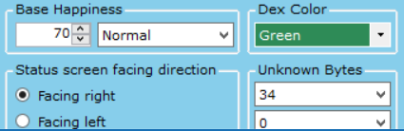

Expanded Text Names
The following text names can expanded by replacing the first four characters in the name with a pointer to a longer text string:
- Trainer Class Names
- Item Names
Additionally, ability names have had their name length changed from 12 to 16.

Pokédex Screen Stats
The boring old size comparison when viewing a Pokémon’s pokedex data has been replaced with a routine by that displays the Pokémon’s stats and abilities instead.

Turbo Boost
A pipelined routine has been written to replace the old main loop with one that now allows the game to run at over 1000% speed using the fast-forward button.

Various Customizable Updates
The file bytereplacement contains a list of optional byte changes:
- Don’t count eggs while healing at the Pokémon Centre.
- Extend number of direct sound tracks to 12.
- Fix for movement type 0xC (Hidden).
- Remove National Dex evolution limiters.
- Remove plot related trade restrictions.
- Fix for Pokédex species name issue.
- Display foreign Pokémon’s id without National Dex.
- PC boxes use more wallpapers.
- Max money increased to 9999999.
To remove any of these changes, simply add a # symbol at the beginning of the line or delete the byte change lines entirely.

Triple Layer Tiles and Cut Grass Tiles¹⁰
Taken from this source, blocks can now have three layers on top of each other. See the original post for details on using this feature.
Additionally, the grass tiles removable using the field move Cut can also be modified. The table containing these tiles is sCutGrassTiles and can be found in src/overworld.c. See the comment above the table for an explanation of adding new entries to this table.

Expanded Coins
The expanded coins option also comes with rewritten coin-related scripting commands. To allow for more coins, if REPLACE_SOME_VANILLA_SPECIALS is defined, using the coin commands (checkcoins, givecoins, removecoins) with argument 0xFFFF will allow the value will be loaded from Var8000 and Var8001. The upper halfword will be the value in Var8000, and the lower halfword will load from Var8001. Checkcoins will also be modified to check if the player has a certain number of coins, and place the result in LASTRESULT.
Example Script:
#org @giveLotsOfCoins
lock
setvar 0x8000 0x1234
setvar 0x8001 0x5678
givecoins 0xFFFF 'The player will receive 0x12345678 (or 305,419,896) coins
release
end

Multichoice Windows

Static Multichoice Windows
Like in JPANs Fire Red Hacked Engine, it is possible to script up custom multichoice boxes for players to select from various options. The hack uses Special 0x24 or Special 0x25 to add list items, and the multichoice scripting command to display the list. The first two arguments in this command are the (x, y) coordinates on the screen. The third argument is the number of list items you have (0x20 is 2 options, 0x25 is 7 options, the maximum). The final argument is either 0 if B allows the player to cancel, or 1 if the player cannot cancel with the B button. Here is a scripting example using special 0x25:

#org @StaticMultichoiceExample
setvar 0x8006 0x0 ‘First list item
loadpointer 0x0 @text1
special 0x25
setvar 0x8006 0x1 '2nd list item
loadpointer 0x0 @text2
special 0x25
setvar 0x8006 0x2 '3rd list item
loadpointer 0x0 @text3
special 0x25
preparemsg @msg 'String to display in the message box
waitmsg
multichoice 0x0 0x0 0x21 0x1 'Multichoice at (0x0), 3 options, ‘B’ CANNOT cancel.
compare LAST_RESULT 0x0
if 0x1 goto @firstOption
'etc…

Scrolling Multichoice Windows
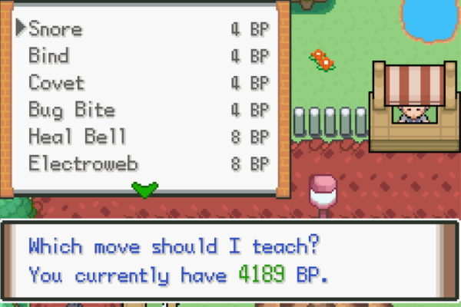
Ported from FBIs asm routine and improved slightly, this feature allows you to include multichoice boxes with more than 6 options at once, such as in the example to the right. To set these up, go to the bottom of src/scripting.c (or jump there by searching “Scrolling Multichoice”). You can define new multichoice lists by adding static const u8* sMultichoiceSet3[] = {…}, where the brackets are filled with pointers to the text you want to add. You can include strings inside the engine by emulating the example strings from the string file strings/scrolling_multichoice.string, eg.
#org @sExampleText_11
Example 11
And then add extern const u8 sExampleText_11[]; underneath Text Declarations in src/scripting.c.
Next, you must add the pointer to your new multichoice list to the set of multichoice lists, gScrollingSets, defined below the multichoice sets. You can add your new list in the same format as the examples given: {sMultichoiceSet3, ARRAY_COUNT(sMultichoiceSet3)},
Finally, here’s how you would display your new list in a script:
#org @ScrollingMultichoiceExample
setvar 0x8000 0x2 'Choose the 3rd multichoice list in gScrollingSets
setvar 0x8001 0x5 'Display 5 text items at once (defines the box height - not total num)
special 0x158
waitstate
compare LAST_RESULT 0x7F
if 0x1 goto @cancelled
compare LAST_RESULT 0x0
if 0x1 goto @firstOption

Tile Interaction Scripts
sMetatileInteractionScripts, located in src/overworld.c contains scripts linked to tile behaviours (what the tile does when the A-button is pressed next to it).
- You can add new interaction scripts by defining/using the metatile behaviour byte in include/constants/metatile_behaviors.h (eg. a library book - start with 0xA7).
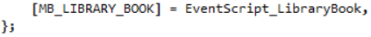
- Link it to a script inside sMetatileInteractionScripts via:
- Make the script inside assembly/overworld_scripts/system_scripts.s. Don’t forget to declare the script above the table and add the needed string to strings/overworld_strings.string!
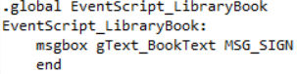

Script Specials
Several new scripting specials have been added to the engine. Many have been ported from JPAN’s hacked engine, and thus will work similar to how they worked there.
If a special is shown to have a var (such as Var 0x8000) as an input, set that var to the required data. If SELECT_FROM_PC is defined, remember to keep track of the Pokémon source from Var 0x8003 before calling specials that manipulate Pokémon attributes.
If a special is shown to have a return value, it must be called with the special2 scripting command.

Pokémon Specials
The following specials check or change Pokémon attributes. If SELECT_FROM_PC is defined, Var 0x8003 will allow you to check/change data from PC boxed Pokémon if it is set to 1. Otherwise it will check/change from a party Pokémon.

Special 0x7 – EV/Contest Stat Checker
Details: Checks a party/boxed Pokémon’s EVs or Contest stats.
Input:
Var 0x8003: From party (0), or box (1).
From Box: Var 0x8000, Var 0x8001 hold the box num/slot, respectively.
From Party: Var 0x8004 holds the party slot number.
Var 0x8005: Stat to check:
HP EV | 0x0
Attack EV | 0x1
Defense EV | 0x2
Speed EV | 0x3
Special Attack EV | 0x4
Special Defense EV | 0x5
Coolness | 0x6
Beauty | 0x7
Cuteness | 0x8
Smartness | 0x9
Toughness | 0xA
Luster | 0xB
Returns: Stat value to given var.
Example Script:
setvar 0x8003 0x0 'Select from party
setvar 0x8004 0x3 '4th Pokémon in party
setvar 0x8005 0x1
special2 LAST_RESULT 0x7
buffernumber 0x0 LAST_RESULT 'Buffer Attack EV stat into [buffer1]

Special 0x8 – Pokémon IV Checker
Details: Checks a party/boxed Pokémon’s IVs
Input:
Var 0x8003: From party (0), or box (1).
From Box: Var 0x8000, Var 0x8001 hold the box num/slot, respectively.
From Party: Var 0x8004 holds the party slot number.
Var 0x8005: IV stat to check:
HP IV | 0x0
Attack IV | 0x1
Defense IV | 0x2
Speed IV | 0x3
Special Attack IV | 0x4
Special Defense IV | 0x5
Returns: IV stat value to given var.
Example Script (with PC Selection Hack):
writebytetooffset 0x1 0x0203b7ac 'Or whatever pcSelect_StateTracker is set to
special 0x3C 'Select boxed mon, box stored to var8000, slot to var8001
waitstate
compare LAST_RESULT 0x7F 'Player exited without selecting
if 0x1 goto @DidNotSelect
setvar 0x8003 0x1 'From boxed mon
setvar 0x8005 0x1 'Check attack IV
special2 LAST_RESULT 0x8
buffernumber 0x0 LAST_RESULT 'Buffer attack IV to [buffer1]

Special 0x9 – Pokémon Ribbon Checker
Details: Checks a Pokémon’s ribbons. The first 5 ribbons have values from 1 - 4 for Normal, Super, Hyper, and Master rank, so be sure to reference the correct bit value(s). See this page for more info. These values cannot be checked from the PC as they are removed to compress box Pokémon size.
Input:
Var 0x8004: Holds the party slot number.
Var 0x8005: Ribbon bit to check. Here are the possible bits and known ribbon values.
Ribbon | Bit(s)/Rank | Var 0x8005 Val
Cool Ribbons | Normal (1) = bit 1 (0001)  Super (2) = bit 2 (0010)  Hyper (3) = bits 1,2 (0011)  Master (4) = bit 3 (0100) | 0  1  0 & 1  2
Beauty Ribbons | Normal (1) = bit 4  Super (2) = bit 5  Hyper (3) = bit 4,5  Master (4) = bit 6 | 3  4  3 & 4  5
Cute Ribbons | Normal (1) = bit 7  Super (2) = bit 8  Hyper (3) = bit 7,8  Master (4) = bit 9 | 6  7  6 & 7  8
Smart Ribbons | Normal (1) = bit 10  Super (2) = bit 11  Hyper (3) = bit 10,11  Master (4) = bit 12 | 9  10  9 & 10  11
Tough Ribbons | Normal (1) = bit 13  Super (2) = bit 14  Hyper (3) = bit 13,14  Master (4) = bit 15 | 12  13  12 & 13  14
Champion | Bit 16 | 15
Winning | Bit 17 | 16
Victory | Bit 18 | 17
Artist | Bit 19 | 18
Effort | Bit 20 | 19
Special 1 | Bit 21 | 20
Special 2 | Bit 22 | 21
Special 3 | Bit 23 | 22
Special 4 | Bit 24 | 23
Special 5 | Bit 25 | 24
Special 6 | Bit 26 | 25
Special 7 | Bit 27 | 26
Fateful Encounter | Bits 28-30 | 27 - 30
Obedience (Mew/Deoxys) | Bit 31 | 31
NOTE: the “hyper” status is a bit more challenging to check for, as the input is a bit number and these ribbon statuses require checking two bits. If this is something you are interested in implementing, you would need to remove the Normal bit upon receiving Super status, and then check for both bits with two separate special calls to determine the Hyper status.

Returns: 1 if the ribbon flag is set, 0 if not.
Example Script:
setvar 0x8004 0x2 '3rd mon in party
setvar 0x8005 15 'Check Champion ribbon
special2 LAST_RESULT 0x9
buffernumber 0x0 LAST_RESULT
compare LAST_RESULT 0x1
if 0x1 goto @IsAChampion
'Else, Pokémon was not in the hall of fame

Special 0xA – Pokerus Timer Checker
Details: Checks the Pokérus virus timer on a Pokémon.
Input:
Var 0x8003: From party (0), or box (1).
From Box: Var 0x8000, Var 0x8001 hold the box num/slot, respectively.
From Party: Var 0x8004 holds the party slot number.
Returns: Pokérus time left to given var.
Example Script:
setvar 0x8003 0x0 'From party
setvar 0x8004 0x0 'First party Pokémon
special2 LAST_RESULT 0xA
buffernumber 0x0 LAST_RESULT 'Pokérus timer into [buffer1]
bufferpartypokemon 0x1 0x0 'Buffer first poke name into [buffer2]
msgbox @timeLeft 0x6

#org @timeLeft
= [buffer2] is sick for [buffer1] more cycles!

Special 0xB – Poké Ball Checker
Details: Check the Poké Ball type of a Pokémon. The ball Ids can be found in include/new/catching.h.
Input:
Var 0x8003: From party (0), or box (1).
From Box: Var 0x8000, Var 0x8001 hold the box num/slot, respectively.
From Party: Var 0x8004 holds the party slot number.
Returns: Poké Ball type to given var.
Example Script:
writebytetooffset 0x1 0x0203B7AC 'Select from PC hack
Special 0x3C 'Store box/slot into vars 0x8000, 0x8001, respectively
waitstate
Compare LAST_RESULT 0x7F
If 0x1 goto @didNotSelect 'Player cancelled without selection
setvar 0x8003 0x1 'From box
special2 LAST_RESULT 0xB
buffernumber 0x1 LAST_RESULT 'Buffer item number to [buffer2]
special 0x7C 'Buffer boxed mon nickname to [buffer1]
msgbox @ball 0x6

#org @ball
= [buffer1] is inside a [buffer2]! How fortunate!
Special 0xC – Check Capture Location
Details:
Input:
Var 0x8003: From party (0), or box (1).
From Box: Var 0x8000, Var 0x8001 hold the box num/slot, respectively.
From Party: Var 0x8004 holds the party slot number.

Returns: Capture Location Id to given var.
Example Script:
setvar 0x8003 0x0 'From party
setvar 0x8004 0x5 'Last party mon
special2 LAST_RESULT 0xC
buffernumber 0x0 LAST_RESULT 'Buffer capture location to [buffer1]

Special 0xD – Happiness Checker
Details: Check the number of happiness points for a Pokémon.
Input:
Var 0x8003: From party (0), or box (1).
From Box: Var 0x8000, Var 0x8001 hold the box num/slot, respectively.
From Party: Var 0x8004 holds the party slot number.
Returns: Happiness value (0-255) to given var.
Example Script:
setvar 0x8003 0x0 'From party
setvar 0x8004 0x2 '3rd Pokémon
special2 LAST_RESULT 0xD
buffernumber 0x0 LAST_RESULT 'Buffer happiness to [buffer1]
compare LAST_RESULT 255
if 0x1 goto @maxedHappiness

Special 0xE – Hold Item Checker
Details: Check hold item value of a Pokémon.
Input:
Var 0x8003: From party (0), or box (1).
From Box: Var 0x8000, Var 0x8001 hold the box num/slot, respectively.
From Party: Var 0x8004 holds the party slot number.

Returns: Hold Item Id to given var.
Example Script:
setvar 0x8003 0x0 'From party
setvar 0x8004 0x3 '4th Pokémon
special2 LAST_RESULT 0xE
buffernumber 0x0 LAST_RESULT 'Buffer to [buffer1]

Special 0xF – Add/Subtract to EVs
Details: Add or subtract values to Pokémon EVs (between 0 and 252).
Input:
Var 0x8003: From party (0), or box (1).
From Box: Var 0x8000, Var 0x8001 hold the box num/slot, respectively.
From Party: Var 0x8004 holds the party slot number.
Var 0x8005: Stat for math (see Special 0x7 for indices).
Var 0x8006: Value to add. 0x01YY to subtract YY, 0x00ZZ to add ZZ.

Returns: Nothing.
Example Script:
setvar 0x8003 0x0 'From party
setvar 0x8004 0x1 '2nd party Pokémon
setvar 0x8005 0x3 'Speed EV
setvar 0x8006 0x0150 'Subtracting 0x50, or 80 speed EVs
special 0xF

Special 0x10 – Set IVs
Details: Set IV values for a Pokémon. No math here, just setting to a specific value.
Input:
Var 0x8003: From party (0), or box (1).
From Box: Var 0x8000, Var 0x8001 hold the box num/slot, respectively.
From Party: Var 0x8004 holds the party slot number.
Var 0x8005: IV stat to change (see Special 0x8 for indices), between 0 and 31 (0x1F).
Var 0x8006: IV value to set.
Returns: Nothing.
Example Script:
setvar 0x8003 0x0 'From party
setvar 0x8004 0x0 'First Pokémon
setvar 0x8005 0x0 'HP IV
setvar 0x8006 31 'Value to set
special 0x10 'Maximize first party Pokémon’s HP IV

Special 0x11 – Set Ribbons
Details: Set or clear a Pokémon’s ribbon flag.
Input:
Var 0x8004: Holds the party slot number.
Var 0x8005: Ribbon flag to set (see Special 0x9 for indices/values).
0x00XX will set a ribbon, 0x01YY will clear a ribbon.
Returns: Nothing.
Example Script:
setvar 0x8004 0x2 '3rd Pokémon
setvar 0x8005 15 'Set Champion ribbon
Special 0x11 'Set the ribbon

Special 0x12 – Set Pokérus
Details: Set a Pokérus timer of a Pokémon.
Input:
Var 0x8003: From party (0), or box (1).
From Box: Var 0x8000, Var 0x8001 hold the box num/slot, respectively.
From Party: Var 0x8004 holds the party slot number.
Var 0x8005: Number of cycles, 0x0 to 0xF, 0x10 to “cure”.
Returns: Nothing.
Example Script:
setvar 0x8003 0x0 'From party.
setvar 0x8004 0x0 'First mon.
setvar 0x8005 0x10 'Cure Pokémon’s Pokérus.
special 0x12

Special 0x13 – Change Happiness
Details: Add or subtract to a Pokémon’s happiness.
Input:
Var 0x8003: From party (0), or box (1).
From Box: Var 0x8000, Var 0x8001 hold the box num/slot, respectively.
From Party: Var 0x8004 holds the party slot number.
Var 0x8005: Amount to add/subtract.
0x01YY will subtract YY from happiness; 0x00XX will add XX to happiness.
Returns: Nothing.
Example Script:
setvar 0x8003 0x0 'From party
setvar 0x8004 0x1 '2nd party Pokémon
setvar 0x8005 0x0150 'Subtracting 0x50, or 80 friendship points
special 0x13

Special 0x14 – Change Pokeball
Details: Set the ball type of a Pokémon.
Input:
Var 0x8003: From party (0), or box (1).
From Box: Var 0x8000, Var 0x8001 hold the box num/slot, respectively.
From Party: Var 0x8004 holds the party slot number.
Var 0x8005: Ball ID to set.
Returns: Nothing.
Example Script:
setvar 0x8003 0x0 'From party
setvar 0x8004 0x0 'First Pokémon
setvar 0x8005 0x1 'Set to Master Ball
special 0x14

Special 0x15 – Change Hold Item
Details: Set the hold item of a Pokémon.
Input:
Var 0x8003: From party (0), or box (1).
From Box: Var 0x8000, Var 0x8001 hold the box num/slot, respectively.
From Party: Var 0x8004 holds the party slot number.
Var 0x8005: Item Id to set.
Note that if the Pokémon is already holding an item, this will not change the item, unless Var 0x8005 is set to 0 to remove the item. Then you can call it again to set a new hold item.
Returns: 0 to LAST_RESULT if successful item change, 1 if not.
Example Script:
setvar 0x8003 0x0 'From party
setvar 0x8004 0x5 'Last mon
setvar 0x8005 0x0 'Remove a hold item first
special 0x15
setvar 0x8005 ITEM_SILKSCARF 'Item to give
special 0x15 'Give silk scarf
compare LAST_RESULT 1
If 0x1 goto @Failed

Special 0x16 – Change Species
Details: Change the species of a Pokémon.
Input:
Var 0x8003: From party (0), or box (1).
From Box: Var 0x8000, Var 0x8001 hold the box num/slot, respectively.
From Party: Var 0x8004 holds the party slot number.
Var 0x8005: Species to change to.
Returns: Nothing.
Example Script:
setvar 0x8003 0x0 'From party
setvar 0x8004 0x0 'First Pokémon
setvar 0x8005 PKMN_CHARMANDER 'Set to Charmander
special 0x16

Special 0x17 – Change Attacks
Details: Set or remove a move for a Pokémon. This one does not work with the PC Selection Hack.
Input:
Var 0x8004: Pokémon Slot (0-5)
Var 0x8005: Move Slot (0-3 for moves 1-4, respectively)
Var 0x8006: Move Id (0 to clear move slot)
Returns: Nothing.
Example Script:
Special 0x9F 'Select a Pokémon from the menu, store slot to Var 0x8004
waitstate
compare LAST_RESULT 0x6
if 0x4 goto @Cancelled
setvar 0x8005 0 'First move
setvar 0x8006 MOVE_HYPERBEAM 'Teach Hyper Beam in slot 0
special 0x17

Special 0x18 – Check Species
Details: Check the species of a Pokémon.
Input:
Var 0x8003: From party (0), or box (1).
From Box: Var 0x8000, Var 0x8001 hold the box num/slot, respectively.
From Party: Var 0x8004 holds the party slot number.
Returns: Species Id to given var.
Example Script:
setvar 0x8003 0x0 'From party
setvar 0x8004 0x0 'Check first Pokémon
special2 LAST_RESULT 0x18
compare LAST_RESULT PKMN_RATTATA 'Check if first Pokémon if Rattata
If 0x0 goto @NotCorrect

Special 0x19 – Check Attack PP
Details: Check a Pokémon move’s PP.
Input:
Var 0x8003: From party (0), or box (1).
From Box: Var 0x8000, Var 0x8001 hold the box num/slot, respectively.
From Party: Var 0x8004 holds the party slot number.
Var 0x8005: Move slot (0-3).
Returns: PP left to given var.
Example Script:
setvar 0x8003 0x0 'From Party
setvar 0x8004 0x0 'First Pokémon
setvar 0x8005 0x0 'First move
special2 LAST_RESULT 0x19
buffernumber 0x0 LAST_RESULT
compare LAST_RESULT 0x0
if 0x1 goto @NoPPLeft

Party Specials

Special 0x62 – Erase Pokémon
Details: Erase a Pokémon from your party, or the entire party.

Input:
Var 0x8004: Slot to erase (0xF for entire party).
Returns: Nothing.
Example Script:
setvar 0x8004 0xF 'Erase entire party
Special 0x62

Special 0x63 – Status Checker
Details: Check the primary status of a Pokémon.
Input:
Var 0x8004: Pokémon Slot
Returns: Status inflicted to given var.

Status | Bits | Hex Value
Sleep | 1  2  3 | 0x1  0x2  0x4
Poison | 4 | 0x8
Burn | 5 | 0x10
Frozen | 6 | 0x20
Paralyzed | 7 | 0x40
Badly Poisoned | 8 | 0x80

Example Script:
setvar 0x8004 0x0 'First party Pokémon
special2 0x8004 0x63 'Get statuses to var 0x8004
setvar 0x8005 0x80 'Badly poisoned
special2 LAST_RESULT 0x42 'Var 0x8004 & Var 0x8005
compare LAST_RESULT 0x1 '& will return 1 if the Pokémon has this status
If 0x1 goto @BadlyPoisoned

Special 0x64 – Status Inducer
Details: Inflict a primary status on a party Pokémon.
Input:
Var 0x8004: Pokémon slot, or 0xF for entire party.
Var 0x8005: Status(es) to induce (see Special 0x63 for values).
Var 0x8006: 1 if status should only be given to Pokémon that can be afflicted with it (ie. No paralysis on Electric-types), 0 otherwise.
Returns: Nothing.
Example Script:
setvar 0x8004 0xF 'First party Pokémon
setvar 0x8005 0x20 'Freeze entire party
setvar 0x8006 0x1 'Don’t freeze Ice-types of Pokémon with Magma Armor
special 0x64

Special 0x65 – Check Pokémon HP
Details: Check the amount of HP remaining for a party Pokémon.
Input:
Var 0x8004: Pokémon slot.
Returns: HP to given var.
Example Script:
setvar 0x8004 0x0 'First Pokémon
special2 LAST_RESULT 0x65
compare LAST_RESULT 0x0
if 0x1 goto @DeadPoke

Special 0x66 – Inflict Party Damage or Heal
Details: Inflict damage on/heal a Pokémon, or entire party.
Input:
Var 0x8004: Pokémon slot, 0xF for entire party.
Var 0x8005: Damage to inflict/heal.
Var 0x8006: 1 to heal, otherwise inflict damage.
Returns: Nothing.
Example Script:
setvar 0x8004 0xF 'Entire party
setvar 0x8005 20 '20 damage to party
setvar 0x8006 0x0 'Damage party
Special 0x66

Special 0xB0 – Load Party Pokémon Types
Details: Gets the types of the requested party Pokémon.
Input:
Var 0x8000: Party Pokémon number.
Returns:
Var 0x8000: Type 1.
Var 0x8001: Type 2.
Example Script:
Special 0x9F 'Select a Pokémon from the menu, store slot to Var 0x8004
waitstate
compare LAST_RESULT 0x6
if 0x4 goto @Cancelled
copyvar 0x8000 LAST_RESULT
special 0xB0

Special 0xB2 –Pokémon Type In Party
Details: Checks if a specific Pokémon type can be found among the party Pokémon.
Input:
Var 0x8000: Pokémon type.
Returns: Last Result: Party Index if type was found in party. 6 otherwise.
Example Script:
setvar 0x8000 0xA 'Check Fire-type in party
special 0xB2
compare LAST_RESULT 0x6
if == goto @NotFound

Special 0xCC –Pokémon in Party that Can Learn Draco Meteor
Details: Checks if any Pokémon in the player's party can learn Draco Meteor. It does not include a friendship check. That is handled in the tutor part.
Input: None.
Returns: Last Result: TRUE if any Pokémon can learn Draco Meteor. 0 otherwise.
Example Script:
special 0xB2
compare LAST_RESULT 0x0
if == goto @NoDragonTypesInParty

Special 0xD0 - Pokémon in Party that Can Learn TM/HM
Details: Checks if any Pokémon in the player's party can learn the given TM/HM number.
Input: Var8000: The TM/HM id to check (1 to NUM_TM + NUM_HMS).
Returns: Given Var: Slot Id of the Pokémon the can learn the TM/HM. 6 if none can learn.
Example Script:
setvar 0x8000 0x1 'Check Focus Punch
special2 LAST_RESULT 0xD0
compare LAST_RESULT 0x0
if == goto @NoFocusPunchPotentialInParty

Key Specials

Special 0x2B – Check AB Buttons
Details: Check if A or B has been pressed
Input: Nothing.
Returns: To the given var:
0x0: Neither pressed.
0x1: A was pressed.
0x2: B was pressed.
0x3: Both A & B were pressed.
Example Script:
#org @Loop
special2 LAST_RESULT 0x2B
compare LAST_RESULT 0x1 'Check for A
if 0x0 goto @Loop 'Player cannot continue onwards until they press A
'Continue

Special 0x2C – Check D-Pad
Details: Check D-Pad presses.
Input: Nothing.
Returns: To given var:
0x0: No direction is pressed.
0x1: Up is pressed.
0x2: Left is pressed.
0x3: Down is pressed.
0x4: Right is pressed.
0x5: Up-left is pressed.
0x6: Up-right is pressed.
0x7: Down-left is pressed.
0x8: Down-right is pressed.
Example Script: Wait Until Player Presses Down Button
#org @start
goto @loop

#org @loop
special2 LAST_RESULT 0x2C
compare LAST_RESULT 0x3 'Down pressed
if 0x1 goto @continue 'exit infinite loop if player pressed down
goto @loop

Special 0x2D – Check Start/Select
Details: Check if Start/Select are pressed
Input: Nothing
Returns: To given var:
0x0: Nothing pressed.
0x1: Select pressed.
0x2: Start pressed.
0x3: Both Start & Select pressed.
Example Script:
special2 LAST_RESULT 0x2D
compare LAST_RESULT 0x2 'Start pressed
If 0x1 goto @PressedStart

Special 0x2E – Check L/R
Details: Check if L/R are pressed.
Input: Nothing.
Returns: To given var:
0x0: Nothing pressed.
0x1: R pressed.
0x2: L pressed.
0x3: L & R pressed.
Example Script:
special2 LAST_RESULT 0x2E
compare LAST_RESULT 0x1 'R pressed
if 0x1 goto @PressedR

Special 0x2F – Dump Keys
Details: Dump any and all keys that have been pressed.
Input: Nothing.
Returns: Key presses to Var 0x800D (LASTRESULT):
Key | Bit | Hex
A | 1 = 0001 | 0x1
B | 2 = 0010 | 0x2
Select | 3 = 0100 | 0x4
Start | 4 = 1000 | 0x8
Right | 5 = 0001 0000 | 0x10
Left | 6 = 0010 0000 | 0x20
Up | 7 = 0100 0000 | 0x40
Down | 8 = 1000 0000 | 0x80
R | 9 = 0001 0000 0000 | 0x100
L | 10 = 0010 0000 0000 | 0x200

Example Script: Wait until player presses A
#org @loop
special 0x2F
Compare LAST_RESULT 0x1 'A pressed
If 0x1 goto @pressedA
goto @loop

Special 0xC9 – Force Key Input
Details: Force a key input from the user.
Input:
Var 0x8004: Key(s) to force (bitfield) (see Special 0x2F for bits).
Var 0x8005: Number of times to press it. For held buttons, a good rule of thumb is 0x10 times the number of times you want to move (see Script Example)
Returns: Nothing.
Example Script:
setvar 0x8004 0x10 'Right
setvar 0x8005 0x30 'Step Right 3 Times
special 0xC9 'Force player to move right 3 steps

Special 0xCA – Prevent Key Press
Details: Prevent player from being able to press button(s).
Input:
Var 0x8004: Key(s) to prevent (bitfield). 0 to allow all keys.
Returns: Nothing.
Example Script:
setvar 0x8004 0x104 'Prevent R and Select from doing anything
Special 0xCA

Special 0xCB – Assign Key Script
Details: assign a specific script to a key
Input:
Var 0x8004: Key to assign script to (0 to remove).
Loadpointer 0x0: Script pointer.
Returns: Nothing.
Example Script:
setvar 0x8004 0x100 'Assign to R
loadpointer 0x0 @DoSomething
special 0xCB 'Now, when in the overworld, pressing R will launch @DoSomething

Variable Math Specials

Special 0x3E – Add Variables
Details: Add the values of two variables together.
Input:
Var 0x8004: Variable holding the first value.
Var 0x8005: Variable holding the second value.
Returns:
Variable Inside Var 0x8004: Sum of two values.
Given Var: 1 if sum overflows 0xFFFF, 0 otherwise.
Example Script:
setvar 0x4050 50
setvar 0x4051 25
setvar 0x8004 0x4050
setvar 0x8005 0x4051
special2 LAST_RESULT 0x3E 'Addition result to first variable, 0x4050
compare LAST_RESULT 0x1
if 0x1 goto @overflow

Special 0x3F – Subtract Variables
Details: Subtract the values inside two variables.
Input:
Var 0x8004: Variable holding first value.
Var 0x8005: Variable holding second value.
Returns:
First Variable: Difference of values.
Given Var: 1 if difference underflows 0x0, 0 otherwise.
Example Script:
setvar 0x8004 0x4059
setvar 0x8005 0x4050
special2 LAST_RESULT 0x3F '[var 0x4059] = [var 0x4059] – [var 0x4050]
compare LAST_RESULT 0x1
If 0x1 goto @overflowed '[var 0x4059] > [var 0x4050]

Special 0x40 – Multiply Variables
Details: Multiply the values of two variables together.
Input:
Var 0x8004: Variable holding first value.
Var 0x8005: Variable holding second value.
Returns:
First Variable: [Var 0x8004] $×$ [Var 0x8005].
Given Var: 1 if product overflows 0xFFFF, 0 otherwise.
Example Script:
setvar 0x8006 400
setvar 0x8007 200
setvar 0x8004 0x8006
setvar 0x8005 0x8007
special2 LAST_RESULT 0x40 '400*200 = 80000 = 0x13880 = (0xFFFF) + 0x3881
Special 0x41 – Divide Variables
Details: Divide the values in two variables.
Input:
Var 0x8004: Numerator.
Var 0x8005: Denominator.
Returns:
Var 0x8004: Integer result of Var8004 / Var8005
Given Var: Remainder (modulus) of the division.
Example Script:
setvar 0x8004 50
setvar 0x8005 6
special2 0x8006 0x41 'Var8004 = 50 / 6 = 8
buffernumber 0x0 0x8006 'Remainder = 2

Special 0x42 – AND Variables
Details: Bitwise AND two variables.
Input:
Var 0x8004: First value.
Var 0x8005: Second value.
Returns: AND result of two variables to given var.
Example Script:
setvar 0x8004 0xCB '1100 1011
setvar 0x8005 0xAA '1010 1010
special2 0x8004 0x42 '[1100 1011] & [1010 1010] = 1000 1010 = 0x8A

Special 0x43 – OR Variables
Details: Bitwise OR two variables
Input:
Var 0x8004: First value.
Var 0x8005: Second value.
Returns: OR result of two variables to given variable
Example Script:
setvar 0x8004 0x4 '0000 0100
setvar 0x8005 0x10 '0001 0000
special2 0x8004 0x43 'Var8004 = [0000 0100] | [0001 0000] = 0001 0100 = 0x14

Special 0x44 – XOR Variables
Details: Bitwise XOR two variables.
Input:
Var 0x8004: First value.
Var 0x8005: Second value.
Returns: XOR result of two variables to given variable
Example Script:
setvar 0x8004 0x12 '0001 0010
setvar 0x8005 0x18 '0001 1000
special2 0x8007 0x44 'Var8007 = [0001 0010] ^ [0001 1000] = 0000 1010 = 0xA

Frontier Specials

Special 0x52 – Generate Frontier Trainer Id
Details: Generates a random battle facility id in gTowerTrainers or gSpecialTowerTrainers, or a preset frontier brain in gFrontierBrains found in src/Tables/Frontier_Trainers.c, and a name for the trainer.
Input:
Var 0x8000: 0 = Load data for trainer Opponent 1.
1 = Load data for trainer Opponent 2.
2 = Load data for partner Trainer.
Var 0x8001: 0 = Load from gTowerTrainers.
1 = Load from gSpecialTowerTrainers.
2 = Load from gFrontierBrains.
Var 0x8002: 0 = If Var 0x8001 is 2, then the frontier brain id num.
Returns: To given var the OW sprite Id of the chosen trainer.
Also buffers the trainer name to gStringVar1.
Example Script: See below.

Special 0x53 – Load Frontier Intro Battle Message
Details: Loads the battle intro message of the requested trainer.
Input:
Var 0x8000: 0 = Load data for trainer Opponent 1.
1 = Load data for trainer Opponent 2.
Var 0x8001: 0 = Load from gTowerTrainers.
1 = Load from gSpecialTowerTrainers.
2 = Load from gFrontierBrains.
Returns: Nothing
Example Script: For battle against a normal single opponent:
#define VAR_RUNTIME_CHANGEABLE 0x4080

setvar 0x8000 OPPONENT_1 '0
setvar 0x8001 REGULAR_TRAINER '0
special2 VAR_RUNTIME_CHANGEABLE SPECIAL_GENERATE_TOWER_TRAINER '0x52
reappear FOE_NPC_ID 'The Person Id of the dynamic overworld person event
setvar 0x8000 OPPONENT_1 '0
setvar 0x8001 REGULAR_TRAINER '0
special BUFFER_TOWER_TRAINER_INTRO_MSG '0x53
callstd MSG_NORMAL 'Displays the buffered intro text

Special 0x54 – Get Frontier Streak
Details: Gets the streak for the requested Frontier format.
Input:
Var 0x8000: 0 = Current Streak.
1 = Max Streak.
Var 0x8001: 0xFFFF = Load style from var VAR_BATTLE_FACILITY_BATTLE_TYPE.
0 = Single battle.
1 = Double battle.
2 = Multi battle.
3 = Link multi battle.
Var 0x8002: 0xFFFF = Load tier from var VAR_BATTLE_FACILITY_TIER.
0 - 0xFF = See VAR_BATTLE_FACILITY_TIER description for available tiers.
Var 0x8003: 1 - 5 = Party size option 1.
6 = Party size option 2.
Var 0x8004: 0 = Load level from VAR_BATTLE_FACILITY_POKE_LEVEL.
1-MAX_LEVEL = Level bracket 1.
MAX_LEVEL = Level bracket 2.
Returns: The requested streak to the given var.
Example Script:
setvar 0x8000 CURRENT_STREAK '0
setvar 0x8001 VAR_LOAD_STYLE_FROM '0xFFFF
setvar 0x8002 VAR_LOAD_TIER_FROM '0xFFFF
setvar 0x8003 FLAG_LOAD_INVERSE_FROM '2
setvar 0x8004 VAR_LOAD_LEVEL_FROM '0
special2 LASTRESULT SPECIAL_GET_TOWER_STREAK '0x54

Special 0x55 – Update Current Frontier Streak
Details: Updates the streak for the current Frontier format.
Input:
Var 0x8000: 0 = Increment streak by 1.
1 = Reset streak.
Returns: Nothing.
Example Script:
setvar 0x8000 INCREMENT_STREAK_BY_1 '0
special SPECIAL_UPDATE_TOWER_STREAK '0x55

Special 0x56 – Determine Battle Points To Give
Details: Gets the number of battle points to give for the player’s previous frontier win.
Input: None.
Returns: Given var:
Streak Length | Num Battle Points
1 - 10 | 2
11 - 19 | 3
20 | 20 (Against Brain)
21 - 30 | 4
31 - 40 | 5
41 - 49 | 6
50 | 50 (Against Brain)
51+ | 7
Example Script:
special2 LASTRESULT SPECIAL_DETERMINE_BATTLE_POINTS '0x56
'Add vars here to update total BP amount

Special 0x6B – Replace Player Team With Multi Trainer Team
Details: Temporarily replaces the player's team with the team of the given multi battle trainer to allow the player to choose which Pokémon they want the partner to use.
Input:
Var 0x8000: Given multi trainer id of trainer in gFrontierMultiBattleTrainers.
Returns: Nothing.
Example Script: See Special 0x6C.

Special 0x6C – Splice Frontier Multi Trainer Team With Player’s Team
Details: To be used after special 0x6B. Merges the player's choice of partner Pokemon onto their team.
Input: None.
Returns: Nothing.
Example Script:
setvar 0x8000 0x0 'First trainer in gFrontierMultiBattleTrainers
special 0x6B 'Replace player’s team
special 0xF5 'Choose Pokémon for battle
waitstate
special 0x6C 'Splice result, even if player cancelled.

Special 0x6D – Load Frontier Multi Trainer Data By Id
Details: Loads any relevant multi trainer data by the given Id value.
Input:
Var 0x8000: 0-0xFE: Given multi trainer id of trainer in gFrontierMultiBattleTrainers.
0xFF: Random multi trainer id.
Returns: Given Var: The OW sprite Id of the chosen trainer.
Also buffers the multi trainer name to gStringVar2 ([BUFFER2] / bufferstring 0x1).
Example Script:
setvar 0x8000 0x0 'First trainer in gFrontierMultiBattleTrainers
special2 VAR_RUNTIME_CHANGEABLE 0x6D
Special 0x6E – Buffer Battle Sands Records
Details: Buffers text relating to Battle Sands records.
Input:
Var 0x8000: 0 = Previous Streak.
1 = Max Streak.
Returns: Last Result: TRUE if the requested record exists.
Also buffers strings to the following:
gStringVar1: Tier name.
gStringVar2: Battle format name.
gStringVar3: Level.
gStringVar7: Inverse on or off.
gStringVar8: Species 1.
gStringVar9: Species 2.
gStringVarA: Species 3.
gStringVarB: Streak length.
gStringVarC: "previous" or "max"
Example Script:
setvar 0x8000 0 'Previous record
special 0x6E 'Buffer records
msgbox @TellRecords MSG_NORMAL

Special 0x6F – Can Team Participate in Battle Mine
Details: Checks if the player's team can enter the Battle Mine. Also sets the VAR_BATTLE_FACILITY_TIER to the chosen tier.
Input:
Var 0x8000: 0 = Check Battle Mine Format 1.
1 = Check Battle Mine Format 2.
2 = Check Battle Mine Format 3.
Returns: LastResult: TRUE if the team can participate.
Example Script:
setvar 0x8000 0 'Check eligibility in Battle Mine Format 1
special 0x6F
compare LASTRESULT 0x0
if == goto @CantParticipate

Special 0x70 – Randomize Battle Mine Options
Details: Randomizes various battle options for a battle in the Battle Mine.
Input: None.
Returns: Buffers strings to the following:
gStringVar7: Tier name.
gStringVar8: Battle format name.
gStringVar9: Level.
gStringVarA: Party size.
gStringVarB: Inverse on or off.
gStringVarC: Dynamax “be able” or “not be able”
Example Script: special 0x70

Special 0x71 – Load Battle Mine Record Tier
Details: Sets the VAR_BATTLE_FACILITY_TIER var to the correct tier the Battle Mine streaks are recorded in. To be used after a battle.
Input: None.
Returns: Nothing.
Example Script: special 0x71

Special 0x72 – Load Battle Circus Effects
Details: Loads random effects for Battle Circus battles.
Input: None.
Returns: Last Result: TRUE if all effects loaded.
gStringVarC: A description of the effect just activated.
Example Script:
setweather 0x0 'Remove overworld weather data

#org @SetEffectsForBattle
special 0x72 'Try to add effect
compare LASTRESULT 0x0
if != goto @Return
msgbox @BattleWillTakePlaceIn MSG_NORMAL
doweather 'Try to update overworld weather
goto @SetEffectsForBattle

#org @Return
Return

Special 0x73 – Modify Team for Battle Facility
Details: Modifies the entered Pokémon’s levels to be used in the Battle facility.
Input: None.
Returns: Nothing.
Example Script:
special 0x27 'Backup original party
special 0xF5 'Choose Pokémon to fight with
waitstate
special 0x28 'Need to have original team when saving game
special 0x23 'Save game
waitstate
special 0x73 'Modify chosen team

Special 0x67 – Generate Random Battle Frontier Team
Details: Generates a random Battle Frontier ready team using VAR_BATTLE_FACILITY_POKE_LEVEL. Teams are generated based on Pokémon found in src/Tables/battle_tower_spreads.h.
Input:
Var8000: Tier
Returns: Nothing.
Example Script: setvar 0x8000 0x0 'Standard tier
special 0x67

Battle Specials

Special 0x51 – Can Team Participate in a Sky Battle
Details: Checks if the player has at least one Pokémon on their team that can participate in a Sky Battle. The Pokémon species banned from participating can be found under gSkyBattleBannedSpeciesList in src/Tables/Pokémon_Tables.c.
Input: None.
Returns: To given var 0 if team can’t participate, 1 if it can.
Example Script:
special2 LASTRESULT 0x51
compare LASTRESULT 0x0
if == goto @CantParticipate
setflag FLAG_SKY_BATTLE 'Defined in config.h
trainerbattle 0x3 0x20 0x0 @lose

Special 0x58 – Buffer Swarm Text
Details: Buffers the map name where there is currently a swarm to buffer1 and the species name where there is currently a swarm to buffer2. Optional: Special2 may be used to return the species roaming.
Input: None.
Returns: Given Var: Species roaming.
Example Script:
special 0x58
msgbox @Saw 0x6 '[buffer1]! They said there’s\na whole bunch of [buffer2] there!

Special 0x59 – Buffer Species Roaming Text
Details: Buffers the map name where the given roamer can be found to buffer1, and the species name of the roamer to buffer2.
Input:
Var 0x8000: Species
Returns: To given var 0 if the requested species isn’t found roaming. 1 otherwise.
Example Script:
setvar 0x8000 SPECIES_CHARMANDER 'Charmander should roam
setvar 0x8001 25 'Level 25
setvar 0x8002 0x1 'Can roam on land
setvar 0x8003 0x0 'Cannot roam on water
special 0x129 'Create roaming Pokemon
compare LASTRESULT 0x0
if 0x1 goto @TooManyRoamers
setvar 0x8000 SPECIES_CHARMANDER 'Find map where Charmander is roaming
special2 LASTRESULT 0x59 'Buffer roaming text
compare LASTRESULT 0x0
if 0x1 goto @NotRoaming
msgbox @Saw 0x6 '[buffer1]! They said a\n[buffer2] appeared there!

Special 0x5A – Wild Data Switch
Details: Overwrites the wild data on all maps until special 0x5B is used.
Input:
Loadpointer 0x0: New wild data header pointer.
Returns: Nothing.
Example Script:
loadpointer 0x0 0x83C9CB8 'Pointer to Route 1 wild data
special 0x5B

Special 0x5B – Cancel Wild Data Switch
Details: Cancels the wild data switch set by special 0x5A.
Input: None.
Returns: Nothing
Example Script:
special 0x5C

Special 0x97 – Random Grass Battle
Details: Initiates a random grass battle from the map wild data. Does nothing if no land data exists.
Input: None.
Returns: Nothing.
Example Script: See Special 0x98.

Special 0x98 – Random Sea Battle
Details: Initiates a random water battle from the map wild data. Does nothing if no water data exists.
Input: None.
Returns: Nothing.
Example Script:
#org @start
special 0x8F 'The trainer position special
special2 LAST_RESULT 0x7F 'Returns 1 if ground battles, 2 if water battle
compare LAST_RESULT 0x1
if 0x1 goto @grass
compare LAST_RESULT 0x2
if 0x1 goto @water
release
end

#org @grass
special 0x97 'Generates a random grass battle.
release
end

#org @water
special 0x98 'Generates a random water battle.
release
end

Special 0x156 – Ghost Battle
Details: Initiate a ghost battle with a given Pokémon, level, and held item.
Input:
Var 0x8004: Ghost species. Setting to 0 initiates a battle with default Marowak.
Var 0x8005: Ghost level.
Var 0x8006: Ghost hold item.
Returns: Nothing.
Example Script:
setvar 0x8004 PKMN_CHARIZARD
setvar 0x8005 100
setvar 0x8006 ITEM_LEFTOVERS
Special 0x156

Special 0xAC - Load Second Trainer Defeat Message
Details: If a battle against two opponents is being started from a flag, this special will load in the defeat text for the second trainer.
Input:
Loadpointer 0x0: Pointer to defeat text.
Returns: Nothing
Example Script: See here.

Special 0x9C – Old Man Battle
Details: Initiate an old man battle with a specific Pokémon species and level.
Input:
Var 0x8004: Species.
Var 0x8005: Level.
Returns: Nothing.
Example Script:
setvar 0x8004 PKMN_BEEDRILL
setvar 0x8005 50
special 0x9C
waitstate

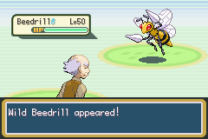

Timer Specials
Another feature from JPANs engine, which allows the player to utilize the game timer for timed events.

Special 0x46 – Start Timer
Details: Start the timer. If called after it started running, it resets the timer.
Input: None.
Returns: Nothing.
Example Script: special 0x46

Special 0x47 – Pause Timer
Details: Pauses the already-started timer. Stores the timer value to gTimerValue
Input: None.
Returns: Nothing.
Example Script: special 0x47

Special 0x48 – Resume Timer
Details: Resume a paused timer.
Input: None.
Returns: Nothing.
Example Script: special 0x48

Special 0x49 – Stop Timer
Details: Stops the timer and returns the value. Timer needs to be started anew, resuming the timer will cause the value to be inaccurate.
Input: None.
Returns: The timer value to the given var.
Example Script: special2 LAST_RESULT 0x49

Special 0x4A – Get Timer Value
Details: Just return the time on the timer.
Input: None.
Returns: The timer value to the given variable.
Example Script: special2 LAST_RESULT 0x4A

Special 0x4B – Stop and Update Playtime
Details: Stop the timer and update playtime value.
Input: None.
Returns: Nothing.
Example Script: special 0x4B

Special 0x4C – Update Playtime
Details: Update the playtime. This is meant for functions that take a while to process that cause delay in playtime.
Input: None.
Returns: Nothing.
Example Script: special 0x4C

Special 0x4D – Check Timer Value
Details: Check if timer has reached a value stored in Var 0x8010.
Input:
Var 0x8010: Value to check against.
Returns: 1 if timer is greater or equal, 0 otherwise.
Example Script:
setvar 0x8010 100 '100 seconds
special2 LAST_RESULT 0x4D
Compare LAST_RESULT 0x1 'Is timer >=
If 0x1 goto @timeReached

Special 0x4E – Save Timer Value
Details: Store the timer value to a free RAM address, gTimerValue to allow you to later reset it to this value.
Input: None.
Returns: Nothing.
Example Script: special 0x4E

Special 0x4F – Start Timer at a Time
Details: Restart the timer at the value stored with Special 0x4E (value in gTimerValue).
Input: None.
Returns: Nothing.
Example Script: special 0x4F

Special 0x50 – Store Timer Value to Variable
Details: Store the timer value from gTimerValue to a given variable
Input:
Var 0x8006: Variable to store timer value to
Returns: Nothing.
Example Script:
Special 0x4e 'save timer value to gTimerValue
Setvar 0x8006 0x8000
special 0x50 'store timer value to variable 0x8000

Special 0x61 – Load Timer Value from Variable
Details: Set the timer value RAM, gTimerValue, from a variable
Input:
Var 0x8006: Variable holding timer value to set
Returns: Nothing.
Example Script:
setvar 0x8000 50
setvar 0x8006 0x8000
special 0x61 'set gTimerValue to 50

Safari Specials

Special 0x86 – Get Safari Balls
Details: Check Safari Ball quantity.
Input: None.
Returns:
Given Var: Number of Safari Balls
Example Script:
special2 LAST_RESULT 0x86
buffernumber 0x0 LAST_RESULT
msgbox @numSafariBalls 0x6

#org @numSafariBalls
= You have [buffer1] Safari Balls remaining!

Special 0x87 – Change Safari Balls
Details: Increase or decrease the safari ball count, maximum up to MAX_SAFARI_BALLS.
Input:
Var 0x8004: Number to increase/decrease by (up to 100)
0x1XX decreases by XX, 0x1YY increases by YY.
Returns: Nothing.
Example Script:
setvar 0x8004 0x011E 'Remove 30 safari balls
special 0x87

Special 0x88 - Get Safari Pedometer
Details: Get the value of the safari pedometer.
Input: None.
Returns: Safari pedometer value to given variable.
Example Script:
special2 LAST_RESULT 0x88
compare LAST_RESULT 50 'Check if taken at least 50 steps
if 0x4 goto @OverFifty

Special 0x89 – Set Safari Pedometer
Details: Set a specific number of steps in the safari.
Input:
Var 0x8004: Pedometer Value to set.
Returns: Nothing.
Example Script:
special2 LAST_RESULT 0x88 'Get current pedometer
Compare LAST_RESULT 50
If 0x3 goto @Continue
setvar 0x8004 50 'Pedometer can only reach 50 steps
Special 0x89 'Set the safari step counter to 50

Walking Specials

Special 0x7E – Get Tile Number
Details: Get the tile number at a specified location on the current map.
Input:
Var 0x8004: Tile x-coordinate.
Var 0x8005: Tile y-coordinate.
Returns: Tile number to the given var.
Example Script:
getplayerpos 0x8004 0x8005 'Player’s current position
addvar 0x8004 0x2 'Check tile 2 steps to the right of the player
special2 LAST_RESULT 0x7E
compare LAST_RESULT SOME_TILE_NUMBER
if 0x1 goto @CorrectTile

Special 0x7F – Get Tile Behaviour
Details: Get a specific tile set of attributes
Input:
Var 0x8004: Tile x-coordinate.
Var 0x8005: Tile y-coordinate.
Returns:
Var 0x8004: Tile background byte.
Var 0x8005: Tile behaviour bytes.
Given Var: Tile background byte.
Example Script:
Getplayerpos 0x8004 0x8005
special2 LAST_RESULT 0x7F 'Get tile attributes on player’s current tile

Special 0x81 – Set Walking Script
Details: Load a walking script to run each step. Setting to zero removes any walking script.
Input:
Loadpointer 0x0: Script pointer.
Returns: Nothing.
Example Script:
Loadpointer 0x0 @WalkingMsg
Special 0x81
release
end

#org @walkingMsg
Msgbox @msg 0x6
end

#org @msg
= This msgbox will play every single step.
Special 0x8A – Read Pedometer Value
Details: This special is not in JPAN’s original engine. It reads the value of one of the extra pedometers included in the engine, which are set with flags (see customization).
Input:
Var 0x8004: Pedometer to read
0: always active pedometer (32bit)
1: large valued-pedometer (32bit)
2: medium valued-pedometer (16bit)
3: first small pedometer (8bit)
4: second small pedometer (8bit)
Returns: Pedometer value to the given variable.
Example Script:
setvar 0x8004 0x0 'Pedometer that’s always on
special2 LAST_RESULT 0x8A 'Get number of steps player has walked
buffernumber 0x0 LAST_RESULT

PC Selection Specials
A couple new specials are added, as well as a few existing specials changed to allow data manipulation of boxed Pokémon.

Special 0x1A – Store/Return Party Pokémon Data
Details: Save or Return party/boxed Pokémon Data
Input:
Var 0x8002:
0 For store to free ram.
1 For return to party from free ram.
2 For store from free ram to box.
3 For store from box to free ram.
Var 0x8005: Party slot number (for special 0xFE inputs).
Returns: 0 or 1 to LAST_RESULT for success/failure, respectively
Script Example:
setvar 0x8002 0 'Store
setvar 0x8005 0 'Save first party mon data
Special 0x1A 'First party Pokémon data now in Enemy data slot 5

Special 0x1B – Swap Party/Boxed Pokémon Data
Details: Swap party and box data
Input:
Var 0x8000: Box Number .
Var 0x8001: Box Position.
Var 0x8002: 0 for withdraw from box, 1 for store to box.
Var 0x8005: Party slot number (for special 0xFE inputs).
Returns: 0 or 1 to LAST_RESULT for success/failure, respectively.
Script Example – Swap Party and Boxed Mon
Msgbox @ask 0x6 'Select party mon to deposit
Special 0x9F
waitstate
copyvar 0x8005 0x8004
setvar 0x8002 0 'From party to free ram
Special 0x1A ' Store from party to free ram
msgbox @ask2 0x6 'Select boxed mon to withdraw
writebytetooffset 0x1 0x0203b7ac
special 0x3C 'Select boxed mon, box stored to Var8000, slot to Var8001
waitstate
setvar 0x8002 0x0 'Withdraw
special 0x1B 'Selected boxed mon to selected party slot (Var8005)
setvar 0x8002 0x2 'Free ram to box
special 0x1A 'Free ram (eg. Original selected party mon) to same box slot

NOTE: Rather than use a single special for this, the dynamic inputs of these specials allow for swapping party/boxed mon, trading, and more.

Special 0x7C – Buffer nickname
Details: Buffer a Pokémon’s nickname to [buffer1].
Input:
Var 0x8003: From party (0), or box (1).
From Box: Var 0x8000, Var 0x8001 hold the box num/slot, respectively.
From Party: Var 0x8004 holds the party slot number.
Returns: Nothing.
Example Script: See Special 0x9E.

Special 0x7D – Check Traded Pokémon
Details: Check if Pokémon is traded.
Input:
Var 0x8003: From party (0), or box (1).
From Box: Var 0x8000, Var 0x8001 hold the box num/slot, respectively.
From Party: Var 0x8004 holds the party slot number.
Returns: LastResult: 0 if traded, 1 if not.
Example Script: See Special 0x9E.

Special 0x9E – Nickname Pokémon
Details: Nickname a Pokémon.
Input:
Var 0x8003: From party (0), or box (1).
From Box: Var 0x8000, Var 0x8001 hold the box num/slot, respectively.
From Party: Var 0x8004 holds the party slot number.
Returns: LastResult: 0 if traded, 1 if not.
Example Script – Nickname a Boxed Pokémon
writebytetooffset 0x1 0x0203B7AC
special 0x3C 'Select boxed mon, box stored to Var8000, slot to Var8001
waitstate
setvar 0x8003 0x1
special 0x7C 'Buffer nickname
Msgbox @AskNickname 0x5 'Nickname [buffer1]?
Compare LAST_RESULT 0x1
If 0x0 goto @Nope
Special 0x7D 'Check traded mon
Compare LAST_RESULT 0
If 0x1 goto @Traded
Special 0x9E 'Nickname boxed mon
waitstate

Other Specials

Special 0x24 – Add Multichoice Text By Variable
Details: Add a dynamic multichoice option by variables
Input:
Var 0x8004: Upper halfword of pointer.
Var 0x8005: Lower halfword of pointer.
Var 0x8006: Multichoice Index.
Returns: Nothing.
Example Script:
setvar 0x8004 0x0890
setvar 0x8005 0x5040
setvar 0x8006 0x0
Special 0x24 'Multichoice index 0 is string pointer 0x08905040

NOTE: Special 0x25 is easier to use, you don’t have to worry about upper/lower sections of a word.

Special 0x25 – Add Multichoice Text by Pointer
Details: Add a dynamic multichoice option by a pointer.
Input:
Var 0x8006: Multichoice Index.
Loadpointer 0x0: Pointer to string.
Returns: Nothing.
Example Script:
setvar 0x8006 0x0
loadpointer 0x0 @option1
special 0x25
setvar 0x8006 0x1
loadpointer 0x0 @option2
special 0x25
preparemsg @msg
waitmsg
multichoice 0x0 0x0 0x20 0x0 'See note below
compare LAST_RESULT 0x0
if 0x1 goto @selectedOption1
compare LAST_RESULT 0x1
if 0x1 goto @selectedOption2

NOTE: multichoice 0xX 0xY 0xWW 0xZ
0xX: X position of box.
0xY: Y position of box.
0xWW: Multichoice box index.
0x20: 2 options (min).
…
0x25: 7 options (max).
0xZ: 0x0 if B can cancel box, 0x1 if not

Special 0x74 – Is Pokémon Storage System Full
Details: Checks if there is space in the PC for a new Pokémon.
Input: None.
Returns: Given Var: 1 if no space left in PC. 0 otherwise.
Example Script:
special 0x74
compare LAST_RESULT 0x0
if == goto @YesSpace

Special 0x75 – Buffer Species
Details: Buffer a Pokémon’s species to [buffer3] and size to [buffer1].
Input:
Var 0x8005: Holds the variable that stores measurements.
Var 0x8006: Species to evaluate.
Returns: Nothing.
Example Script: See below

Special 0x76 – Measure Pokémon
Details: Play the measure Pokémon game.
Input:
Var 0x8004: Party slot of Pokémon.
Var 0x8005: Holds the variable that stores measurements.
Var 0x8006: Species to evaluate.
Returns: Given var:
1: Pokémon is not of selected type.
2: Pokémon is smaller.
3: Pokémon is bigger, also stores biggest value in variable in Var 0x8005.
4: Sizes are equal.

Special 0x18B – Show Fossil Image
Details: Load a custom image into the fossil image window.
Pointer Table - Defined in src/config.h
Table can also be generated by the engine in src/script_specials.c. Search for gFossilImageTable.
Name | Bytes | Description
Fossil Pointer | 4 | Pointer to a section of data that has the needed information for the function to work.
Palette Pointer | 4 | A simple uncompressed palette must be on the other end.
Fossil Data (Pointed to from “Fossil Pointer”)
Image Pointer | 4 | Pointer to the actual image. Uncompressed, 64x64 pixel, so each should take 4kb worth of space.
Constant bytes | 4 | Don’t know what they do, but when changed they mess up the whole picture. Must be 0008581b.
Null bytes | 8 | 8 zeros. Changing them will result in the same as messing with the above bytes.

Input:
Var 0x8004: Image number.
Var 0x8005: X coordinate on screen.
Var 0x8006: Y coordinate on screen.
Returns: Nothing.
Example Script:
setvar 0x8004 0x2 'Show third image in table
setvar 0x8005 0x0 'At (0x0)
setvar 0x8006 0x0 'At (0x0)
special 0x18B

Special 0x9A – Stop Sounds
Details: Stops all sound effects currently playing
Input: None.
Returns: Nothing.
Example Script:
sound 0x15
special 0x9A 'Stops the sound

Special 0xAE – Dynamic Clearflag
Details: Clears the flag loaded.
Input:
Var 0x8000: Flag to clear.
Returns: Nothing.
Example Script:
setvar 0x8000 0x2D 'Clear flag 0x2D
special 0xAE

Special 0xAF – Dismount Bicycle
Details: If the player is on the bicycle, they dismount.
Input: None.
Returns: Nothing.
Example Script: special 0xAF

Special 0xB1 – Choose Item From Bag
Details: Opens the bag and lets the player select an item.
Input:
Var 0x8000: 0 = Any pocket, Open from Item's pocket.
1 = Any pocket, Open from Key Item's pocket.
2 = Any pocket, Open from Poke Ball pocket.
3 = Any pocket, Open from Item's pocket.
4 = Berry Pouch
5 = TM Case
Returns: Var 0x800E: The item the player chose. 0 if they chose nothing.
Example Script:
setvar 0x8000 0x4 'Choose berry
special 0xB1
Special 0x196 – Try To Copy TM/HM Name To Buffer1
Details: If the given item is a TM/HM, buffers its name.
Input:
Var 0x8000: Item id of TM/HM.
Returns: Given Var: 0 if couldn’t copy name. 1 if name copied.
gStringVar1: TM/HM Name.
Example Script:
setvar 0x8000 TM01
special 0x196

Special 0xD1 – Create Follower NPC
Details: Causes the requested NPC to begin following the player wherever they go. This feature will not work perfectly in every situation (NOT BUGS). Eg, the NPC will not spin like the player on spin pads, and jumping over ledges / going on side stairs have a slight delay while the player waits for it to finish the jump / exit the staircase. It also is set to not follow during scripts. Adding an NPC to the table gFollowerAlternateSprites in src/follow_me.c, will allow you to set specific biking and surfing sprites.
Input:
Var 0x8000: Id of NPC (or var containing id) to start following the player.
Var 0x8001: Flags to determine follower properties (bitset):
0x1 = NPC has specific running frames like the player.
0x2 = Player is allowed to bike while with NPC. Changes NPC to its biking frames (if can).
0x4 = Player can use Fly, Teleport, Dig, or use an Escape Rope while with NPC.
0x8 = Player can surf while with NPC. Changes NPC to its surfing frames (if can).
0x10 = Player can use Waterfall while with NPC.
0x20 = Player can use Dive while with NPC.
0x40 = Player can use Rock Climb while with NPC.
0x80 = Follower returns to original location if the player whites out.
Returns: Nothing.
Example Script:
setvar 0x8000 LAST_TALKED 'NPC player is currently talking to
setvar 0x8001 0x48 'Can Surf + Rock Climb (0x8 + 0x40)
special 0xD1 'Convert the NPC into a follower

Special 0xD2 – Destroy Follower NPC
Details: If special 0xD1 was used to create a follower NPC prior, then this follower NPC will now disappear. Any flag given to the original NPC will also be set.
Input: None.
Returns: Nothing.
Example Script: special 0xD2
Special 0xD3 – Face Follower NPC
Details: If special 0xD1 was used to create a follower NPC prior, then the player and the follower will face each.
Input: Var PLAYERFACING (0x800C) must be correct.
Returns: Nothing.
Example Script:
special2 PLAYERFACING 0x1AA 'Update PLAYERFACING
special 0xD3
Special 0xE1 – Does Player Have Follower
Details: Checks if there is currently an NPC following the player.
Input: None.
Returns: Last Result: 0 if the player has no follower. 1 otherwise.
Example Script:
special 0xE1
compare LASTRESULT 0x0
if == goto @NoFollower

Special 0xB3 – Do Choose Number Screen
Details: Opens the naming screen and allows the player to input a number.
Input: None.
Returns: Last Result: The number entered. 0xFFFF if number was invalid.
Example Script:
special 0xB3
waitstate
compare LASTRESULT 0xFFFF
if == goto @NotValidNumber

Special 0x12C – Do Enter Phrase Screen
Details: Opens the naming screen and allows the player enter a phrase.
Input: Var 0x8000: 0 = Display the string “Enter Phrase”.
1 = Display the string “Enter Password”.
Returns: Nothing.
Example Script: See below.

Special 0x12D – Compare Entered Phrase
Details: Compares the phrase the Player entered in special 0x12C to another string.
Input: LoadPointer: The string to compare against.
Returns: LastResult: 0 if the strings are the same. Some other number otherwise.
Example Script:
special 0x12C
waitstate
special 0x12D
compare LASTRESULT 0x0
if != goto @IncorrectPhrase

Special 0xE2 – Is DexNav Complete In Current Location
Details: Checks if all Pokémon searchable with the DexNav in the current location have been caught.
Input: None.
Returns: LastResult: 0 if not all the Pokémon have been caught. 1 otherwise or if no Pokémon can be searched by the DexNav in the current location.
Example Script:
special 0xE2
compare LASTRESULT 0x0
if == goto @DexNavNotComplete

Scripted Field Move Specials
These specials can be used to help implement the PokéRide feature found in recent main series Pokémon games.
Special 0x100 – Can Player Use Flash In Current Location
Details: Checks if Flash can be used from the player’s current location.
Input: None.
Returns: LastResult: 0 if can’t use Flash, 1 if can.
Example Script: See below.

Special 0x101 – Can Player Use Fly In Current Location
Details: Checks if Fly can be used from the player’s current location.
Input: None.
Returns: LastResult: 0 if can’t use Fly, 1 if can.
Example Script: See below.

Special 0x102 – Is Player Facing Surfable Water
Details: Checks if Surf can be used from the player’s current location.
Input: None.
Returns: LastResult: 0 if can’t use Surf, 1 if can.
Example Script: See below.

Special 0x103 – Is Player Facing Climbable Waterfall
Details: Checks if Waterfall can be used from the player’s current location.
Input: None.
Returns: LastResult: 0 if can’t use Flash, 1 if can.
Example Script: See below.

Special 0x104 – Is Player on Diveable Water
Details: Checks if Dive can be used from the player’s current location.
Input: None.
Returns: LastResult: 0 if can’t use Dive, 1 if can.
Example Script: See below.

Special 0x105 – Is Player Facing Climbable Wall
Details: Checks if Rock Climb can be used from the player’s current location.
Input: None.
Returns: LastResult: 0 if can’t use Rock Climb, 1 if can.
Example Script: (Also for all above)
special 0x1XX 'Where XX is replaced with one of the above special numbers
compare LASTRESULT 0x0
if == goto @CantUse

Special 0x109 – Is Player Facing NPC With Overworld Sprite
Details: Checks if the player is facing an NPC with a given overworld sprite number.
Input:
Var 0x8000: Sprite Id of NPC to check for.
Returns: LastResult: 0 if not facing NPC with sprite Id, 1 if is facing.
Example Script:
setvar 0x8000 95 'Sprite Id of Cut tree
special 0x109
compare LASTRESULT 0x0
if == goto @NotFacing

Special 0x10A – Can Use Cut On Tree
Details: Simplifies the check for using Cut in the overworld down to one scripting command.
Input: None.
Returns: Var 0x8004: Party Id of the Pokémon that can use Cut.
6 if no Pokémon in party that can use Cut.
Example Script:
See Below.

Special 0x10B – Can Use Rock Smash on Cracked Rock
Details: Simplifies the check for using Rock Smash in the overworld down to one scripting command.
Input: None.
Returns: Var 0x8004: Party Id of the mon that can use Rock Smash.
6 if no Pokémon in party that can use Rock Smash.
Example Script:
See Below.

Special 0x10C – Can Use Strength on Boulder
Details: Simplifies the check for using Strength in the overworld down to one scripting command.
Input: None.
Returns: Var 0x8004: Party Id of the Pokemon that can use Strength.
6 if no Pokémon in party that can use Strength.
Example Script:
special 0x10C
compare 0x8004 0x0
if == goto @CantUse
bufferpartypokemon 0x0 0x8004

Time-Based Specials

Special 0xA0 - Check And/Or Set Daily Event
Details: Checks if a daily event has been run. It can also simultaneously set a daily event to “done”.
Input:
Var 0x8000: The first of a pair of vars containing the daily event data. Note that the var after this var is used as well (hence why “pair” was mentioned).
Var 0x8001: Set to 0 if you just want to check if the event has been done. Any other value sets the daily event as “done”.
Returns: 0 if the event has already been completed. 1 otherwise.

Special 0xA1 - Update Time in Vars
Details: Updates the time stored in a pair of vars to the current time.
Input:
Var 0x8000: The first of a pair of vars containing the daily event data. Note that the var after this var is used as well (hence why “pair” was mentioned).

Special 0xA2 - Get Time Difference
Details: Gets the time difference between the data stored in a pair of vars and the current time. These vars should be set by special 0xA1 or special 0xA2.
Input:
Var 0x8000: The first of a pair of vars containing the daily event data. Note that the var after this var is used as well (hence why “pair” was mentioned).
Var 0x8001: Set to one of the following values:
- 0 - Get the minute difference.
- 1 - Get the hour difference.
- 2 - Get the day difference.
- 3 - Get the month difference.
- 4 - Get the year difference.

Example Script:
#define SP_DAILY_EVENT 0xA0
#define SP_UPDATE_TIME_IN_VARS 0xA1
#define SP_GET_TIME_DIFFERENCE 0xA2
#define VAR_DAILY_EVENT 0x50D2 'Also uses 0x50D3

#dynamic 0x740000
#org @start
setvar 0x8000 VAR_DAILY_EVENT
setvar 0x8001 0x0 'Don’t set daily event var to done
special2 LASTRESULT SP_DAILY_EVENT
compare LASTRESULT 0x0
if == goto @AlreadyDid
setvar 0x8000 VAR_DAILY_EVENT
special SP_UPDATE_TIME_IN_VARS
msgbox @havenot ‘“I have not done it.”
callstd MSG_FACEPLAYER
end
#org @AlreadyDid
setvar 0x8000 VAR_DAILY_EVENT
setvar 0x8001 0x0 'Minute difference
special2 LASTRESULT SP_GET_TIME_DIFFERENCE
buffernumber 0x0 LASTRESULT
msgbox @already ‘“\v\h02 minutes ago I did it.”
callstd MSG_FACEPLAYER
end

Special 0xAD - Get Time Of Day
Details: Gets the current time of day.
Input:
Var 0x8001: 0 = Distinct times.
1 = Merge morning, day, and evening into day.
Returns: Given Var:
0 = Morning.
1 = Day.
2 = Evening.
3 = Night.
Example Script:
special2 LASTRESULT 0xAD
compare LASTRESULT 0x0
if == goto @Morning

Special 0xD9 - Get Hour
Details: Gets the current hour in the day.
Input: None.
Returns: Given Var: Current hour of the day.
Example Script: special2 LASTRESULT 0xD9

Special 0xDA - Get Day of Week
Details: Gets the current day of week.
Input: None.
Returns: Given Var: Current day of week.
Example Script: special2 LASTRESULT 0xDA

Raid Battle Specials
This is an advanced feature! If you’re having trouble understanding anything here, then this feature is not for you!
Make sure the den listings found in src/Tables/raid_encounters.h and partner listings found in src/Tables/raid_partners.h are complete before using any of the below specials!

Special 0x115 - Raid Battle Available
Details: Checks if a Raid Battle is available in the current location. The current location is determined by using the Dynamic Warp (127, 127, 127). If a Raid Battle has already been completed in the current location, then a Raid will not be available until the flag is cleared.
Input: None.
Returns: LastResult: 0 if a Raid Battle is not available. 1 otherwise.
Example Script: See below.

Special 0x116 - Start Raid Battle Intro
Details: Initializes the Raid Battle by displaying the Raid Battle intro screen and allows the Player to choose a partner to help them in the Raid Battle.
Input: None.
Returns: LastResult: 0 if the player decided not to start the Raid Battle. 1 otherwise.
Example Script: See below.

Special 0x117 - Create Raid Pokémon
Details: Creates the Pokémon to fought against in the Raid Battle.
Input: Special 0x116 Before
Returns: Nothing.
Example Script: See below.

Special 0x118 - Start Raid Battle
Details: Starts a Raid Battle.
Input: None.
Returns: Nothing.
Example Script: See below.

Special 0x119 - Start Raid Battle
Details: Starts the current location’s Raid Battle flag to completed.
Input: None.
Returns: Nothing.
Example Script: See below.

Special 0x11A - Clear Raid Battle Flag
Details: Clears the current location’s Raid Battle flag or all Raid Battle flags.
Input: Var 0x8000: 0 = This location’s flag only (ie. if player throws a Wishing Piece).
1 = All Raid Battle flags (ie. if new day).
Returns: Nothing.
Example Script:
setvar 0x8000 0x0 'Clear this location’s flag
special 0x11A
Special 0x11B - Are All Raid Battles Completed
Details: Starts the current location’s Raid Battle flag to completed.
Input: None.
Returns: LastResult: 0 if there are still Raid Battles needing completion. 1 if they’ve all been completed.
Example Script:
special 0x11B
compare LASTRESULT 0x0
if == goto @StillMoreToDo

Special 0x11C - Give Raid Battle Rewards
Details: Gives the item drops associated with the Raid Boss defeated. The quanties of different item types can be found in the function GetRaidRewardAmount in the file src/dynamax.c.
Input: Var 0x4000 = 0
Returns: LastResult: 1 if done giving rewards. 0 otherwise.
Example Script:
special SPECIAL_IS_RAID_BATTLE_AVAILABLE
compare LASTRESULT 0x0
if == goto @RaidScript_NoBattle
msgbox @StartRaidBattle MSG_SIGN
fadescreen FADEOUT_BLACK
special SPECIAL_RAID_BATTLE_INTRO
waitstate
compare LASTRESULT 0x0
if == goto @RaidScript_End
setflag FLAG_TAG_BATTLE
msgbox @PartnerTeamedUp MSG_SIGN
special SPECIAL_CREATE_RAID_MON
special SPECIAL_START_RAID_BATTLE
waitstate
special2 LASTRESULT 0xB4 'Get battle outcome
compare LASTRESULT 0x4 'Ran
if == goto @RaidScript_End
compare LASTRESULT 0x5 'Teleported / Lost Battle
if == goto @RaidScript_End
special SPECIAL_SET_RAID_BATTLE_FLAG
setvar 0x4000 0x0

#org @RaidScript_GiveReward
special SPECIAL_GIVE_RAID_BATTLE_REWARDS
compare LASTRESULT 0x0
if != goto @RaidScript_End 'Done giving rewards
callstd MSG_FIND
goto @RaidScript_GiveReward

#org @RaidScript_End
release
end

Creating New Battle Mechanics
The following sections detail how to add new moves, abilities, poke balls, and items to the battle engine. Because there is no cookie-cutter methodology for writing code for each ability or item effect, these sections only tell you how to set up the necessary data. The actual logic and coding are up to the user.

Moves
- Declaration
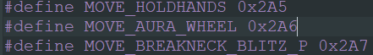
  - Add a definition in include/constants/moves.h following the same format, #define MOVE_<your move name>. It should ideally go after Hold Hands and before the Z-Moves.
  - This index must stay the same in all table positions! This is easily done by not editing any move IDs and adding new moves after MOVE_HOLDHANDS. If adding new moves before the Z-Moves, make sure to change the defined indices for all Z-Moves as well.
- Move Name
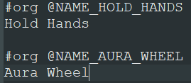
  - Add to the end of strings/attack_name_table.string following the #org @NAME_<your name here> format. The move name “table” is generated directly from the ordering of the #org declarations in this file, so make sure the ordering is correct!
- Move Description
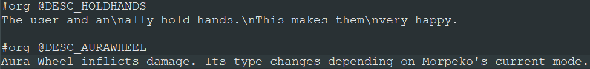
  - Add to the end of strings/Attack_Descriptions.string following the #org @DESC_<your name here> format, following the ordering of your move ID definitions from step 1!
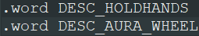
  - Add a pointer in the gMoveDescriptions table in assembly/data/attack_description_table.s , following the .word DESC_<your name here> format, following the ordering of your move ID definitions from step 1!
- Animation
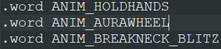
  - Add the animation pointer in the respective location in gAttackAnimations, typically called ANIM_<your move name>. Follow the ordering of your move ID definitions from step 1!
  - Create your animation. This is most easily done with animation command macros. See examples after the table in assembly/data/attack_anim_table.s as well as the macros in Anim_Defines.asm

  - If you are adding new backgrounds:
    - Add the indexed image to graphics/Backgrounds/Animation_Backgrounds/ for a 256x112 image. 256x256 may go in Larger_Anim_BGs.
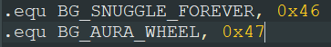
    - Add the new BG index to Anim_Defines.asm. It is easiest to add just after BG_SNUGGLE_FOREVER.
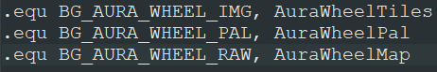
    - Add the definition to assembly/data/anim_backgrounds_graphics_defines.s following the same format. This step isn’t 100% necessary, but helps keep formatting consistent. If your file name is NewBg, your image declaration would be NewBgTiles, your palette would be NewBgPal, and the Map would be NewBgMap.
    - Add the background to the animation background table in assembly/data/anim_background_table.s, following the ordering of your indices from step 4.b.ii. The table goes [IMG_PTR, PAL_PTR, MAP_PTR], so follow your definitions from 4.b.iii.
    - Your background can now be called in animations by your definition from 4.b.ii, eg. loadBG1 BG_<your_bg_name>
  - If you are adding new particles:
    - Add the indexed .png file to graphics/Attack_Particles/
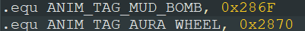
    - Define a new particle tag at the end of Anim_Defines.asm. It is easiest to keep all current definitions and add to the end after ANIM_TAG_MUD_BOMB.
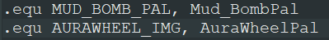
    - Add the particle definitions to assembly/data/Anim_Particle_Graphics_Defines.s. Similar to the backgrounds, this isn’t necessary but keeps the naming convention consistent. For a file called NewParticle.png, your image header will be called NewParticleTiles and your palette will be NewParticlePal.
    - Add the above definitions to gBattleAnimPicTable and gBattleAnimPaletteTable in assembly/data/anim_particle_table.s. These are two separate tables, the palettes following the images. So make sure you add animparticle <your_particle_IMG>, (<width> * <height>) / 2, ANIM_TAG_<your_particle_tag> and animparticlepal <your_particle_PAL, ANIM_TAG_<your_particle_tag>, 0x0 in the appropriate spots in each respective table.
    - You can now call your particles by the defined particle tag in any objtemplate (follow examples in assembly/data/Attack_Anim_Table.s).
- Battle Data
  - Add your static definition in the respective location inside gBattleMoves, found in src/Tables/battle_moves.c, following any existing move for each structure element definition. Here is a description of each element in the BattleMove structure:
Structure Element | Definition
effect | Battle effect, e.g. poisoning, atk up. See include/battle_move_effects.h
power | Base power (0-255)
type | Move type (eg. TYPE_NORMAL)
accuracy | Move base accuracy % (0-100)
pp | Move’s base pp
secondaryEffectChance | Chance of activating the move’s effect % (0-100)
target | Who the move targets:  MOVE_TARGET_SELECTED – choose target  MOVE_TARGET_DEPENDS – depends on the move/scenario (eg. counter)  MOVE_TARGET_USER_OR_PARTNER – Acupressure, choose between self or partner  MOVE_TARGET_RANDOM – random target, eg. Thrash  MOVE_TARGET_BOTH – affects both opponents  MOVE_TARGET_USER – targets self  MOVE_TARGET_FOES_AND_ALLY – all adjacent targets, eg. Surf  MOVE_TARGET_ALL – target all battlers  MOVE_TARGET_OPPONENTS_FIELD – affect the opponent’s field, eg. Spikes
priority | Move’s priority.  See here.  Priority is a signed integer, so negative values would subtract from 256. Eg. Revenge has priority -4, or 252.
flags | FLAG_MAKES_CONTACT – contact move  FLAG_PROTECT_AFFECTED – move blocked by protect  FLAG_MAGIC_COAT_AFFECTED – Move is reflected by Magic Coat  FLAG_SNATCH_AFFECTED – Move is affected by Snatch  FLAG_MIRROR_MOVE_AFFECTED – Move is copyable by Mirror Move  FLAG_KINGS_ROCK_AFFECTED – King’s Rock works with the move  FLAG_TRIAGE_AFFECTED – Move is affected by the ability Triage
z_move_power | Base power of the associated Z-move
split | SPLIT_PHYSICAL, SPLIT_SPECIAL, SPLIT_STATUS for move split type
z_move_effect | Move effect of the associated Z-move. See z_move_effects.h
See here to add your move to a table and give it special effects. You now have a fully defined move! You can add it to a Pokémon’s learnset inside src/Tables/level_up_learnsets.c, give it to a trainer’s Pokémon, add in some AI logic, and whatever else you desire.

Abilities
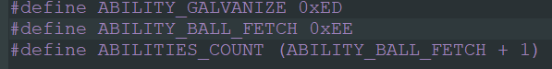
- Ability ID – add your #define ABILITY_<your_ability> at the end of include/constants/abilities.h. Then adjust ABILITIES_COUNT to the last ability index +1.
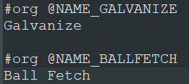
- Ability Name – add #org @NAME_<your_ability> and the ability name in strings/ability_name_table.string. Make sure the positioning of your ability name matches the index in Step 1.
- Ability Description – add the header, #org @DESC_<your_ability> to strings/ability_descriptions.string, as well as the description itself.
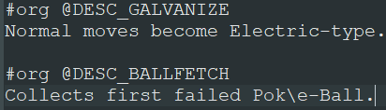
- Add a pointer to your description inside gAbilityDescription, found in assembly/data/Ability_Description_Table.s. Make sure the position matches the index defined in Step 1!
- Add your new ability to one of the ability tables (see here) above the ABILITY_TABLES_TERMIN to give it a certain property (such as being affected by Mold Breaker, being ignored by Skill Swap, etc.).
- Your new ability is now defined and can be assigned to a Pokémon with the Ability ID defined in Step 1. Any ability coding/logic must be written by the user. If you wish to give the ability the same effect as a pre-existing ability, simply search for the ability name in the engine and add logic for the new ability as well. This is easiest when the pre-existing ability is checked for in a switch statement. Simply stack the new ability as a case on top. See here for an explanation of switch statements.

Poke Balls
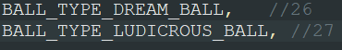
- Define a Ball ID – add a new ball type inside the enum BallTypes via BALL_TYPE_<ball_name> inside include/new/catching.h. You can only have up to 32 ball types, due to the restriction on bits.
  - Update LAST_BALL_INDEX and NUM_BALLS as needed.
- Throwing Image – add the indexed 16x48 .png file to graphics/Poke_Balls/, and any new particles to graphics/Poke_Balls/Opening_Particles/.
  - Note that the bag image is excluded because item data is untouched in this engine.
- Open src/Tables/Ball_Graphics_Tables.c.
  - Declare the throwing image and palette with
extern const u8 gInterfaceGfx_<ball_name>Tiles[]; and
extern const u8 gInterfaceGfx_<ball_name>Pal[];
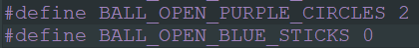
  - Any new opening particles can be declared underneath the image/pal declarations,
eg. extern const u8 gBattleAnimSpriteSheet_Particles<your_particle>Tiles/Pal[];
You can define the desired starting frame (for particle animations) similar to BALL_OPEN_WHITE_STARS
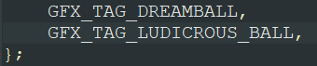
  - Ball Tag – add GFX_TAG_<ball_name> at the end of enum BallTags
  - Ball Particle Tags – add TAG_BALL_OPEN_<ball_name> at the end of enum BallOpenParticleTags
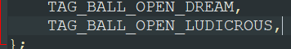
  - Add the sprite sheet info to gBallSpriteSheets following the same format as the other entries
  - Add the sprite palette info to gBallSpritePalettes, again following the same table format.
  - Add the sprite template info to gBallSpriteTemplates, emulating another table entry. The tileTag and paletteTag should be the only elements that change.
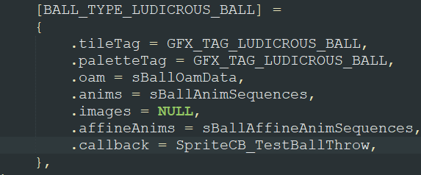
  - Add an entry to the particle sprite sheet, gBallOpenParticleSpritesheets, following the format of the other entries. gBattleAnimSpriteSheet_Particles is used for any existing opening particles (eg. the sticks/stars defined in enum BallOpenParticles). If you’ve included custom opening particles, assign them similar to the dusk ball or heal ball.
  - Add an entry for the particle palette table, gBallOpenParticlePalettes, again following the table format. gBattleAnimSpritePalette_136 is for the given opening particles (sticks, stars, etc). Custom particle palettes can be defined similar to the dusk or heal ball.
  - Add an entry to gBallOpenParticleAnimNums, linking your ball ID to the opening particle. It is easiest to assign existing particles, eg. BALL_OPEN_STICKS. Custom particles are defined similar to the dusk or heal ball, eg. follow BALL_OPEN_PURPLE_CIRCLES and its definitions/uses.
  - Create a particle trajectory animation entry in gBallOpenParticleAnimationFuncs. The existing animation trajectories are hard to describe, just test them yourself. 😊
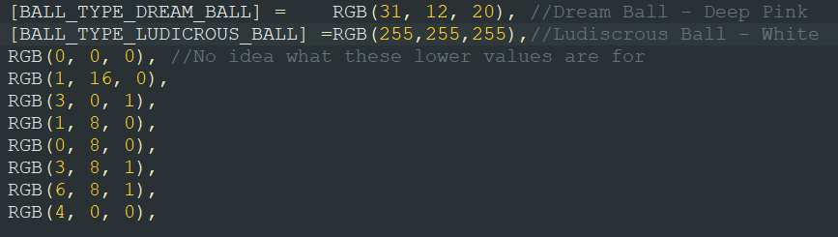
  - Add an entry to the gBallOpenMonFadePal table, which is the color the Pokémon fades to when it exits a Poké Ball. You can play around with RGB values in paint to find one you like. Keep the definitions after BALL_TYPE_DREAM_BALL at the end.
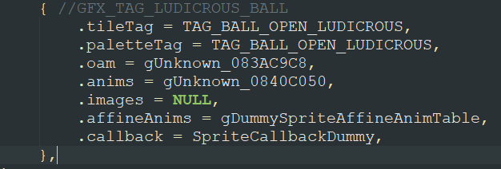
  - Create a sprite template entry in gBallParticleSpriteTemplates following the structure of one of the new balls such as Dusk Ball or Dream Ball. Again, your tileTag and paletteTag should be the only differences between entries.

- Ball Catch Multiplier
  - Open src/catching.c and find the function, atkEF_handleballthrow.
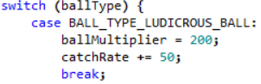
  - Add a case for your new ball inside the switch (ballType) statement to include logic for your specific ball catch multiplier. A ballMultiplier value of 10 corresponds to a 1x catch multiplier, as the value is divided by 10 later on. You can also add or subtract values by modifying the variable catchRate¸ as in the Heavy Ball’s case (it’s weird - don’t do it).
- You have now fully defined your new Poké Ball! You can now assign it to specific trainer’s Pokémon (eg. Battle Frontier). You will still need to create the item data if you want the player to be able to use it. This is entirely up to the user, as this engine does not directly modify item data.
- Please do not make a ball named Ludicrous Ball 😊

Items
NOTE: Defining a new battle item is easily done with this engine. The logic for the hold item effect is not generic and must be done by the user.
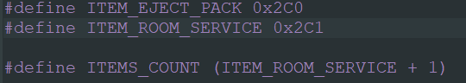
- Define an Item ID – add a define: #define ITEM_<your_item_name> inside include/constants/items.h. This is your item’s index. Update ITEMS_COUNT
- Define a hold item effect index - #define ITEM_EFFECT_<your_effect_name> in include/constants/hold_effects.h. Update ITEM_EFFECT_COUNT as needed.
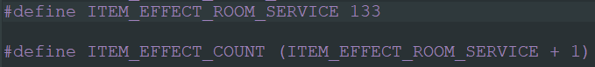
- Create your new item – this is handled entirely by the user, as item data is untouched in this engine. Just make sure the item index (step 1) matches. Assign the item the hold effect defined in Step 2.
- There is no hold effect information needed. The user must find an appropriate location to include logic for their new battle item effect. The function ItemId_GetHoldEffect is an effective way to obtain the Pokémon in question’s hold item effect from its hold item ID. The same logic with adding new ability effects to switch statements applies here as well for item effects.

Code Files

Below is a list of all code files which can be found in src, along with features contained in each file. Each file’s respective header file can be found in include/new.
File | Description
ability_battle_effects.c | Functions that introduce or modify battle effects via abilities or otherwise. Includes terrain effects and ability pop-up
accuracy_calc.c | Rewrites how accuracy is calculated, including all relevant abilities, effects, etc. Includes protection logic
attackcanceler.c | Handles any logic for discerning if a move can be used or is effective, eg. mold breaker, flinch status, truant, etc.
battle_anims.c | Functions and structures to modify attack animations.
battle_contoller_opponent.c | Handles the functions responsible for the user moving between battle menus, choosing moves, etc.
battle_script_util.c | General functions that aide in battle scripting via callasm.
battle_start_turn_start.c | Handles the logic for determining which pokemon attacks first. Also handles setting up battle data.
battle_strings.c | Modifies the strings displayed in battle.
battle_terrain.c | Functions responsible for checking/loading/removing battle terrain.
battle_transition.c | Handles the transition into battle, eg. trainer mugshots.
battle_util.c | General functions for aiding in battle logic for everything.
build_pokemon.c | Modifies the data that is set for generated pokemon, eg. for battle tower/frontier team generation and others.
catching.c | Handles the catch probability logic, expands pokeballs, etc.
character_customization.c | Functions for altering the player's sprite based on the current sprite/palette selections
cmd49.c | Handles a ton of battle logic at the end of each turn
damage_calc.c | Functions responsible for calculating damage, including modifications from abilities, effects, etc...
daycare.c | Functions that handle all daycare functions, including attribute inheritance and step counts.
dexnav.c | Functions for the simplified dexnav system.
dns.c | Handles functions and palette changes for the day, night, and seasons feature.
dynamic_ow_pals.c | Handles the dynamic loading and tracking of overworld sprite palettes.
end_battle.c | Handles all battle termination logic and data resetting/saving.
end_turn.c | Handles all effects that happen at the end of each turn.
evolution.c | Handles old and new evolution methods.
exp.c | Functions that handle the exp share and exp gain.
follow_me.c | Functions relating to an NPC following around the player.
form_change.c | Functions/structures/arrays that handle species that change form.
frontier.c | All supporting and master functions for developing a battle frontier.
frontier_records.c | Handle player's status in the battle frontier.
general_bs_commands.c | Functions that support the battle scripting in assembly/battle_scripts.
item.c | Handles all item related functions, such as returning hold effects, tm/hm expansion, etc.
item_battle_effects.c | Handles functions that deal with battle effects of specific items.
learn_move.c | Handles functions for pokemon trying to learn moves.
link.c | Handles data transfer.
mega.c | Functions that support mega evolution logic and execution.
move_menu.c | Functions for displaying move data and z moves in the battle menu.
multi.c | Handles partner battle logic.
new_bs_commands.c | Functions for any additional battle scripting commands that are used inside battle scripts.
options_menu.c | Functions for secondary options menu.
overworld.c | Functions for anything regarding the overworld, such as trainer spotting, whiteout, step counters, etc.
party_menu.c | Handles anything related to the party menu, such as field moves, new party menu GUIs, etc...
pokemon_storage_system.c | Handles pokemon storage expansion and related functions
read_keys.c | Emulated JPANs keypad hacks, allowing the designer to force key presses, prevent them, or map functions onto them, among other uses.
roamer.c | Handles roaming pokemon and relevant functions/hooks.
save.c | Handles save block expansion functions/structures.
scripting.c | Handles all scripting specials or other functions associated with scripts.
set_effect.c | Handles move effects.
set_z_effect.c | Handles the logic for z move effects, including special z moves.
start_menu.c | Functions to redo how the start menu is generated, and associated functions such as safari steps/ball count.
stat_buffs.c | Adjusts stat-related functions to include abilities and effects that change their operations (eg. contrary).
switching.c | Handles battle switching logic.
trainer_sliding.c | Handles mid-battle trainer sliding and related message.
util.c | General utility functions.
wild_encounter.c | Handles functions related to wild encounter probability and associated features.

The following files can be found in src/Battle_AI are contain code for the updated battle AI.
File | Description
ai_advanced.c | Advanced logic for the AI, including move prediction and fight classes
ai_master.c | The master function(s) for the AI logic
ai_negatives.c | All possible subtractions to an AIs move viability.
ai_partner.c | Partner AI logic function(s)
ai_positives.c | All possible additions to an AIs move viability
ai_util.c | Commonly used functions in AI logic

The following files can be found in src/Tables and contain various data tables for the user to modify as they see fit.
File | Description
attack_data_table.c | Contains data for all the different battle moves.
ball_graphics_tables.c | Contains data for new in-battle Poke Ball graphics.
class_based_poke_ball_table.c | Used in conjunction with the definition TRAINER_CLASS_POKE_BALLS to assign unique Poké Balls toe each trainer class.
experience_tables.c | Contains larger Exp yield data for each species (see GEN_7_BASE_EXP_YIELD). Also contains experience per level tables to help account for a possible increased max level.
frontier_trainers.c | Contains data for various trainers which can appear in Battle Facilities.
learnsets.c | Contains data for the level-up movepool of each Pokémon to support the increased number of moves the engine has to offer.
music_tables.c | Contains data to set trainer encounter music by class (see ENCOUNTER_MUSIC_BY_CLASS), battle music by class, and battle music by wild species.
pickup_items.c | Contains the different items that can be picked up using the ability Pickup.
pokemon_tables.c | Contains data tables for alternate species height and weights (for example, if a mega form is a different size), and several Pokémon ban lists.
terrain_table.c | Contains data for each battle background and how it influences various effects in battle such as Camouflage, Nature Power, Secret Power, and Burmy.
wild_encounter_tables.c | Contains data for setting up time-based wild encounters and swarms.

The following files can also be found in src/Tables and also contain various data tables for the user to modify, however, as they are header files, a change must be made in the file that includes them in order for them to recompile without cleaning the whole engine.

File | Description
battle_tower_spreads.h | Set up EVs, IVs, ability types, items, moves, ball type, etc, for trainers in the battle tower.
frontier_multi_spreads.h | Set up battle frontier multi battle spreads: EVs, IVs, ability type, item, moves, pokeball type, and more!
frontier_special_trainer_spreads.h | Set up battle frontier species for special trainers, including EVs, IVs, nature, ability, ball type, etc!
frontier_trainer_names.h | Set up tables of names for battle frontier trainers
trainers_with_evs_table.h | Defining the EV/IV/ability/ball type to be assigned to trainer pokemon

The following files can be found in assembly/data and contain various data tables for the user to modify as they see fit.
File | Description
ability_description_table.s | Contains a table with pointers to the different ability descriptions.
ability_tables.s | Contains several tables with abilities mainly used by the battle engine to see if certain abilities are in a given list.
anim_background_table.s | Contains a table of all the in-battle animation backgrounds.
anim_backgrounds_graphics_defines.s | Contains defines for  assembly/data/Anim_Background_Table.s
anim_particle_graphics_defines.s | Contains defines for  assembly/data/Anim_Particle_Table.s
anim_particle_table.s | Contains a table of all the in-battle attack particles.
attack_anim_table.s | Contains a table and data for all the new attack animations.
attack_description_table.s | Contains a table with pointers to the attack descriptions.
battle_script_commands_table.s | Contains both the original battle scripting command table, as well as a second battle scripting command table.
item_tables.s | Tables with items that are checked during the execution of certain moves.
move_effect_table.s | Contains a table with the battle scripts for each move effect, as well as certain tables of move effects which are used by the AI.
move_tables.s | Contains several tables with moves mainly used by the battle engine to see if certain moves are in a given list.
special_battle_anim_table.s | Contains a table and data for special in-battle animations.
trainer_backsprite_table.s | Contains various tables relating the trainer backsprites shown at the start of battle.
type_tables.s | Contains tables for move type effectives and graphics data for the different type icons.
z_move_name_table.s | Contains a table with pointers to the names of all the different Z-Moves.

The following files can be found in assembly/battle_scripts and contain several different scripts that run in-battle.
File | Description
ability_battle_scripts.s | Contains battle scripts for various ability effects.
attackcanceler_battle_scripts.s | Contains battle scripts for the battle scripting command attackcanceler.  See src/attackcanceler.c.
battle_start_turn_start_battle_scripts.s | Contains battle scripts that can run at the beginning of the battle or each turn.  See src/battle_start_turn_start.c.
cmd49_battle_scripts.s | Contains battle scripts for the battle scripting command cmd49 (moveend).  See src/CMD49.c.
et_battle_scripts.s | Contains battle scripts that can run at the end of each round.  See src/end_turn.c.
fainting_battle_scripts.s | Contains the battle scripts that run when a Pokémon faints.
general_attack_battle_scripts.s | Contains various battle scripts for the different move effects.
item_battle_scripts.s | Contains various battle scripts for item effects.  See src/item_battle_effects.c.
mega_battle_script.s | Contains battle scripts for Mega Evolution, Primal Reversion, and Ultra Burst.  See src/mega.c.
move_menu_battle_scripts.s | Contains battle scripts which print strings for the player while they are selecting moves.  See src/move_menu.c.
set_effect_battle_scripts.s | Contains battle scripts for various secondary move effects.  See src/set_effect.c.
standard_damage_battle_script.s | Contains battle scripts that are called for nearly every damaging move and moves that fail.
switch_battle_scripts.s | Contains battle scripts that run when Pokémon are switched out.  See src/switching.c.
trainer_sliding_battle_scripts.s | Contains battle scripts for when the opposing trainer sliding back onto the screen to give a message.  See src/trainer_sliding.c.
z_effect_battle_scripts.s | Contains battle scripts for various secondary Z-Status move effects.  See src/set_z_effect.c.

The following files can be found in assembly/overworld_scripts and contain a few different scripts that run in the overworld.
File | Description
system_scripts.s | Contains scripts that are run by the engine rather than as an event script (such as overworld poison, repels, etc.).
trainer_battle_scripts.s | Contains scripts that help initiate new types of trainer battles.

The following files can be found in assembly/hooks and contain different sets of hooks for updated functions.
File | Description
bag_expansion_hooks.s | Contains hooks relating to expanding the bag size.  See src/item.c.
follow_me_hooks.s | UNUSED
general_hooks.s | Contains various general hooks that didn’t fit into one specific category.
illusion_hooks.s | Contains hooks for the ability Illusion.  See src/ability_battle_effects.c.
mega_hooks.s | Contains hooks for Mega Evolution, Primal Reversion, and Ultra Burst.  See src/mega.c.
multi_hooks.s | Contains hooks that help implement multi battles against two opponents.  See src/multi.c and  src/battle_controller_opponent.c.
multi_partner_hooks.s | Contains hooks that help implement multi battles with a partner  See src/multi.c.
pokemon_data_hooks.s | Contains hooks for the alteration of various Pokémon data.  See src/build_pokemon.c.

The following files can be found in assembly and contain different assembly routines.
File | Description
main.s | Similar to assembly/hooks/general_hooks.s, this file was mainly used by ghouslash, while the former was mainly used by Skeli.
pokedex_screen_stats.s | Contains a routine the replace the Pokédex size comparison with a screen showing the stat values of the Pokémon.
rtc.s | Contains a routine originally created by prime-dialga that implements the real-time clock using whatever hardware the emulator is running on.
thumb_compiler_helper.s | Contains various functions to helper the C compiler.

Table Compendium

Below is a list of all tables/arrays found in the engine that may be modified:

Table Name | File Name | Description
gAbilityDescriptions | assembly/data/ability_description_table.s | Pointers to descriptions of each ability, ordered by ability index
gRolePlayBannedAbilities | assembly/data/ability_tables.s | Banned abilities to be copied by Role Play
gRolePlayAttackerBannedAbilities | assembly/data/ability_tables.s | Banned abilities for the user of Role Play
gSkillSwapBannedAbilities | assembly/data/ability_tables.s | Banned abilities for Skill Swap
gWorrySeedGastroAcidBannedAbilities | assembly/data/ability_tables.s | Worry Seed and Gastro Acid ban list
gEntrainmentBannedAbilitiesAttacker | assembly/data/ability_tables.s | Entrainment attacker ability ban list
gEntrainmentBannedAbilitiesTarget | assembly/data/ability_tables.s | Entrainment target ability ban list
gSimpleBeamBannedAbilities | assembly/data/ability_tables.s | Simple Beam ban list
gReceiverBannedAbilities | assembly/data/ability_tables.s | Receiver ban list
gTraceBannedAbilities | assembly/data/ability_tables.s | Trace ban list
gAnimationBackgrounds | assembly/data/anim_background_table.s | Pointer to image, palette, and map for each animation background, ordered by background index
gBattleAnimPicTable | assembly/data/anim_particle_table.s | Images of animation particles
gBattleAnimPaletteTable | assembly/data/anim_particle_table.s | Palettes of animation particles
AttackAnimationTable | assembly/data/attack_anim_table.s | Attack animations for each move (ordered by move index)
AttackDescriptionTable | assembly/data/attack_description_table.s | Descriptions for each attack
gBattleScriptingCommandsTable | assembly/data/battle_script_command_table.s | Battle script commands
gBattleScriptingCommandsTable2 | assembly/data/battle_script_command_table.s | Extra battle script commands
gNaturalGiftTable | assembly/data/item_tables.s | Natural gift effects
ConsumableItemEffectTable | assembly/data/item_tables.s | List of consumable items
gBattleScriptsForMoveEffects | assembly/data/move_effect_tables.s | Battle scripts for each move effect
gSetStatusMoveEffects | assembly/data/move_effect_tables.s | Move effects that set a status
gStatLoweringMoveEffects | assembly/data/move_effect_tables.s | Move effects that lower a stat
gConfusionMoveEffects | assembly/data/move_effect_tables.s | Move effects that confuse
gMoveEffectsThatIgnoreWeaknessResistance | assembly/data/move_effect_tables.s | Move effects that ignore weakness or resistance
gSheerForceBoostedMoves | assembly/data/move_tables.s | Moves boosted by Sheer Force
gRecklessBoostedMoves | assembly/data/move_tables.s | Moves boosted by Reckless
gPunchingMoves | assembly/data/move_tables.s | List of Punching moves
gPulseAuraMoves | assembly/data/move_tables.s | List of Pulse and Aura moves
gBitingMoves | assembly/data/move_tables.s | List of Biting moves
gBallBombMoves | assembly/data/move_tables.s | List of Ball and Bomb moves
gDanceMoves | assembly/data/move_tables.s | List of Dance moves
gGravityBannedMoves | assembly/data/move_tables.s | List of moves that can’t be used under intense Gravity.
gMeFirstBannedMoves | assembly/data/move_tables.s | List of moves Me-First can’t call.
gCopycatBannedMoves | assembly/data/move_tables.s | List of moves Copycat can’t call.
gInstructBannedMoves | assembly/data/move_tables.s | List of moves Instruct can’t call.
gMetronomeBannedMoves | assembly/data/move_tables.s | List of moves Metronome cannot become
gAssistBannedMoves | assembly/data/move_tables.s | List of moves Assist can’t call
gMimicBannedMoves | assembly/data/move_tables.s | List of moves Mimic can’t copy
gPowderMoves | assembly/data/move_tables.s | List of Powder-based moves
gSoundMoves | assembly/data/move_tables.s | List of Sound-based moves
gSubstituteBypassMoves | assembly/data/move_tables.s | List of moves that bypass Substitute
gTypeChangeExceptionMoves | assembly/data/move_tables.s | List of moves that can’t have their types changed by Electrify
gSkyBattleBannedMoves | assembly/data/move_tables.s | List of moves banned in Sky Battles
gIgnoreStatChangesMoves | assembly/data/move_tables.s | List of moves that ignore stat changes
gHighCriticalChanceMoves | assembly/data/move_tables.s | List of moves with a high critical hit chance
gAlwaysCriticalMoves | assembly/data/move_tables.s | List of moves that always land a critical hit
gSleepTalkBannedMoves | assembly/data/move_tables.s | List of moves Sleep Talk can’t call
gMovesThatCallOtherMoves | assembly/data/move_tables.s | List of moves and that call other moves
gMovesThatRequireRecharging | assembly/data/move_tables.s | List of moves and that require recharging
gAlwaysHitWhenMinimizedMoves | assembly/data/move_tables.s | List of always and hit when that target is minimized
gMoldBreakerMoves | assembly/data/move_tables.s | List of moves that ignore the target’s ability like Mold Breaker
gFlinchChanceMoves | assembly/data/move_tables.s | List of moves that have a chance to flinch the target
gParentalBondBannedMoves | assembly/data/move_tables.s | List of moves that only strike once with Parental Bond
gMovesCanUnfreezeAttacker | assembly/data/move_tables.s | List of moves and can unfreeze the attacker
gMovesCanUnfreezeTarget | assembly/data/move_tables.s | List of moves and can unfreeze the target
gMovesThatChangePhysicality | assembly/data/move_tables.s | List of moves that are either Phsyical or Special depending on the higher stat
gTwoToFiveStrikesMoves | assembly/data/move_tables.s | List of two-five strikes moves
gTwoStrikesMoves | assembly/data/move_tables.s | List of two strikes moves
gThreeStrikesMoves | assembly/data/move_tables.s | List of three strikes moves
gPercent25RecoilMoves | assembly/data/move_tables.s | Moves that recoil 25% HP.
gPercent33RecoilMoves | assembly/data/move_tables.s | Moves that recoil 33% HP.
gPercent50RecoilMoves | assembly/data/move_tables.s | Moves that recoil 50% HP.
gPercent66RecoilMoves | assembly/data/move_tables.s | Moves that recoil 66% HP.
gPercent75RecoilMoves | assembly/data/move_tables.s | Moves that recoil 75% HP.
gPercent100RecoilMoves | assembly/data/move_tables.s | Moves that recoil 100% HP.
gIgnoreInAirMoves | assembly/data/move_tables.s | List of moves that ignore when are Pokémon mid-air
gIgnoreUndergoundMoves | assembly/data/move_tables.s | List of moves that ignore when are Pokémon are underground
gIgnoreUnderwaterMoves | assembly/data/move_tables.s | List of moves that ignore when are Pokémon are underwater
gAlwaysHitInRainMoves | assembly/data/move_tables.s | List of moves that always hit in rain
gSpecialAttackPhysicalDamageMoves | assembly/data/move_tables.s | List of Special moves that do physical damage
gSpecialWholeFieldMoves | assembly/data/move_tables.s | List of moves that “target” the user but really affect the whole field
gAromaVeilProtectedMoves | assembly/data/move_tables.s | List of moves blocked by Aroma Veil
gMovesThatLiftProtectTable | assembly/data/move_tables.s | List of moves that lift protect
gBattleAnims_General | assembly/data/special_battle_anims_table.s | List of special battle animations that can be called from the playanimation battle script command
gTypeEffectiveness | assembly/data/type_tables.s | Type effectiveness table. The format goes: {[attacking type], [defending type], [damage multiplier]}
gMoveMenuInfoIcons | assembly/data/type_tables.s | Type icon sizes
gZMoveNames | assembly/data/z-move_name_table.s | List of Z-Move names
sSmartWildAITable | src/battle_ai/ai_master.c | Link specific **Wild** species with intelligent AI usage. Terminate the table with {0xffff, 0}
gTrainerBackPicPaletteTable | src/tables/back_pic_tables.c | Link trainer back pic indices to specific palettes. Follow the given format.
gTrainerBackAnimsPtrTable | src/tables/back_pic_tables.c | Table for the animation frames for each backsprite
gTrainerBackPicCoords | src/tables/back_pic_tables.c | Offset of each backsprite
gSpriteTemplateTable_TrainerBackSprites | src/tables/back_pic_tables.c | Sprite templates for each backsprite
gBallSpriteSheets | src/tables/ball_graphics_tables.c | Throwing images for each Poké Ball type
gBallSpritePalettes | src/tables/ball_graphics_tables.c | Throwing palettes for each Poké Ball type
gBallSpriteTemplates | src/tables/ball_graphics_tables.c | Sprite templates for each Poké Ball type
gBallOpenParticleSpritesheets | src/tables/ball_graphics_tables.c | Poké Ball type particle images
gBallOpenParticlePalettes | src/tables/ball_graphics_tables.c | Poké Ball type particle palettes
gBallOpenParticleAnimNums | src/tables/ball_graphics_tables.c | Poké Ball particle animation numbers
gBallOpenParticleAnimationFuncs | src/tables/ball_graphics_tables.c | Poké Ball particle animation functions (aka particle trajectories)
gBallOpenMonFadePal | src/tables/ball_graphics_tables.c | Pokémon fade color by Poké Ball type (when exiting Poké Ball)
gBallParticleSpriteTemplates | src/tables/ball_graphics_tables.c | Sprite templates for Poké Ball particles
gBattleMoves | src/tables/battle_moves.c | Attack data for each Pokémon move
gClassPoké Balls | src/tables/class_based_poké ball_table.c | Assign a Poké Ball type to each trainer class
gBaseExpBySpecies | src/tables/experience_tables.c | Base experience values for each species (gen 7)
gExperienceTables | src/tables/experience_tables.c | Experience values for each level
sPickupCommonItems | src/tables/item_tables.c | Common items in pickup table
sPickupRareItems | src/tables/item_tables.c | Rare items in pickup table
gFlingTable | src/tables/item_tables.c | Damage and effects from Fling
gConsumableItemEffects | src/tables/item_tables.c | Set of item effects that are consumable (see IsConsumable in src/end_battle.c)
gItemsByType | src/tables/item_tables.c | Sorting items by their type
gLevelUpLearnsets | src/tables/level_up_learnsets.c | Learnset pointers for each Pokémon
sPreBattleMugshotSprites | src/tables/mugshot_tables.c | Custom mugshot sprites. Mugshot image replaces the player sprite
sMugshotsBigPals | src/tables/mugshot_tables.c | Palettes for the Big Mugshot Style
sMugshotsDpPals | src/tables/mugshot_tables.c | Palettes for the DP Mugshot Style
sMugshotsTwoBarsPals | src/tables/mugshot_tables.c | Palettes for the Two Bar Mugshot Style
sMugshotPlayerPals | src/tables/mugshot_tables.c | Palettes for the Player Mugshot Style
gClassBasedTrainerEncounterBGM | src/tables/music_tables.c | Encounter music for each trainer class
gClassBasedBattleBGM | src/tables/music_tables.c | Battle music for each trainer class
gWildSpeciesBasedBattleBGM | src/tables/music_tables.c | Battle music for specific wild Pokémon species
gRandomBattleMusicOptions | src/tables/music_tables.c | Random battle music possibilities
gAlternateSpeciesSizeTable | src/tables/pokemon_tables.c | Defines the height and weight for alternate forms
gTelekinesisBanList | src/tables/pokemon_tables.c | Species that cannot be affected by Telekinesis
gSkyBattleBannedSpeciesList | src/tables/pokemon_tables.c | Species that cannot enter a Sky Battle
gUltraBeastList | src/tables/pokemon_tables.c | Ultra Beasts ids
gDeerlingForms | src/tables/pokemon_tables.c | Deerling form ids
gSawsbuckForms | src/tables/pokemon_tables.c | Sawsbuck form ids
gVivillonForms | src/tables/pokemon_tables.c | Vivillon form ids
gFlabebeForms | src/tables/pokemon_tables.c | Flabebe form ids
gFloetteForms | src/tables/pokemon_tables.c | Floette form ids
gFlorgesForms | src/tables/pokemon_tables.c | Florges form ids
gFurfrouForms | src/tables/pokemon_tables.c | Furfrou form ids
gPikachuCapForms | src/tables/pokemon_tables.c | Pikachu-Cap form ids
gSetPerfectXIvList | src/tables/pokemon_tables.c | Species created with perfect Ivs (if CREATE_WITH_X_PERFECT_IVS defined)
gRandomizerSpeciesBanList | src/tables/pokemon_tables.c | Species banned from being created by the randomizer
gRandomizerAbilityBanList | src/tables/pokemon_tables.c | Abilities banned from being assigned in the randomizer
gTerrainTable | src/tables/terrain_tables.c | Define parameters for each battle terrain
gAttackTerrainTable | src/tables/terrain_tables.c | Terrain move background info
gCamouflageColours | src/tables/terrain_tables.c | Colors for camouflage based on battle terrain
gTrainersWithEvsSpreads | src/tables/trainers_with_evs_table.h | Ev/Iv spreads to be assigned to enemy Pokémon
gWildMonMorningHeaders | src/tables/wild_encounter_tables.c | Assign morning wild Pokémon data by map
gWildMonEveningHeaders | src/tables/wild_encounter_tables.c | Assign evening wild Pokémon data by map
gWildMonNightHeaders | src/tables/wild_encounter_tables.c | Assign nighttime wild Pokémon data by map
gSwarmTable | src/tables/wild_encounter_tables.c | Swarm species by map
gAbilityRatings | src/ability_battle_effects.c | Rate abilities for Battle Frontier/random assignment
gMoldBreakerIgnoredAbilities | src/ability_battle_effects.c | Add abilities to be ignored by mold breaker
sImmunities | src/build_pokemon.c | Link immunities to specific types for building battle frontier party
sCharacterPalSwitchTable | src/character_customization.c | General character customization struct for Pokemon Unbound. Can emulate for your own game
gOverworldTableSwitcher | src/character_customization.c | Pointers for each overworld table
sPlayerAvatarGfxIds | src/character_customization.c | Object Ids for each player avatar state
gEndBattleFlagClearTable | src/end_battle.c | List of flags to clear at the end of each battle
gFollowerAlternateSprites | src/follow_me.c | Sprites to change the npc follower to in specific cases: {WALKING/RUNNING SPRITE ID, BIKING SPRITE ID, SURFING SPRITE ID}
gMiniorCores | src/form_change.c | Ids for Minior cores
sBannedBackupSpecies | src/form_change.c | Ids not to revert to after battle
sEntryHazardsStrings | src/general_bs_commands.c | Strings for each entry hazard
sKeystoneTable | src/mega.c | Item Ids for Mega Rings
sTypeIconPositions | src/move_menu.c | Position of healthbar type icons
sTypeIconPicTable | src/move_menu.c | Define sprites for healthbar type icons
gDefaultWalkingScripts | src/overworld.c | Pointers to custom walking scripts
sMetatileInteractionScripts | src/overworld.c | Scripts to run when interacting with certain tiles/behaviour bytes
sCutGrassTiles | src/overworld.c | Tiles removable by using the Cut field move from the party menu.
sRoamerLocations | src/roamer.c | Maps that include roaming pokemon
gFossilImageTable | src/scripting.c | Include images to show with the fossil image hack
sMultichoiceSetX | src/scripting.c | Lists of strings for scrolling multichoice set X
gScrollingSets | src/scripting.c | Scrolling multichoice sets
sMoveEffectsThatIgnoreSubstitute | src/set_effect.c | Moves that pass through substitute
sShieldDustIgnoredEffects | src/set_effect.c | Effects that are ignored by Shield Dust
gTrappingMoves | src/set_effect.c | Wrap-type moves
gWrappedStringIds | src/set_effect.c | Strings to display on wrap effect
sSpecialZMoveTable | src/set_z_effect.c | Link special z moves to the respective species
sStartMenuItems | src/start_menu.c | Items of the start menu
sStartMenuDescriptionItems | src/start_menu.c | Descriptions for each start menu item
sTrainerSlides | src/trainer_sliding.c | Trainer sliding conditions/messages

Battle Tower/Frontier Tables
Table Name | File Name | Description
gFrontierSpreads | src/Tables/battle_tower_spreads.h | Basic enemy data for the Battle Frontier
gFrontierLegendarySpreads | src/Tables/battle_tower_spreads.h | Legendary enemy data for the Battle Frontier
gMiddleCupSpreads | src/Tables/battle_tower_spreads.h | Middle Cup Pokémon data for the Battle Frontier
gLittleCupSpreads | src/Tables/battle_tower_spreads.h | Little Cup Pokémon data for the Battle Frontier
gArceusSpreads | src/Tables/battle_tower_spreads.h | Pokémon spreads for Arceus
gPikachuSpreads | src/Tables/battle_tower_spreads.h | Pokémon spreads for Pikachu
gWormadamSpreads | src/Tables/battle_tower_spreads.h | Pokémon spreads for Wormadam
gRotomSpreads | src/Tables/battle_tower_spreads.h | Pokémon spreads for Rotom
gOricorioSpreads | src/Tables/battle_tower_spreads.h | Pokémon spreads for Oricorio
gTowerTrainers | src/Tables/battle_frontier_trainers.c | Trainer information for the Battle Frontier
gSpecialTowerTrainers | src/Tables/battle_frontier_trainers.c | Special Trainer info for Battle Frontier
gFrontierBrains | src/Tables/battle_frontier_trainers.c | Smart, advanced trainer info for Battle Frontier
gFrontierMultiBattleTrainers | src/Tables/battle_frontier_trainers.c | Multi Battle Trainer info for Battle Frontier
gMaleFrontierNamesTable | src/Tables/frontier_trainer_names.h | Array of male trainer names for Battle Frontier
gFemaleFrontierNamesTable | src/Tables/frontier_trainer_names.h | Array of female trainer names for Battle Frontier
gBattleTowerStandardSpeciesBanList | src/Tables/Pokemon_Tables.c | Species ban for the standard battle tier
gGSCup_LegendarySpeciesList | src/Tables/Pokemon_Tables.c | Legendary species allowed to participate in the GS Cup tier
gSmogonOU_SpeciesBanList | src/Tables/Pokemon_Tables.c | Species ban list for Smogon OU Singles
gSmogonOUDoubles_SpeciesBanList | src/Tables/Pokemon_Tables.c | Species ban list for Smogon OU doubles
gSmogonOU_AbilityBanList | src/Tables/Pokemon_Tables.c | Ability ban list for Smogon OU singles
gSmogonOUDoubles_AbilityBanList | src/Tables/Pokemon_Tables.c | Ability ban list for Smogon OU doubles
gBattleTowerStandard_ItemBanList | src/Tables/Pokemon_Tables.c | Item ban list for the standard tier
gSmogonOU_ItemBanList | src/Tables/Pokemon_Tables.c | Item ban list for Smogon OU singles
gSmogonOUDoubles_ItemBanList | src/Tables/Pokemon_Tables.c | Item ban list for Smogon OU doubles
gSmogonOUDoubles_MoveBanList | src/Tables/Pokemon_Tables.c | Moves ban list for Smogon OU doubles
gSmogon_MoveBanList | src/Tables/Pokemon_Tables.c | Move ban list for general Smogon tiers
gSmogonLittleCup_SpeciesList | src/Tables/Pokemon_Tables.c | Allowed species list for Little Cup
gSmogonLittleCup_MoveBanList | src/Tables/Pokemon_Tables.c | Move ban list for Little Cup
gSmogonLittleCup_ItemBanList | src/Tables/Pokemon_Tables.c | Item ban list for Little Cup
gMiddleCup_SpeciesList | src/Tables/Pokemon_Tables.c | Allowed species list for Middle Cup
gMiddleCup_AbilityBanList | src/Tables/Pokemon_Tables.c | Ability ban list for Middle Cup
gMiddleCup_ItemBanList | src/Tables/Pokemon_Tables.c | Item ban list for Middle Cup
gSmogonMonotype_SpeciesBanList | src/Tables/Pokemon_Tables.c | Species ban list for Monotype
gSmogonMonotype_AbilityBanList | src/Tables/Pokemon_Tables.c | Ability ban list for Monotype
gSmogonMonotype_ItemBanList | src/Tables/Pokemon_Tables.c | Item ban list for Monotype
gSmogonCamomons_SpeciesBanList | src/Tables/Pokemon_Tables.c | Species ban list for Camomons
gSmogonAverageMons_SpeciesBanList | src/Tables/Pokemon_Tables.c | Species ban list for Averagemons
gSmogonAverageMons_ItemBanList | src/Tables/Pokemon_Tables.c | Item ban for Averagemons
gSmogonAverageMons_MoveBanList | src/Tables/Pokemon_Tables.c | Move ban list for Averagemons
gSmogonAverageMons_AbilityBanList | src/Tables/Pokemon_Tables.c | Ability ban list for Averagemons
gSmogon350Cup_SpeciesBanList | src/Tables/Pokemon_Tables.c | Species ban list for 350 Cup
gSmogon350Cup_ItemBanList | src/Tables/Pokemon_Tables.c | Item ban list for 350 Cup
gSmogon350Cup_AbilityBanList | src/Tables/Pokemon_Tables.c | Ability ban list for 350 Cup
gSmogonScalemons_SpeciesBanList | src/Tables/Pokemon_Tables.c | Species ban list for Scalemons
gSmogonScalemons_ItemBanList | src/Tables/Pokemon_Tables.c | Item ban list for Scalemons
gSmogonScalemons_AbilityBanList | src/Tables/Pokemon_Tables.c | Ability ban list for Scalemons
gSmogonBenjaminButterfree_SpeciesBanList | src/Tables/Pokemon_Tables.c | Species ban list for Benjamin Butterfree
gBattleTowerTiers | src/frontier.c | Tiers available in the Battle Tower
gBattleMineFormat1Tiers | src/frontier.c | Tiers available in Battle Mine Fmt 1
gBattleMineFormat2Tiers | src/frontier.c | Tiers available in Battle Mine Fmt 2
gBattleMineFormat3Tiers | src/frontier.c | Tiers available in Battle Mine Fmt 3
gBattleMineTiers | src/frontier.c | Tiers available in the overall Battle Mine
gBattleCircusTiers | src/frontier.c | Tiers available in the Battle Circus
gBattleFrontierTierNames | src/frontier.c | Names of Battle Frontier tiers
gBattleFrontierFormats | src/frontier.c | Names of Battle Frontier formats
sBattleCircusEffectDescriptions | src/frontier.c | Descriptions for Battle Circus effects

Engine Scripts

Clean.py

Clean.py’s role is to clean up the repository by removing generated files. The following commands can be used from the command line:
Command | Description
python scripts/clean.py | Removes all object files (not including those from images), generated repoints, generated offsets, and generated roms.
python scripts/clean.py all | Removes all object files, generated repoints, generated offsets, and generated roms.
python scripts/clean.py build | Removes all object files (not including those from images), generated offsets, and generated roms.
python scripts/clean.py graphics | Removes all object and header files from images.
python scripts/clean.py file FILE_PATH | Removes only the object file for the given file path. Make sure "/" and not "\" is used to separate the directory names.

String.py

String.py’s role is to compile .string files (found in the strings directory). The following rules apply to compiling .string files:
- Placing MAX_LENGTH=XX at the top of the file where XX is a number of your choosing will force all strings compiled in that file to have a maximum length of XX (not including the terminator character, 0xFF).
- When used in conjunction with MAX_LENGTH, placing FILL_FF=True at the top of the file will force all strings shorter than MAX_LENGTH to have FFs appended onto the end to make them the correct size. This is how arrays of strings are made possible (such as gMoveNames and gAbilityNames).
- Each string name starts with the directive #org @ and is followed by the title of the string. Several #org’s made be piled on top of one another to make several string defines point to the same string. For example:

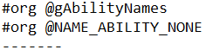

- The line after the #org contains the string. It can be written in plain text with no quotation marks on either side and with no terminator character at the end. The string may be spread onto multiple lines if you so wish. The string is terminated when the next #org is parsed.
- There are different escape characters which can be used with the string files:
Character | Becomes
\n | Newline
\p | New textbox (display arrow)
\l | Scroll line
\e | é
\$ | ₽
\" | ”

- Text buffers can be used too (see SpecialBuffers in scripts/string.py for all available):
Buffer | Description
[.] | …
[BUFFER] | Start a buffer. Usually followed by a hex buffer.
[ATTACKER] | IN-BATTLE: Loads the attacker’s name (found in gBankAttacker).
[TARGET] | IN-BATTLE: Loads the target’s name (found in gBankTarget).
[EFFECT_BANK] | IN-BATTLE: Loads the bank found in gEffectBank.
[SCRIPTING_BANK] | IN-BATTLE: Loads the bank found in gBattleScripting->bank.
[CURRENT_MOVE] | IN-BATTLE: Loads the move found in gCurrentMove.
[LAST_ITEM] | IN-BATTLE: Loads the item found in gLastUsedItem.
[LAST_ABILITY] | IN-BATTLE: Loads the ability found in gLastUsedAbility.
[ATTACKER_ABILITY] | IN-BATTLE: Loads the attacker’s ability (from gBankAttacker).
[TARGET_ABILITY] | IN-BATTLE: Loads the target’s ability (from gBankTarget).
[SCRIPTING_BANK_ABILITY] | IN-BATTLE: Loads the ability of gBattleScripting->bank.
[PLAYER_NAME] | IN-BATTLE: Loads the player’s name.
[PLAYER] | OVERWORLD: Prints the player’s name.
[RIVAL] | OVERWORLD: Prints the rival’s name.
[WHITE] | OVERWORLD: Changes the text colour to white.
[BLACK] | OVERWORLD: Changes the text colour to black.
[GRAY] | OVERWORLD: Changes the text colour to gray.
[RED] | OVERWORLD: Changes the text colour to red.
[ORANGE] | OVERWORLD: Changes the text colour to orange.
[GREEN] | OVERWORLD: Changes the text colour to green.
[LIGHT_GREEN] | OVERWORLD: Changes the text colour to light green.
[BLUE] | OVERWORLD: Changes the text colour to blue.
[LIGHT_BLUE] | OVERWORLD: Changes the text colour to light blue.
[SHRINK] | OVERWORLD: Uses a smaller font for the following characters.
[ALIGN][XX] | OVERWORLD: Adds XX whitespace characters.
[PAUSE_UNTIL_PRESS] | OVERWORLD: Stops printing text until a key is pressed.
[XX]  Eg. [FA] or [52] | Any two hex characters to represent that byte exactly (hex buffer). Can be used in conjunction with [BUFFER]. For example, in the overworld, [BUFFER][02] is the same as saying [buffer1] in XSE.

Credits

Main Contributors:
Skeli
Ghoulslash

Code:
Lixdel - Attack Animations
Pret - PokeRuby, PokeFireRed, PokeEmerald
Sagiri - Trainer Class Poke Balls, Pickup Update, Move Item, Summary Screen Wrapping
DizzyEgg - Emerald Battle Engine Upgrade V1 & V2, Dizzy's Emerald Hacked Engine
FBI - Expanded Saveblock, Dexnav
Touched – Follow Me, Mega Evolution source
Navenatox – Dynamic Overworld Palettes
Doesntknowhowtoplay & Squeetz - Pokedex Screen Stats
Azurile13 - Hidden Abilities
Squeetz - Footstep Noises, Attack Animations
JPAN – Fire Red Hacked Engine Source
Diegoisawesome – Triple Layer Tiles
Jiangzhengwenjz – Linux compatibility
Leon Dias – Gen 8 Descriptions and other data

Graphics:
Golche - Attack Particles, Battle Backgrounds, Other Graphics
Criminon - Ultra Burst indicator
Bela - Poke Balls
Solo993 - Backsprites
canstockphoto.ca - Battle Backgrounds

Testers:
Criminon
Dionen
Gail
Leon Dias
Recko Juice
Patrickz
If you actually read all the pages up until this point you deserve a medal. No, wait, a cookie. You deserve a cookie. Good job!



THE END

Credits to Squeetz for the original routine.
Credits to the Emerald Battle Engine Upgrade V2.0 for the original source code.
Credits to Sagiri for the original code.
Credits to FBI for this feature.
Credits to FBI and the Community Hack for this feature.
Credits to Navenatox for this feature.
Credits to DizzyEgg for this feature.
Credits to azurile13 for this feature.
Credits to DoesntKnowHowToPlay and Squeetz for this feature. ¹⁰Credits to Diegoisawesome for this feature.

